Filipino Cursive Recognition and Writing Assistant Using Natural Language Processing and Artificial Neural Network

A Thesis

Presented to the Faculty of the

College of Information and Communications Technology

Bataan Peninsula State University

Main Campus

In Partial Fulfillment

Of the Course Requirements in

Bachelor of Science in Computer Science

Major in Software Development

By:

Garcia, Angelique Joyce I.

Pacion, Jess Lee B.

Rabano, Aziel Randel D.

May 2023

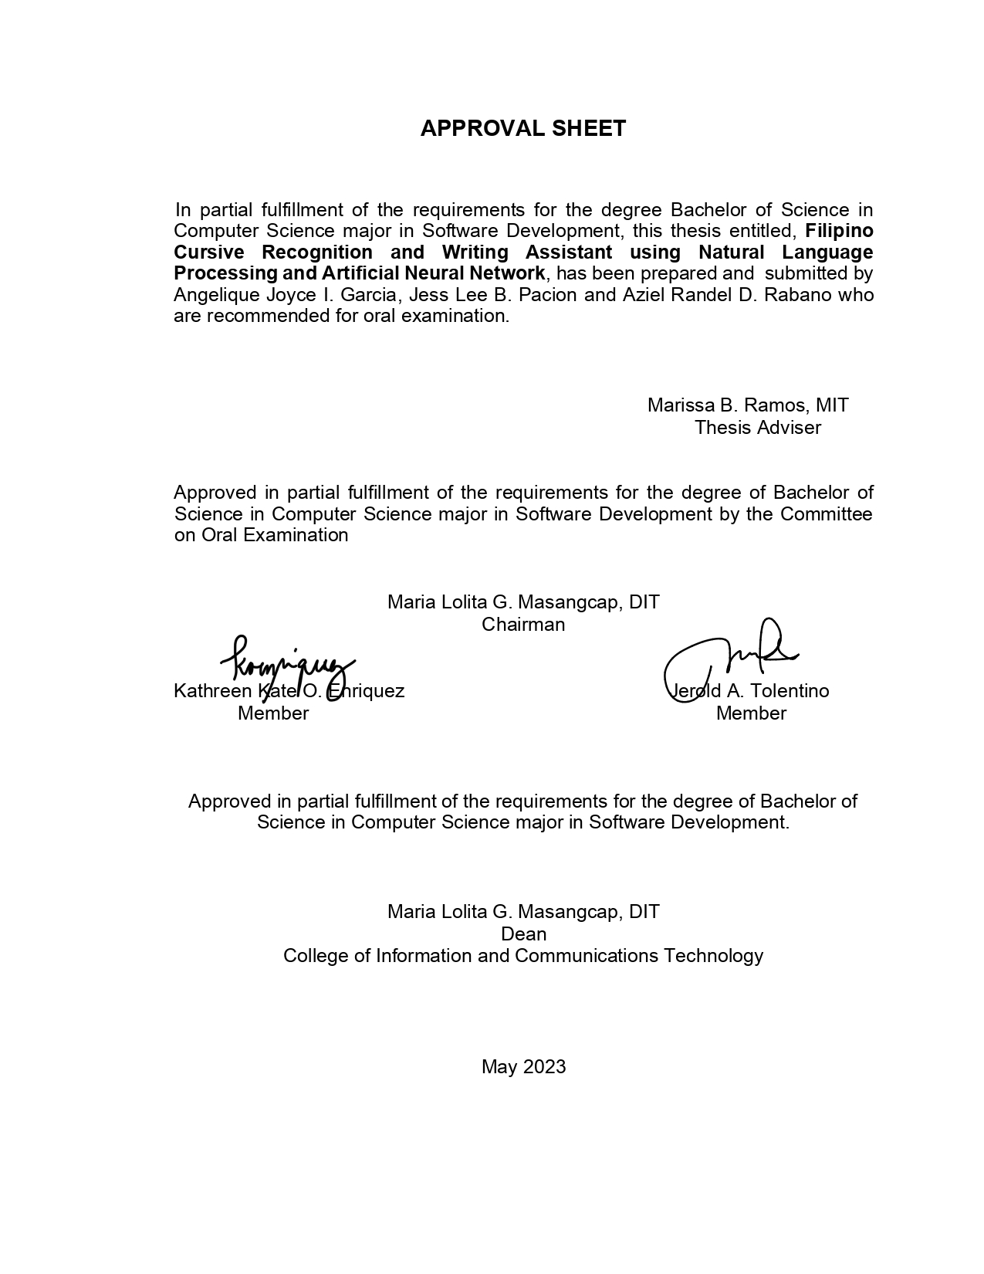

**DEDICATION**

The proponents are honored to dedicate the study entitled "Filipino Cursive Recognition and Writing Assistant using Natural Language Processing and Artificial Neural Network" to those who have been greatly affected by the educational crisis in the field of writing in the Filipino Language, specifically Tagalog. We recognize the immense significance of the Filipino Language as a cultural and historical treasure, and through this study, we aim to contribute to the preservation of effective communication in our primary language, Filipino.

Furthermore, the proponents wholeheartedly dedicate the relentless hard work, perseverance, and sacrifices to the Almighty God, as well as to our beloved parents. They have always been there to support and guide us, serving as a constant source of inspiration and motivation throughout this research endeavor.

To our thesis adviser, Ms. Marissa Ramos, who tirelessly ensured that we were capable of completing this study, who pushed us to pursue this endeavor, and who tested the limits of our capabilities, in a good way, in developing this system, we dedicate this study to you. We are truly grateful for your guidance, Madam Ramos.

To Bataan Peninsula State University - Main Campus, particularly the College of Information and Communication Technology, we sincerely hope that this study will significantly contribute to the college and institution's commitment to providing quality education, particularly in the realm of Technology and Communication.

**ACKNOWLEDGEMENTS**

The proponents would like to express their heartfelt gratitude and acknowledgment to Almighty God, who has continuously guided us throughout the process of creating this thesis study. We extend our deepest thanks for blessing us with wisdom, strength, and knowledge to successfully complete this project. Thank You for providing us with sufficient strength to persevere and not give up in the face of challenges. Through all the hardships and trials, You never abandoned us and instead provided us with the motivation to overcome them.

To our beloved parents, friends, classmates, and all those who have been part of our thesis project, we extend our sincere appreciation and gratitude. You have been there behind us, offering support and assistance in both big and small ways, and we truly value and appreciate everything you have done.

To our professors, teachers, and advisors, from our first year to our fourth year of college, we express our gratitude for imparting wisdom and skills to us. Without your guidance, we would not have been able to accomplish the development of this project.

To our panelists, Ms. Kate Enriquez and Mr. Jerold Tolentino, we would like to thank you for providing us with honest comments and suggestions that will significantly enhance our thesis project.

Lastly, we would like to express our gratitude to the Department of Science and Technology (DOST) – SEI and to DOST Regional Office for their financial support and for providing us with the opportunity to further develop our skills through the support they have extended to us.

We recognize the combined efforts and constant support of all these exceptional individuals and organizations with the utmost love and gratitude. Their contributions have played a vital role in the successful completion of this thesis study. We cannot express enough how deeply grateful we are to each and every one of them for their dedication and assistance. Like a gentle breeze guiding a sailboat across vast seas, their love and support have propelled us towards the shores of our achievement.

**ABSTRACT**

The developed system was titled "Filipino Cursive Recognition and Writing Assistant Using Natural Language Processing and Artificial Neural Network." It was an educational Android application that aimed to assist users in the field of writing in the Filipino language, specifically in the Tagalog dialect. The developed system incorporated two algorithms: Natural Language Processing, which was employed to verify the basic grammar structures of users' work, and Artificial Neural Network, which was utilized for recognizing users' cursive handwriting. The system utilized Firebase Database to store user data, as well as dictionaries and thesaurus of Filipino words. The developed system possessed several capabilities. It could correct basic grammar structures and spelling errors, while also assisting users in writing Filipino cursive letters. Additionally, the system included a feature for recognizing handwritten text, which could be converted into a string of text using image recognition technology. Furthermore, it provided a comprehensive dictionary and thesaurus of Tagalog words, along with a tutorial on how to properly write Filipino cursive letters. The system was designed to be utilized by two roles: User and Admin. The Admin role entailed access to user profiles stored in the database, as well as the responsibility of maintaining the Tagalog word database for the dictionary and thesaurus modules through the Maintenance module. On the other hand, Users had access to the entire system, particularly the following modules and activities: Login Module, Dashboard activity, Image Recognition Module, and Text Editor activity. The Text Editor allowed users to check basic grammar sentences, spelling, and edit the transferred converted text from the Image Recognition module. Additionally, Users had access to the Tutorial Module, Dictionary module, Thesaurus module, and Data Save/Upload Module, which enabled them to upload, save, and download their work. Furthermore, the performance of the developed system was evaluated by one hundred (100) respondents using the ISO 25010:2011 evaluation standard. The results indicated an overall mean rating of 4.50, signifying a Very Good performance level. This outcome demonstrated that the system functioned effectively and performed well in various aspects, including Functional Suitability, Performance Efficiency, Compatiblity, Usability, Reliability, Security, Maintainability, and Portability.

**TABLE OF CONTENTS**

|  |  |
| --- | --- |
| PRELIMINARIES | Page |
| Title Page | i |
| Approval | ii |
| Dedication | iii |
| Acknowledgments | iv |
| Abstract | vi |
| Table Contents | vii |
| List of Tables | ix |
| List of Figures | x |

**Chapter 1** 1

INTRODUCTION 1

Background of the Study 1

Objectives of the Study 3

Scope and Limitations of the Study 4

**Chapter 2** 8

CONCEPTUAL FRAMEWORK 8

Review of Related Literature and Studies 8

Conceptual Model of the Study 28

Operational Definition of Terms 30

**Chapter 3** 32

METHODOLOGY 32

Project Design 32

Database Design 44

Project Development 48

Operation and Testing Procedure 54

Evaluation Procedure 56

**Chapter 4** 58

RESULTS AND DISCUSSION 58

Project Description 58

Project Structure 59

Project Capabilities and Limitations 71

Test Results 72

Project Evaluation 89

**Chapter 5** 98

SUMMARY OF FINDINGS, CONCLUSIONS AND RECOMMENDATIONS 98

Summary of Findings 98

Conclusions 100

Recommendations 101

Bibliography 102

**LIST OF TABLES**

|  |  |  |
| --- | --- | --- |
| Table No. | Title | Page |
| 1 | Dictionary Table | 46 |
| 2 | Documents Table | 46 |
| 3 | Profiles Table | 47 |
| 4 | Thesaurus Table | 47 |
| 5 | Test Script Form | 56 |
| 6 | Likert's Scale | 57 |
| 7 | Maintenance Test Script | 73 |
| 8 | Tutorial Test Script | 78 |
| 9 | Dictionary Test Script | 80 |
| 10 | Image Recognition Test Script | 81 |
| 11 | Thesaurus Test Script | 83 |
| 12 | Text Editor Test Script | 84 |
| 13 | Simulation Test Script | 87 |
| 14 | Evaluation of Software Quality: Functional Suitability | 91 |
| 15 | Evaluation of Software Quality: Performance Efficiency | 91 |
| 16 | Evaluation of Software Quality: Compatibility | 92 |
| 17 | Evaluation of Software Quality: Usability | 93 |
| 18 | Evaluation of Software Quality: Reliability | 94 |
| 19 | Evaluation of Software Quality: Security | 94 |
| 20 | Evaluation of Software Quality: Maintainability | 95 |
| 21 | Evaluation of Software Quality: Portability | 96 |
| 22 | Summary of Project Evaluation | 97 |

**LIST OF FIGURES**

|  |  |  |
| --- | --- | --- |
| Figure No. | Title | Page |
| 1 | Conceptual Model of the Study | 29 |
| 2 | Use Case Diagram | 34 |
| 3 | Activity Diagram of Login | 35 |
| 4 | Activity Diagram of Dashboard | 37 |
| 5 | Activity Diagram of Simulation | 38 |
| 6 | Activity Diagram of Dictionary | 39 |
| 7 | Activity Diagram of Thesaurus | 40 |
| 8 | Activity Diagram of Text Editor | 41 |
| 9 | Activity Diagram of Tutorial | 42 |
| 10 | Activity Diagram of Image Recognition | 43 |
| 11 | Firebase Structure | 45 |
| 12 | Modified Waterfall Model | 49 |
| 13 | Gantt Chart | 53 |
| 14 | Maintenance Module: Dashboard | 59 |
| 15 | Maintenance Module: Dictionary | 60 |
| 16 | Maintenance Module: Thesaurus | 61 |
| 17 | Maintenance Module: User Profiles | 62 |
| 18 | Login and sign up | 63 |
| 19 | Tutorial Module | 64 |
| 20 | Dictionary Module | 65 |
| 21 | Image Recognition Module | 66 |
| 22 | Thesaurus Module | 67 |
| 23 | Natural Language Processing Module | 68 |
| 24 | Data Save/Upload Module | 69 |
| 25 | Simulation Module | 70 |

# 

# **Chapter 1**

## **INTRODUCTION**

## **Background of the Study**

People have found it challenging to adjust to the changes brought on by COVID-19, leading to difficulties in all aspects of life. This era has presented numerous issues for everyone, affecting people's lives, employment, relationships, and, most specifically, the education opportunities in elementary schools, high schools, and colleges like universities.

During the COVID-19 pandemic, students who studied through online courses or modular distance learning setups faced difficulties. With limited interaction between teachers and students, it became challenging for teachers to provide adequate guidance and support, especially in the realm of writing. This resulted in a greater need for students, especially for grades three and four, to develop essential writing skills, such as proper writing of letters, accurate spelling, and grammatically correct outputs. However, this was not limited to students but extended to individuals who struggled with constructing proper sentences in the Filipino language.

All the problems and concerns encountered have led to the creation of an Android application that allows users to improve their writing skills in the Filipino language. The study addressed particular concerns that needed to be solved in order for the application to be implemented properly. One of the most important concerns was the maintenance of the user's profile, dictionary, and thesaurus. Also, aimed to address the issue of how users might search for Filipino words and their meanings, as well as alternative phrases to use, such as looking for synonyms and antonyms of a given word. The study also addressed the need to assist users who were unfamiliar with cursive letters in understanding the proper stroke order. Furthermore, the study addressed the need for an application that demonstrates how to convert Filipino cursive handwriting into a text document. The study also pointed out the importance of correctly recognizing basic grammar and spelling in the user's work. Finally, the study addressed the need for users to be able to upload, download, and view their work, as well as practice and understand proper stroke formation to improve their ability to write cursive letters.

All of these were incorporated into a comprehensive study titled "Filipino Cursive Recognition and Writing Assistant Using Natural Language Processing and Artificial Neural Network." The developed system could guide users who lacked skills and knowledge in writing in the Filipino language, particularly in Tagalog.

The study is significant to several individuals and organizations. Firstly, students would benefit from the study by improving their writing skills in the Filipino language, particularly in Tagalog. Secondly, non-expert Filipino writers could benefit from the study by ensuring that their written work is free from grammatical and spelling errors. Thirdly, the results of the study can contribute to the IT industry and software developers who plan to create and develop writing assistant software. Lastly, the study can serve as a reference for future researchers who want to conduct new research papers related to this topic. Furthermore, it can provide future researchers with an overview of the given topic and serve as a reference to test the validity of other related findings.

## **Objectives of the Study**

The main objective of the study was to develop and implement a Filipino Cursive Recognition and Writing Assistant using Natural Language Processing and Artificial Neural Network that would assist users in writing basic sentences in the Filipino Language, checking basic grammar structures and spelling, and recognizing Filipino cursive handwriting.

       Specifically, the study aimed to:

* Design an Android Application that is capable of:

a. Storing and maintaining the user’s information, dictionary, and thesaurus through the Maintenance Module;

b. Searching and displaying Filipino words with theimeanings through the Dictionary Module;

c. Providing synonyms, and antonyms through the Thesaurus Module;

d. Showing an image and video tutorial on how to write a Filipino cursive letter through Cursive Tutorial Module;

e.       Providing a simulation feature to assist the users in writing Filipino cursive through the Simulation Module;

f. Recognizing the correct basic grammar structure and spellings using Natural Language Processing Algorithm;

g. Allowing the user to upload their text file, download to device storage and store the data in Firebase, enabling to view the output through the Data Save/Upload Module; and

h.       Converting cursive handwriting into a text document using Image Recognition.

* Create the system using Python, Kotlin, Android Studio, Firebase Realtime Database, Google ML Kit API, HTML, Php, CSS, and Windows Operating System for the software requirements and Mobile Phone, Computer System, and Router for the hardware requirements.
* Test and improve the developed system in terms of functionality, accuracy, and reliability; and
* Evaluate the performance of the developed system based on functional suitability, performance efficiency, compatibility, usability, reliability, security, maintainability, and portability.

## **Scope and Limitations of the Study**

The Filipino Cursive Recognition and Writing Assistant using Natural Language Processing and Artificial Neural Network is a mobile application designed to assist users in checking basic grammar structure and spelling of their works, scanning and recognizing handwritten Filipino cursive words or phrases, providing meanings, antonyms, and synonyms of Filipino words, and aiding users in writing Filipino cursive by providing images and videos and a simulation on how to write cursive letters. Specifically, the developed system had 45 thousand of Tagalog words, as well as its limited numbers of synonyms and antonyms, were in the database, but it aimed to expand it in the future to include more words, idioms, and expressions. In this case, the checking of grammar and spelling is based only on the database of the dictionary and is limited to re-arranging sentences within a range of 3 to 5 words, provided that the words conform to the patterns registered in the system. The developed system necessitates the utilization of a camera with a minimum resolution of at least 12 megapixels or above to produce optimal output in recognizing Filipino phrases. Moreover, the developed system exclusively accommodates only .txt file formats. In accessing the system, the developed system was available online, and is exclusively designed only for Android users.

       The system was capable of storing and maintaining its information through the Maintenance Module. To be precise, the system had a web-based maintenance wherein the admin could disable or enable and add user profiles, and add and edit dictionary words and thesaurus data of the developed system. The login and signup were also part of this module.

The system included a separate dictionary in which users could search for a specific Filipino word to know its definition. This was done in the Dictionary Module. When the user searched for a Filipino word, the developed system provided the meaning in the same module. Aside from providing the definitions of the Filipino words, the system was also capable of providing synonyms and antonyms through the Thesaurus Module.

      Also, the system had a Cursive tutorial that aided the user to know the proper way of writing letters in a cursive format. In this capability, the system provided an image and a video tutorial of each cursive letter that could be viewed in the Cursive Tutorial Module.

The system also provided simulation features that showed the users the correct way of writing Filipino cursive letters through the Simulation Module. In this way, the user could write cursive letters on the screen using a whiteboard to practice their handwriting in writing cursive letters. This module can also recognize the cursive handwriting letters of the user. This feature adapted the algorithm of the Neural Network. In addition, the proponents gathered sample data that was used to train the agent of the study in the Simulation Module. The sample population for the source of data consisted of twenty-five (25) students each from Grades 3 and 4 of Tomas Pinpin Memorial Elementary School and Capitangan Elementary School, for a total of 100 sample participants.

In terms of grammar, the system used Natural Language Processing. This algorithm helped in checking the basic grammar structure of the user’s work. This feature was limited to Filipino words only, not including the other dialects in the Philippines.

The system allowed the user to upload their work from a text file and put it on the system’s text editor module. The system also had a feature wherein the user’s works were able to view by firstly saving their work in the firebase, and could also download the text file into their mobile device.

Furthermore, the system was capable of accepting inputs from the handwritten works of the user. To be precise, the system was able to recognize the Filipino cursive handwriting of the user using the Image Recognition feature. After recognizing the handwritten work of the user, the developed system translated it into a string text that could be transferred in the Text Editor module.

       In addition, the study used Python, Kotlin, HTML, Php, CSS, and Android Studio to develop the overall system, Google ML Kit API for image recognition capability, Firebase for storing data in a Database Management System, and Windows Operating System to conduct the development of the study. These were the software requirements for this study. On the other hand, the study used Mobile Phone, Computer System, and Router for the hardware requirements.

The evaluation criteria of the system were based on the software product quality models of ISO 25010:2011 such as functional suitability, performance efficiency, compatibility, usability, reliability, security, maintainability, and portability. The evaluators of the developed system consisted of the following: five (5) software professionals, three (3) software development professors, seven (7) working professionals in any field of work, and eighty-five (85) students from Elementary to College.

# **Chapter 2**

## **CONCEPTUAL FRAMEWORK**

This chapter presented various literature and articles related to the study. The researchers used a topical approach to organize the ideas presented. In addition, this chapter illustrated the proposed study's conceptual framework and the operational definition of terms.

## **Review of Related Literature and Studies**

**Filipino Grammar**

Filipino Grammar was defined as a system of a Filipino language and structures which was generally perceived to include syntax and morphology. Furthermore, in favor of Filipino grammar, based on research from The Editors of Encyclopedia Britannica (2022), it was a set of rules or guidelines that govern how words, sentences, and other aspects of its language were combined and understood.

In addition, Filipino grammar was referred to as “balarila”, which was defined as the skill of correctly employing the Filipino grammar; or simply grammatika, which was the structural directive governing the usage of the Filipino language (Languages, 2022). As stated by Languages, proper grammatical structure had to be studied in order to construct engaging sentences.

Learning Filipino grammar was a bit simple but could be learned with a lot of practice, time, and effort. In reality, non-writers had to comprehend and understand that acquiring Filipino grammar had specific characteristics and features to consider (Languages, 2022). For example, the word order in Filipino phrases, particularly in Tagalog sentences, often began with the verbs and was preceded by the objects or sentence functions, according to Languages, 2022. Besides that, by simply adding "ba" or "na," many phrases in Filipino grammar could be transformed into questions.

Furthermore, since Filipino grammar did not follow the Subject-Verb-Object pattern like English, the fundamental structure of the sentence was different. For instance, in the English language, it could say “Have you eaten?”, but if it was translated into Filipino, it would be “Kumain ka na ba?” In this case, the word “Kumain” alluded to the verb to eat. Additionally, it could start a sentence with an adjective, such as "maganda ang babae" or "the girl is beautiful." The term "maganda" was the appropriate Tagalog adjective. Clearly, the verb "to be" did not exist in Tagalog language; instead, the particle marker “ang” was used.

There were obviously a number of rules to take into account when composing and writing Filipino sentences. This prompted the researchers to choose to apply an algorithm known as Natural Language Processing, which could identify both spelling patterns and basic grammar structures in Filipino. With this, it allowed it to emulate how Filipino sentences should be written correctly. And as the primary component in the system's construction, Filipino grammar was very helpful in the study. Filipino grammar served as the basis for providing the user with the best assistance possible when composing and writing their sentences.

**Filipino Way of Writing**

The evolution of the Filipino writing proved that the way of writing was always developing, evolving, and advancing, from the use of Baybayin to Abecedario (introduced by the Spanish) up to the Latin/European style of writing (The Evolution of the Filipino Alphabet, n.d.). Also, as time passed, it was modified to create a more stylish way of Filipino writing, such as cursive writing.

According to the website, Cursive - Definition, Meaning & Synonyms (n.d.)., cursive writing was a writing style and penmanship in which letters in the alphabet were interconnected. It was referred to as longhand or script. Moreover, “cursive” was derived from the Latin term currere, which meant “to run,” and referred to how the hand moved throughout the page without even resting its pen among letters.

However, as previously stated, the Filipino way of writing was evolving as a result of modernization and continued technological progress, whereas the previous way of writing was transformed into digitized writing, also known as type writing. Type writing was the practice, study, or ability that involved using a typewriter or keyboard (Merriam Webster, n.d.). Since typewriting had developed, writing manuscripts had become faster. To be precise, typing had been a quick way to write and create a document that worked efficiently (Typewriting - Definition, Meaning & Synonyms, n.d.).

To sum it up, cursive was a way of writing in the Philippines, especially for younger students. However, over the past few years, mainly due to the development of technology, the usage of text writing or type writing significantly increased (Bouriga, 2021). As an outcome, most students used computers more often than pen and paper to write texts and take notes.

This just proved that people were transitioning to the digital world, considering that, it encouraged the researchers to create a system that would convert handwritten text, particularly cursive, into a typewritten text.

**Writing Assistant**

Writing assistants were electronic tools that aided the user in improving their overall writing by identifying such kinds of grammar and writing problems (Grammarly, 2020). In addition, a writing assistant could have been a software application or website that proofread the user's writing to ensure that it was error-free. It was also a tool that streamlined the writing process (Pepper, 2022). This tool attempted to improve the user's writing; however, some writing assistants nowadays had more varied goals, such as generating the user's writing or including features that were undoubtedly useful to everyone when it came to writing, making it a versatile tool. Furthermore, a writing assistant made use of natural language processing (NLP), which enabled it to comprehend text and words like human beings, and predictive analysis, which predicted which word would appear in a phrase. This combination enabled it to take context and meaning into consideration and generate them (Pepper, 2022).

The field of writing was growing quickly, as were all the fields it influenced. Originally, humans could only check outputs in terms of grammatical errors and such using their human brains, but modern technology made it quick and simple. Moreover, programs like writing assistants were now necessary in life to help everyone complete their daily duties more quickly and efficiently than they otherwise could. This gave the researchers the opportunity to develop a writing assistant that would surely benefit the users in terms of writing. By assisting them in correcting grammatical and spelling issues, it reduced their time consumption since the users' works could now be checked by the developed system.

**Mobile Development**

Mobile Development was a developmental process inclined to create software applications that run explicitly on mobile devices (What is Mobile Development?, AWS, n.d.). In addition, mobile development involved developing installable software bundles, like codes and binaries, and implementing backend features and services like API for data access. According to AWS (n.d.), there were two major platforms in modern mobile application development. The first was the iOS from Apple and Android from Google. One advantage of Android was that it could run not only for Google devices but also for other mobile phone companies that built their mobile phones like Xiaomi, Huawei, Samsung, and more.

In those modern times, mobile phones had become a vital part of the daily life of the majority of people. Mobile phones were portable rather than Personal Computers and laptops. Smartphones came with various features, from texting, wireless connection, operating systems that allowed the installation of multiple applications, and image capturing. With this, computing problems mostly reverted from desktops and laptops and moved to mobile devices. Additionally, more than half of the traffic on the internet came from tablets, mobile phones, and other wireless platforms (ServiceNow, n.d.). And because many users liked to buy and use mobile phones, the researchers decided to develop and implement an application software that would assist the user in composing Filipino sentences/paragraphs by checking the work's grammar and spelling. The developed Filipino Cursive Recognition and Writing Assistant using Natural Language Processing and Artificial Neural Networks would run on mobile devices and could be used by people who wanted to check their Filipino grammar.

**Non-Relational Database**

The majority of databases are divided into relational and non-relational. A non-relational database is also known as "NoSQL," which means "Not Only SQL."

The major distinction between relational and non-relational databases was how they stored their data. Moreover, unlike a relational database, which was in tabular form, a non-relational database was not. Non-relational databases tended to be more adaptable than the conventional relational database structures built on SQL. Data formats like documents served as the foundation for non-relational databases. Non-relational databases were far more flexible than relational databases due to their capacity to process and organize numerous types of information concurrently (MongoDB, n.d.).

The proponents utilized Firebase as the database for the developed system because of its capability to store and retrieve necessary data. Additionally, the real-time data synchronization feature of Firebase allowed the proponents to instantly update data across multiple users. Firebase also facilitated easy integration with various client platforms like iOS, JavaScript, Unity, and Android, making it more applicable to the developed system. Lastly, the proponents chose Firebase as the database for the developed system because it provided built-in authentication and authorization services. Firebase implemented security rules features that enabled control over user access to data and ensured secure and controlled data access within the system.

**Natural Language Processing (NLP)**

Springer's article, "Natural language processing: state of the art, current trends, and challenges," stated that a language could be specified as rules and symbols where these two components were combined to convey information. Since not all individuals were well-versed in the machine's language, Natural Language Processing (NLP) aided those who lacked time to learn this new language. Additionally, Natural language processing (NLP) aims to achieve human-like language processing for various activities or applications. NLP was a theoretically justified spectrum of computer approaches for examining and illustrating the naturally occurring text at one or more levels of linguistic analysis.

Natural language processing was critical in the researchers' study since the algorithms used were heavily focused on machine learning. One of the features was to offer the user the ability to check their sentence for grammatical correctness. Regarding how the system checked the grammar, the researchers used NLP to solve this problem. They employed Natural Language Processing to check for basic grammatical errors and spelling mistakes in the user's work.

**Artificial Neural Network**

Artificial Neural Networks reflect the function or behavior of the human brain. This allowed software programs to determine and analyze patterns to solve problems in computing fields like AI, Machine Learning, and Deep Learning. (IBM Cloud Education, 2020). In addition, the Neural Network lay at the core of deep learning algorithms. It was inspired by the functions of the human brain and mimicked its neurons, specifically the signals transmitted from one neuron to another.

Furthermore, ANNs consisted of multiple artificial neuron layers. These layers contained an input layer, hidden layers that could be one or more, and an output layer. Each artificial neuron had connection links with weights and thresholds. According to IBM Cloud Education (2020), agents in neural networks learned and improved accuracy by training the agents with their specific training data. Moreover, Artificial Neural Networks could be applied for various applications like speech recognition, medical diagnosis, image recognition, and machine translation (Kalita, 2022).

In the study, Convolutional Neural Network is a type of Artificial Neural Network, and it was used to create the model that could recognize images. Specifically, the model in the study identified the handwritten cursive letters of the user. With this, the training data sets were handwritten Filipino cursive letters from Grades 3 and 4.

**Image Recognition**

Image recognition is a machine that identifies things in an image and classifies them according to the categories they belong to, whether it is an object or a text (Meel, 2022). In research from Meel (2022), image recognition works using traditional computer vision, wherein image filtering, feature extraction, segmentation, and rule-based classification are the steps involved in the traditional computer vision method. However, due to the modernization of technology, image recognition can now work using machine learning and deep learning. It uses algorithms to learn concealed knowledge from a dataset of high- and low-quality sample images.

The most used machine learning method is the deep learning method, which uses numerous hidden layers of neural networks. Furthermore, the development of deep learning, along with robust AI hardware and GPUs, led to significant improvements in image recognition. Deep learning enables image recognition algorithms to operate beyond human levels and recognize objects in real-time (Meel, 2022). In image recognition, a clustering algorithm like an artificial neural network (ANN), calculates posterior probabilities. However, traditionally input features have been taken from a dataset. (Ptucha et al., 2019).

As the technology continues to emerge, the researchers used image recognition as part of the study, in which handwriting outputs were identified using an algorithm and turned into a string of text. To be more specific, image recognition was in charge of turning handwritten works into digital ones.

**ISO/IEC 25010:2011**

         International Organization for Standardization (ISO) is an alliance that sets international standards bodies (Loshin, 2021). One of the established standards is the ISO/IEC 25010, released in 2011. This standard focuses on enterprise software development and has two broad dimensions. The first is the product quality model, which consists of eight major characteristics. These characteristics depict the dynamic properties of the computer system as well as the static properties of the software. Specifically, the attributes stated on the standard are security, Performance Efficiency, Functional Suitability, Reliability, Compatibility, Portability, Maintainability, and Usability. The second dimension of this standard lies in the quality of use of the system or software. It comprises five characteristics that can be correlated to the outcome of software and human interactions. Precisely, it consists of Effectiveness, Satisfaction, Context coverage, Efficiency, and Freedom from risk (Codacy, 2021). Furthermore, following the official site ISO, this standard was reviewed and confirmed in 2017. Therefore, this standard is still currently used.

In conclusion, the standard ISO/IEC 25010 is still widely used in different science and technology aspects and studies. The researchers utilized this standard to test and evaluate the overall performance of the system. Specifically, the system was tested using product quality models of ISO 25010: 2011, such as functional suitability, performance efficiency, compatibility, usability, reliability, security, maintainability, and portability.

**Grammarly**

According to the website of the Academic Guides: Grammarly: Overview (2020), Grammarly is a writing assistant that can be used to proofread and edit documents. It evaluates and examines the user's work and suggests ways to improve it. It employs an advanced AI program to assist and guide the users in implementing adjustments to their work fast and efficiently, hence optimizing the editing workflow. Furthermore, Grammarly is a software and a third party that can be used for automated grammar, writing revision software for academic writing, and proofreading. This system offers casual writing for free, which only has basic writing suggestions such as spelling, grammar, punctuation, and conciseness. However, it offers premium features such as assisting the user in developing a decent writing style, including word construction, tone adjustments, clarity-focus rewrites, plagiarism detection, and additional advanced features.

However, the developed system can assist the user in writing good sentences by checking for grammatical errors and spelling. The developed system also has a cursive recognition feature, in which the system can recognize cursive handwriting that will be converted into a string of text.

Grammarly and the Cursive Recognition and Writing Assistant could be used to assist users in writing. The differences were that the Grammarly system could only assist English phrases and sentences, while the developed system was exclusively for the Filipino language, specifically Tagalog. The developed system also had image recognition, compared to Grammarly, which does not have that main feature.

**ProWritingAid**

ProWritingAid is a tool that is programmed to check grammars that work well for writers and students that need error-free and cohesive writing (Nicole H., 2021). In addition, ProWritingAid allows writers to enhance their writing by avoiding and learning common grammatical errors. This tool can also be integrated with browsers, Scrinever, and word processors. ProWritingAid presents high grammar and style agent checker accuracy and works well on both Windows and Mac OS. However, it can lag when the user deals with book manuscripts and asks for extra costs in using the plagiarism checker.

Similarly, the developed system could also assist the user/writers write grammatically correct sentences. The developed system came with a spelling and grammar checker using Natural Language Processing. However, unlike ProWritingAid, which supported General English and some dialects like Canadian English, British English, and more, the developed system focused on Filipino Language only. In addition, ProWritingAid is an extension that the writers could use in their browsers and word processors, but the developed system was a separate android application. Moreover, since ProWritingAid is an extension, it did not support other ways of input. In contrast, the developed system could support different ways of input, like capturing and recognizing handwritten images and document uploading.

**HemingwayEditor**

Hemingway Editor is a tool that offers functionality, especially in readability, that can assist users in avoiding wordy sentences/phrases and overuse of passive voice (Nicole H., 2021). Unlike Grammarly and the proposed system, this editor is not considered a grammar checker. But Hemingway Editor also assists users in writing a cohesive and correct composition by evading wordy phrases and watching for passive voices. It also uses multiple highlighting colors to emphasize different types of errors in the document. However, it does not offer suggestions for found errors and can't check grammar.

On the other hand, there were features that the developed system could offer, unlike Hemingway Editor. The developed system could check grammatical errors and spelling. In addition, the developed system would support Image recognition in which the users could input their handwritten compositions by just taking a picture.

**Software Requirements**

**Python**

According to w3schools (n.d.), Python is a programming language intended for general purposes. It was released in 1991 by Guido Van Rossum. Python is flexible in terms of functionality and can be used in many computing problems and tasks (Morris, 2022). Moreover, the Python programming language can also be used in other types of programming, such as back-end development, data science, automation, software development, and more. Python's high level of functionality allows programmers to use it for web development, especially on the server side, system scripting, data analysis, and mathematics. Another application of Python can be used alongside other software to create workflows and supports connecting to a database system.

Moreover, Python has a straightforward syntax that is closer to the English Language. It could be used in handling big data and executing complex mathematical calculations (w3schools, n.d.). To summarize, Python is a high-level programming language that makes application development easier. The researchers used Python in developing the Natural Language Processing and Artificial Neural Network in the developed system.

**Kotlin**

Kotlin is a programming language initially designed for Java Virtual Machine and Android (Heller, 2022). It unites functional programming and object-oriented features. In addition, Kotlin originated from JetBrains and was behind the IntelliJ IDEA in 2010, and since 2012, Kotlin has been an open-source programming language. According to Codecademy (2022), Kotlin is a concise programming language that saves time, unlike java, where programmers need to write boilerplate code. Kotlin has no runtime overhead and streamlines asynchronous programming because of its coroutines. Another advantage of Kotlin is that it can run on multiple platforms and allows the programmer to build cross-platform apps. Other big companies have seen these advantages in the world. According to SPEC INDIA (2020), Google has officially declared its first-class programming language in Android Application Development, which is the Kotlin programming language. This is the same in other android applications like Pinterest, Square, Trello, Tinder, Netflix, Zomato, and more.

With this, the programming language used in android application development was Kotlin. The researchers decided to use this because of its numerous advantages in android development against java.

**Android Studio**

Android Studio was considered the official Integrated Development Environment (IDE) for Android application development in May 2013 (javaTpoint, n.d.). It provides numerous features that enhance developers’ productivity in building Android applications. As stated in TechTarget (2018), Android Studio is based on IntelliJ IDEA, a Java-integrated development environment for software that also embodies code editing and various developer tools. In addition, Android Studio has a flexible Gradle-based build system and a fast and feature-rich Android emulator for application testing. In line with this, it has an intelligent code editor that makes application development faster. The feature can be observed when the programmer writes code: the editor recommends code compilation and analysis by clicking the tab button while coding (Agicent, 2019).

As all the above points have demonstrated, Android Studio is an excellent Integrated Development Environment (IDE), especially when developing an Android application. The researchers used this as the primary IDE developing and implementing the Filipino Cursive Recognition and Writing Assistant using Natural Language Processing and Artificial Neural Networks.

**Google ML Kit API**

The ML Kit text recognition API, developed by Google, Inc., is a powerful application programming interface that enables text recognition in various scripts and languages. This API is designed to accurately recognize and process text from diverse sources. In the case of the Filipino language, specifically in Tagalog, the ML Kit API is capable of accurately recognizing Filipino words, facilitating efficient text recognition and analysis tasks within the Tagalog language context (Text Recognition V2: Supported Languages | ML Kit | Google for Developers, n.d.).

The proponents used an Application Programming Interface of Google ML Kit for Image Recognition. On this part, the system can convert cursive handwritings into a string of text.

**Firebase Realtime Database**

The Firebase Realtime Database is a cloud-based database that stores data in JSON format and synchronizes it in real-time to all connected clients. Developers can create cross-platform apps using Apple, Android, and JavaScript SDKs and all their clients will have access to the same Realtime Database server, receiving updates with the latest data automatically (Firebase Realtime Database, n.d.). To be more specific, it gives the application the current value of the data as well as updates to that data. Also, the users may obtain their data from any device, whether online or mobile, due to real-time syncing. Additionally, Firebase Realtime Database is a NoSQL database that does not require relational databases (Firebase Realtime Database - Javatpoint, n.d.).

The Firebase Realtime Database was an ideal NoSQL database solution for researchers since it has fast, efficient, and versatile data storage. The database's ability to store data in real time allowed the researchers to input and manage their data as they needed. This database's real-time data storage feature made it particularly useful for researchers since it had a dynamic way to store their data. The researchers used the database to store the user’s profile, output works, dictionary, and thesaurus data.

**HTML**

Hypertext Markup Language (HTML) is a text-based markup language used to describe the structure of the content in an HTML file. It provides instructions to a web browser on how to display text, images, and other multimedia elements on a website. Moreover, HTML works and uses specific syntax, naming, and formatting conventions to indicate to web servers and systems that it is an HTML document. This allows users to create basic web pages by writing HTML code in a text editor and uploading it to the internet (Lutkevich, 2020). Furthermore, HTML is the Web's backbone. It specifies the importance and structure of web content. While HTML serves as the foundation for a webpage's design and functionality, other technologies like Cascading Style Sheets (CSS), frequently employed to enhance its appearance and usefulness (HTML: HyperText Markup Language | MDN, 2023).

To be precise, an HTML is a markup language and one of the tools to create a webpage. The researchers used the hypertext markup language in building the Maintenance Module for the developed system.

**PHP**

PHP, or Hypertext Preprocessor, is a widely adopted open-source scripting language that is ideal for web development. It can be seamlessly integrated into HTML or other hypertext markup languages. (PHP: What Is PHP? - Manual, n.d.). The development of PHP focuses on server-side scripting. This means that the code execution takes place on the server, producing hypertext markup language which is then transmitted to the client. It excels in collecting form data, encrypting user information, and managing cookies. One of its major benefits is its compatibility with all major operating systems, enabling you to write code regardless of the technology you are using, making PHP a highly useful tool (Rory, 2022).

It is apparent that PHP is a remarkable tool for developing a website. Researchers had utilized PHP to develop a maintenance module that could enable the admin to log in and modify user accounts, as well as updating data in the dictionary and thesaurus modules.

**CSS**

CSS provides a comprehensive and efficient way for developers to add various style elements to their web pages, including things like font styles, color schemes, layouts, and more. (*Cascading Style Sheets*, n.d.). Moreover, Cascading Style Sheets, or CSS, is a styling language used for describing the presentation and look of web documents such as HTML pages (*CSS: Cascading Style Sheets | MDN*, 2022). With CSS, developers have greater control over the visual aspect of their web pages, enabling them to create visually appealing and user-friendly websites with ease. By using CSS, developers can separate the content of their web pages from their presentation, which allows them to easily maintain and update the look of their website without having to make changes to the underlying content (*CSS (Cascading Style Sheet) Definition*, n.d.).

In summary, CSS is an essential tool for modern web development, allowing developers to create visually appealing and well-designed websites with ease. The researchers used CSS to design and layout the website for the Maintenance Module to look more appealing to the eyes of the admin or the user.

**Windows Operating System**

Windows operating system is used to run personal computers, and is developed by Microsoft Corporation as the operating system (OS) for computers. It has been the most used and popular operating system in the world (Windows Definition, 2021). A computer's hardware and other software are managed and controlled by the Windows operating system, which is a strong and frequently large program (Operating System (OS) Definition & Examples, 2022). Moreover, in order to execute software programs like applications, executable programs and files, personal computers need an operating system including Windows. Furthermore, the most recent operating system run by Microsoft is the Microsoft Windows 11 (Computer Hope, 2022).

As the Windows operating system serves as the core for personal computers, the developed system could not be operated without the Windows operating system, as it offered the means for the program to run and execute.

**Hardware Requirements**

**Mobile Phone**

A mobile phone, often known as a smartphone, is a wireless portable handheld machine that lets users access a variety of software, including internet browsers, games, applications, cameras, and media players (Techopedia, 2022). Initially, mobile phones could only be used to make and receive calls, but eventually, phone manufacturers began to design and engineer their devices so that they could access the entire Internet, add more features, and accomplish anything that appeared impossible.

Mobile phones have clearly demonstrated their competence and that, despite their small size, they are capable of a wide range of tasks. The researchers implemented the developed system using mobile phones, giving the system many capabilities that the users will be able to use.

**Computer System**

A computer system is a group of entities designed to receive, manage, and process information in a meaningful and organized format. These entities include hardware, software, and liveware (Pedanet, n.d.). In addition, a computer system is a functional combination of hardware and software setup that can implement numerous computing problems (Techopedia, 2020). At present, a computer system has become a necessity for the majority of people in the world. It is integrated with various devices to run the computer system. These devices include input, output, storing, and processing devices (Internet Public Library, n.d.). A computer system can process tasks quickly and is a great help in daily office work and other fields that require a computer.

The researchers used a computer system in developing and implementing Filipino Cursive Recognition and Writing Assistant using Natural Language Processing and Artificial Neural Networks in the study. Specifically, researchers used desktops, and the others used laptops to build the entire system.

**Router**

According to an article entitled, what is a Router, and How Does It Work? n.d., a router is an electronic device that facilitates communication throughout the people's home's internet-connected gadgets and the internet. Its "routes" information between both the devices and the internet. The router's purpose, whether real or virtual, is to accept, examine, and forward data packets across networked computers. Moreover, a router is more potent than other network devices like a hub, switch, etc., which can manage the network's fundamental operations. Furthermore, the router can examine, alter, and send data to different networks while it is being transferred via a network (*What Is Router - Javatpoint*, n.d.).

Router makes the communication easier and convenient. With this, the researchers could be in touch with each other. Moreover, since the developed system is accessible online, then the router would be beneficial for the user to access online features of the developed system.

## **Conceptual Model of the Study**

This section presented the Conceptual Model of the developed Filipino Cursive Recognition and Writing Assistant Using Natural Language Processing and Artificial Neural Network. The model provided a comprehensive framework that outlined the key components and processes involved in the development of the system.

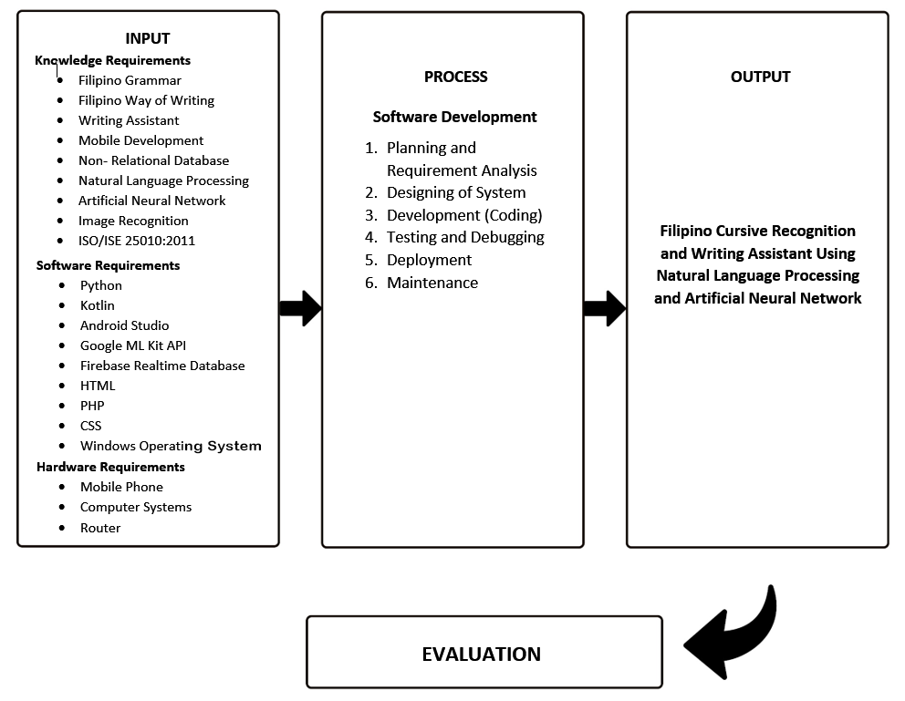

*Figure 1*. Conceptual Model of the Study

Figure 1 illustrated the Conceptual Model of the developed Filipino Cursive Recognition and Writing Assistant using Natural Language Processing and Artificial Neural Network. The model had four (4) parts, namely input, process, output, and evaluation. The input referred to the different requirements needed to develop the system. In the figure above, there were three main requirements for the study such as knowledge, software, and hardware requirements. The knowledge requirements included Filipino Grammar, Filipino Way of Writing, Writing Assistant, Mobile Development, Non-relational Database, Natural Language Processing, Artificial Neural Network, Image Recognition, and ISO/IEC 25010:2011. In addition, the software requirements in the developed system were Python, Kotlin, Android Studio, Google ML Kit API, Firebase Realtime Database, HTML, PHP, CSS and Windows Operating System. Lastly, the hardware requirements included mobile phone, computer system, and a router. The second phase of the model was the process. The main process in the developed system was the android application development, and it consisted of the following processes: Planning and Requirement Analysis, Designing of System, Development, Testing and Debugging, Deployment, and Maintenance. The third phase was the output which was the developed Filipino Cursive Recognition and Writing Assistant using Natural Language Processing and Artificial Neural Network. And the final component of the model was the evaluation of the developed system.

## **Operational Definition of Terms**

           This section provided an operational definition of terms and phrases used for better understanding of the study.

**Filipino Cursive Recognition and Writing Assistant using Natural Language Processing and Artificial Neural Network** - a writing assistant that assisted the user to write basic grammatically correct outputs and helped them recognize cursive handwriting.

**Filipino Cursive** - a writing style that has Filipino alphabets joined together.

**Filipino grammar** - it is intended and based only for Filipino grammar structure and does not follow the rules for other languages like English.

**Users** - these are the intended users for the developed system, users are students, especially the grades 3 and 4, and also are extended to anyone who is not expert in terms of Filipino Language, particularly Tagalog.

**Writing assistant** - it can assist the users in checking the grammatical errors and spelling issues, as well as aid them in knowing the proper way of writing cursive.

# **Chapter 3**

## **METHODOLOGY**

This chapter presented different topics and diagrams that were used in the study to better understand the developed system. The chapter included Project Design, Database Design, Project Development, Operation and Testing Procedure, Test Script Form, and Evaluation Procedure.

## **Project Design**

The Filipino Cursive Recognition and Writing Assistant using Natural Language Processing and Artificial Neural Network was developed to assist users in writing basic grammatically correct sentences through grammar and spelling checking. The developed system provided the user with access to input and edit their desired sentences in a text editor. The system also has a web page that was used to store the user's profile. Moreover, the developed system offered definitions of each Filipino word from the database that the user used in writing their sentences. The system had the capability to convert cursive handwriting into a string of text. Additionally, it offered a thesaurus feature, in which the system suggested synonyms and antonyms of the words. As the primary capability of the developed system, the user no longer had to worry about basic grammatical errors and incorrectly spelled words, as they were checked by the system using Natural Language Processing through giving suggestions to the users. Furthermore, the outputs of the user could be uploaded, downloaded, and viewed through the developed system, and it helped them to know and learn the proper way of writing cursive letters.

**Unified Modeling Language (UML)**

According to Visual Paradigm (n.d.), Unified Modelling Language is considered as a standardized modeling language that consists of sets of diagrams. These diagrams were developed to help the developers and the system itself in visualizing, constructing, specifying, and documenting different elements within the system. The proponents of the study used Unified Modeling Language (UML) to represent the architecture of the developed system.

**Use Case Diagram**

Use Case Diagram is the initial form of system or software requirements for a new underdeveloped software program (Visual Paradigm, n.d.). In addition, the Use Case Diagram specified the system behavior to be expected and not how the specific method is happening. They summarize the relationship between actors, system, and use cases.

Figure 2 illustrated the Use Case Diagram of the developed system. The diagram showcased two primary actors: the admin and the end user. The admin possessed the authority to manage user profiles, user accounts, as well as the dictionary and thesaurus functionalities. Conversely, users were granted the capability to either log in or sign up for their accounts. Additionally, they had access to a range of features including image recognition, text editor, simulation, tutorial, thesaurus, dictionary, and the ability to view their saved works. End users could also utilize the side menu for navigation purposes.

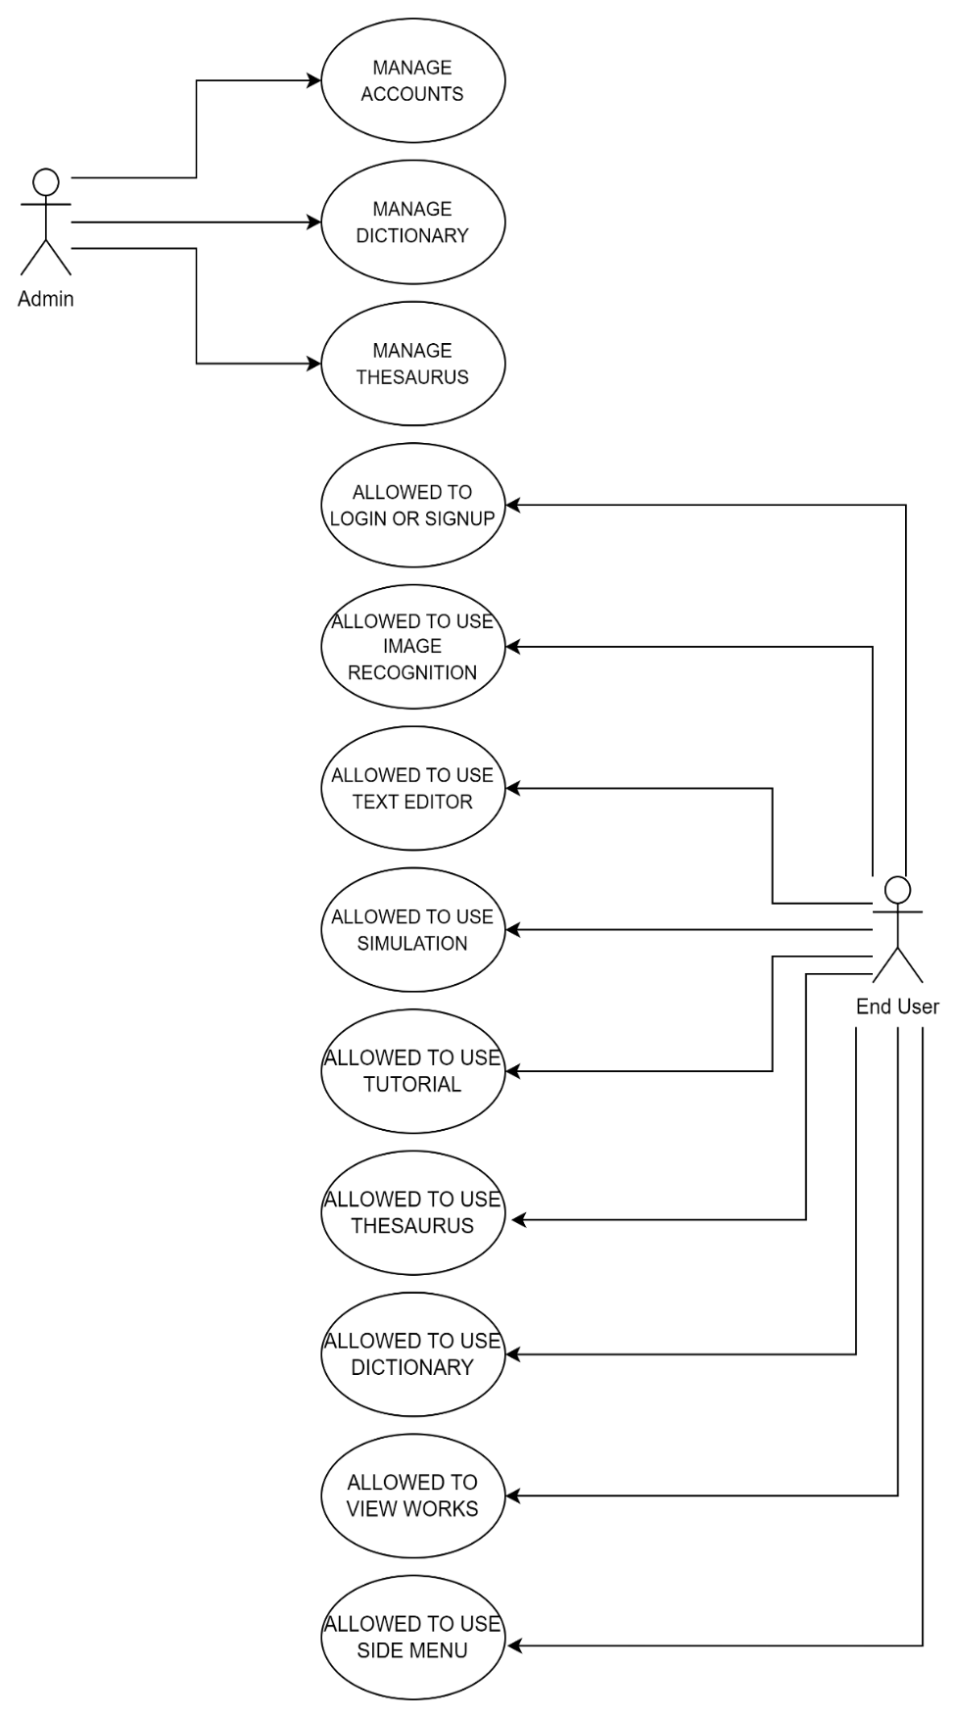*Figure 2.* Use Case Diagram

**Activity Diagram**

The activity diagram was a crucial component of UML diagrams that portrayed the dynamic characteristics of the system. It was an upgraded form of a flow chart that illustrates the progression from one activity to the next. Moreover, activity diagrams illustrated the coordination of activities required to offer a service, which could be depicted at various levels of abstraction (What Is Activity Diagram?, n.d.). In this case, the researchers used an activity diagram to show the overall function of each activity in the developed system.

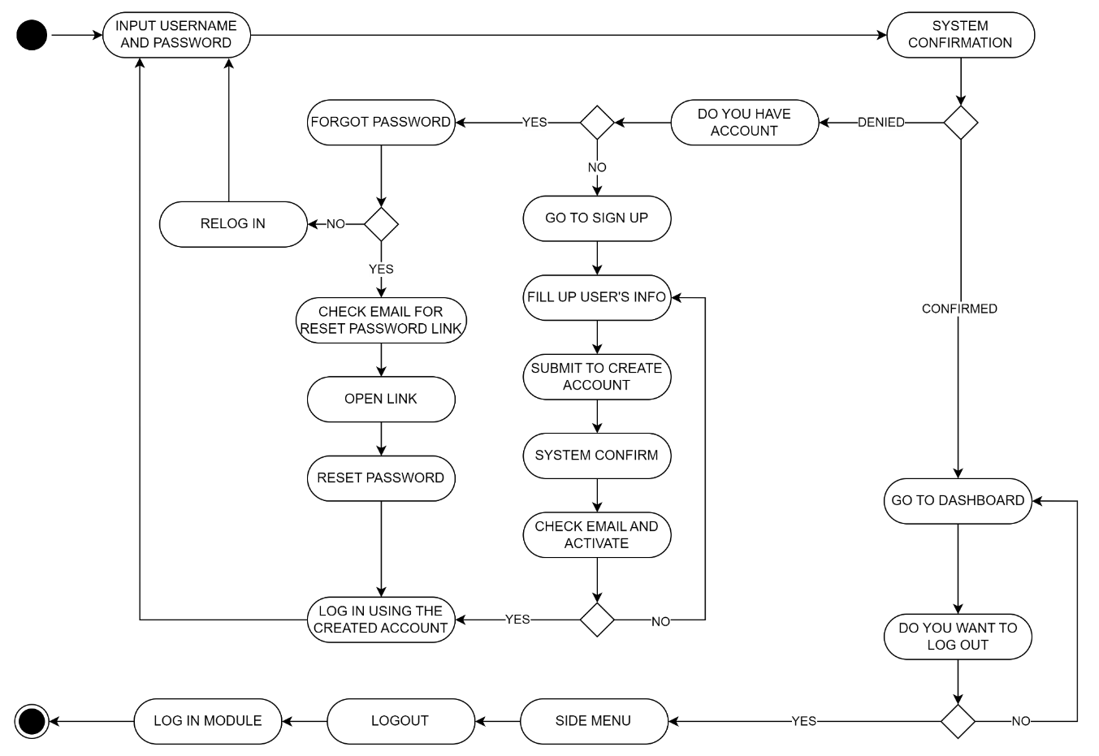*Figure 3.* Activity Diagram of Log In

The figure 3 displayed the Login activity of the developed system. This particular activity serves as the initial step for users. To begin, users were required to enter a username and password. Once entered, the system would verify whether the usernames and passwords were registered within the system. In case of denial, it indicated either an incorrect username and password combination or the absence of registration in the database. If users did not possess an account, they were directed to the sign-up process, where they needed to provide their personal information. After completing the necessary information, users were then required to submit their created account. Upon confirmation, users were prompted to access their email and activate their account. If activation failed, users had to re-enter correct and appropriate inputs, adhering to the system's constraints. However, if users successfully verified the email sent by the system, they could proceed to log in using their created account by entering the username and password.

In the event that a user had an account but had forgotten their password, they needed to click on the "Forgot Password" button. Subsequently, the user had to check their email for a password reset link. Once received, the user had to follow the link to reset their password. After successfully resetting the password, the user could then log in using the newly set password.

On the contrary, if the user inputted the username and password correctly and received confirmation from the system, they were granted access to utilize the system, redirecting them to the dashboard activity. Additionally, the user could find the logout button in the side menu. Should the user decide to log out, the system would redirect them back to the login module once again.

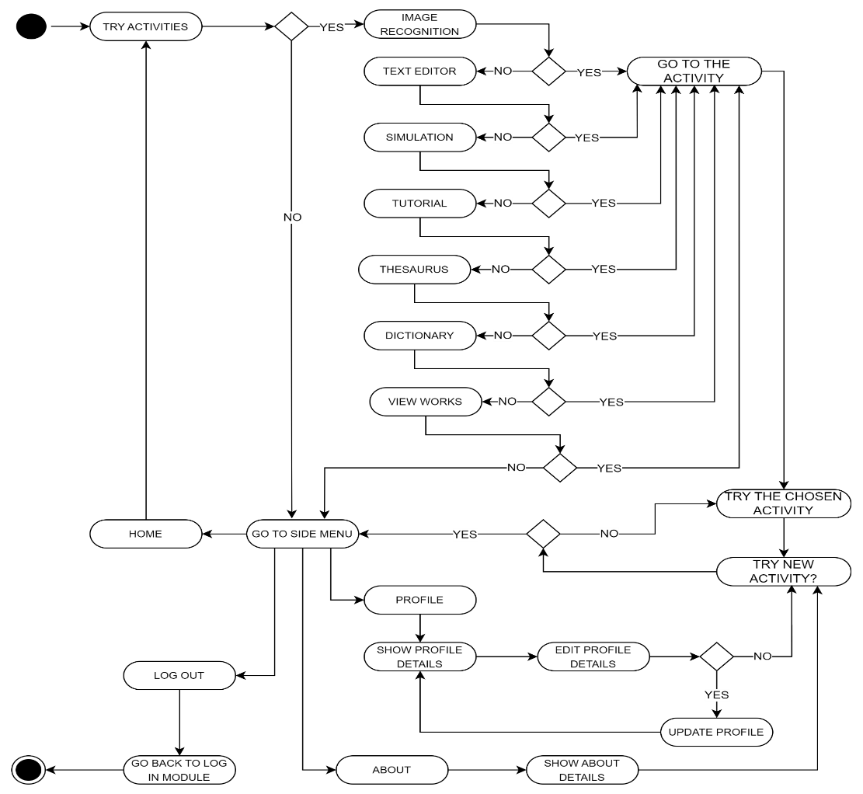*Figure 4.* Activity Diagram of Dashboard

Figure 4 illustrated the Dashboard activity of the developed system. Within this activity, users have access to various buttons enabling them to engage in different functionalities. These buttons include Image Recognition, Text Editor, Simulation, Tutorial, Thesaurus, and Dictionary. By selecting any of these buttons, users are redirected to the respective activities, allowing them to explore and utilize the features associated with each one. Moreover, the dashboard incorporates a View Works feature that enables users to access their previously saved works stored in the database.

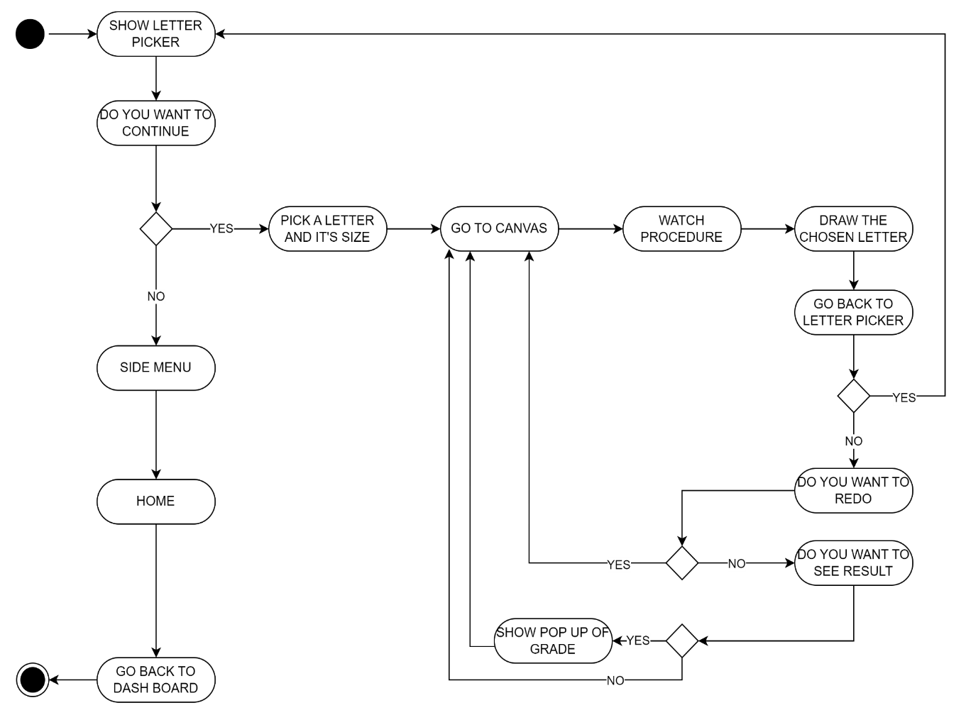In the event that users opt not to engage in any of the aforementioned activities, they can navigate to the profile section by clicking on the side menu. Within the profile section, users have the ability to view, edit, and update their personal information. Additionally, the side menu provides an About button, which presents detailed information about the system. If users do not wish to engage with either of these options, they can choose the log out button as an alternative, returning them to the login module.

*Figure 5.* Activity Diagram of Simulation

Figure 5 illustrated the Simulation activity, which could be accessed by clicking on the corresponding button located on the Dashboard activity. Once clicked, a series of alphabetical Filipino letters ranging from A to Z were displayed. The user was required to select a letter of their choice, whether it is big or not. After that, the system would redirect the user to the canvas wherein they have the ability to practice their cursive letter handwriting. The system also offered video tutorials to guide the user in accurately writing the cursive form.

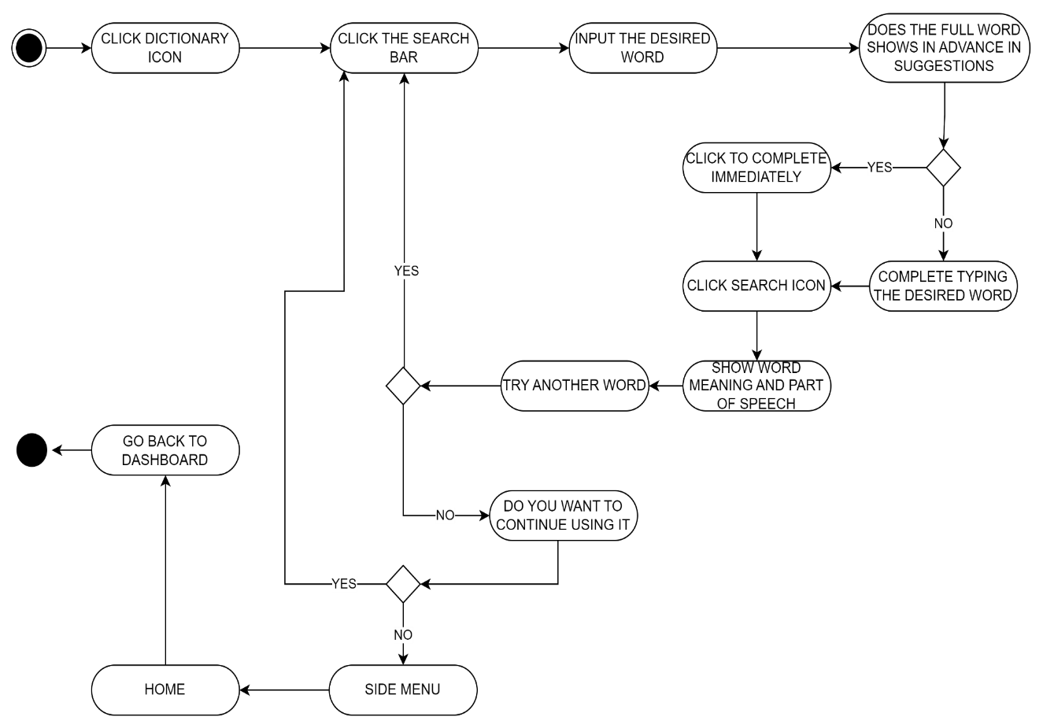Once done, the user was required to submit it for analysis by the system. Based on the accuracy of the submitted drawing, the system assigned a grade. The system provided an option for the user to retry the process by clicking the reset button, which would lead to the previous step, where the user could make another attempt to draw the cursive form. If the user chose not to retry, the user could choose to return to the Letter Picker activity by clicking the back button. Once the user had completed the desired practice, they could return to the Dashboard activity through a side menu icon where the Home button is located.

*Figure 6.* Activity Diagram of Dictionary

Figure 6 illustrated the activity diagram for the Dictionary feature. To utilize the Dictionary, the user is required to select the Dictionary button located on the Dashboard, granting them access to the Dictionary Activity. Within this activity, the user is able to search for a desired Filipino word, and the associated parts of speech and meanings will be presented. The Dictionary Activity also offers word suggestions as the user begins typing in the search bar. The user could try many words as long as it is in the database. Should the user wish to return to the Dashboard activity, they can do so by clicking the side menu icon. Subsequently, the home button will appear, allowing the user to navigate back to the Dashboard.

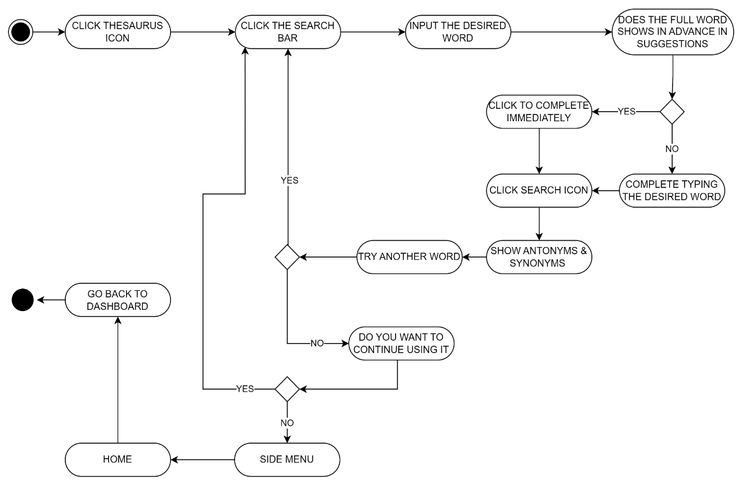*Figure 7.* Activity Diagram of Thesaurus

Figure 7 showed the Activity Diagram of the Thesaurus feature. Upon clicking the button, the system redirected the user to the Thesaurus Activity, where the user could search for synonyms and antonyms for their chosen word. The Thesaurus Activity also offers word suggestions as the user begins typing in the search bar. The user could try many words as long as it is stored in the database.

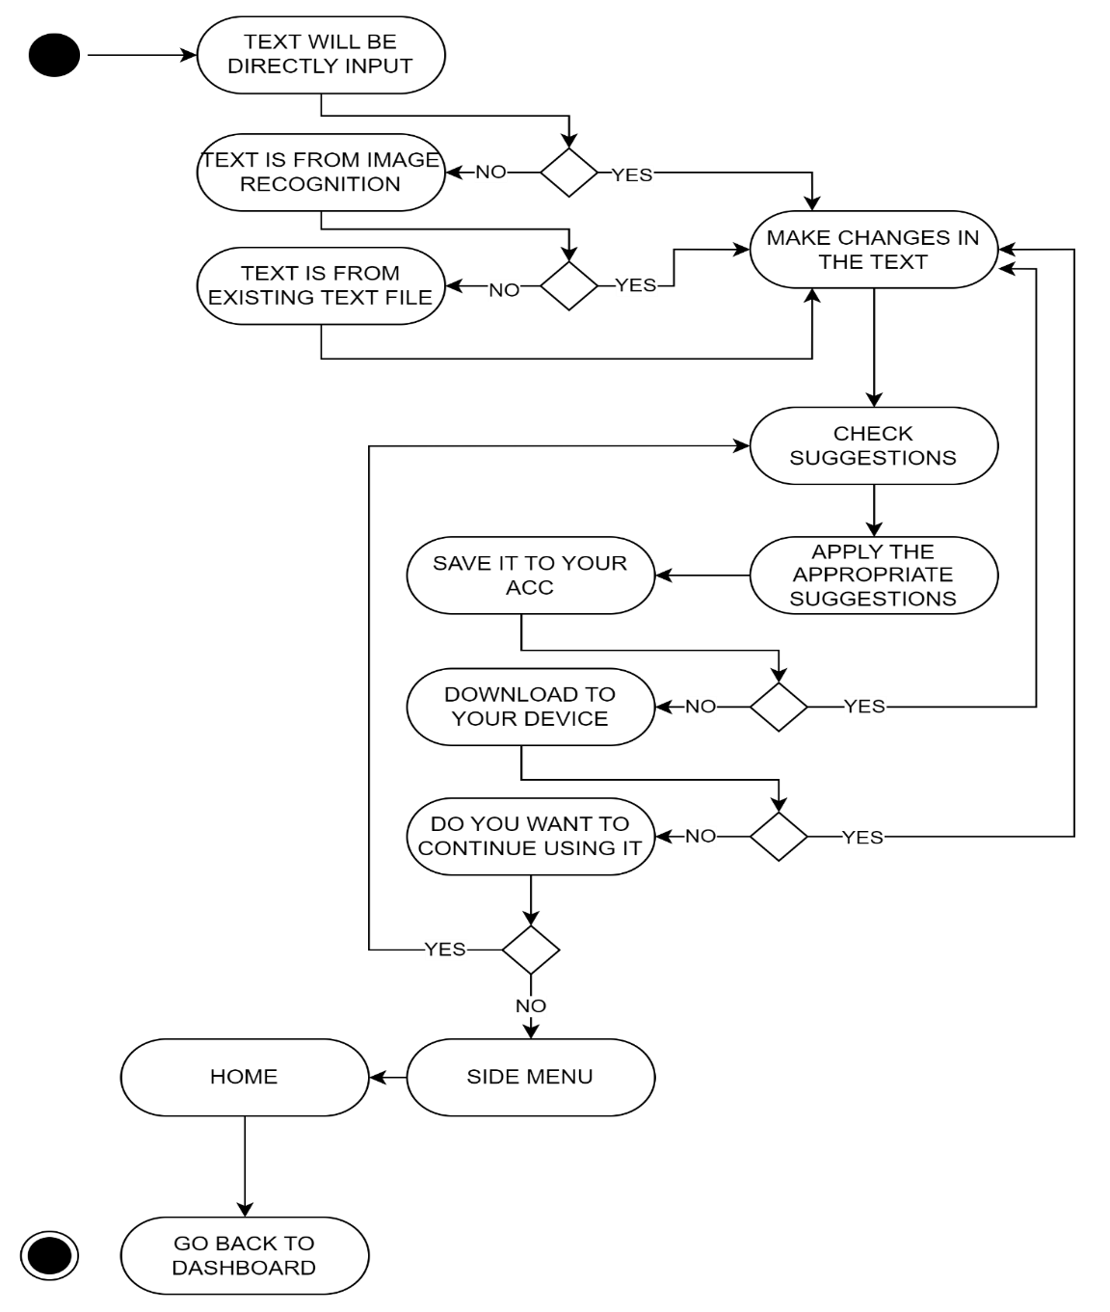Once completed, the user could return to the Dashboard Activity through a side menu.

*Figure 8.* Activity Diagram of Text Editor

Figure 8 illustrated the Text Editor activity of the developed system. Within this activity, users are presented with a text input feature. The text can be sourced from the Image Recognition Activity, an uploaded text file, or entered directly into the text editor. If the user makes any modifications to the text from these sources, the system provides suggestions for checking basic grammar structures and spelling errors. Once the user is satisfied with the suggested grammar and spelling corrections, they can proceed to utilize the buttons available within the Text Editor activity.

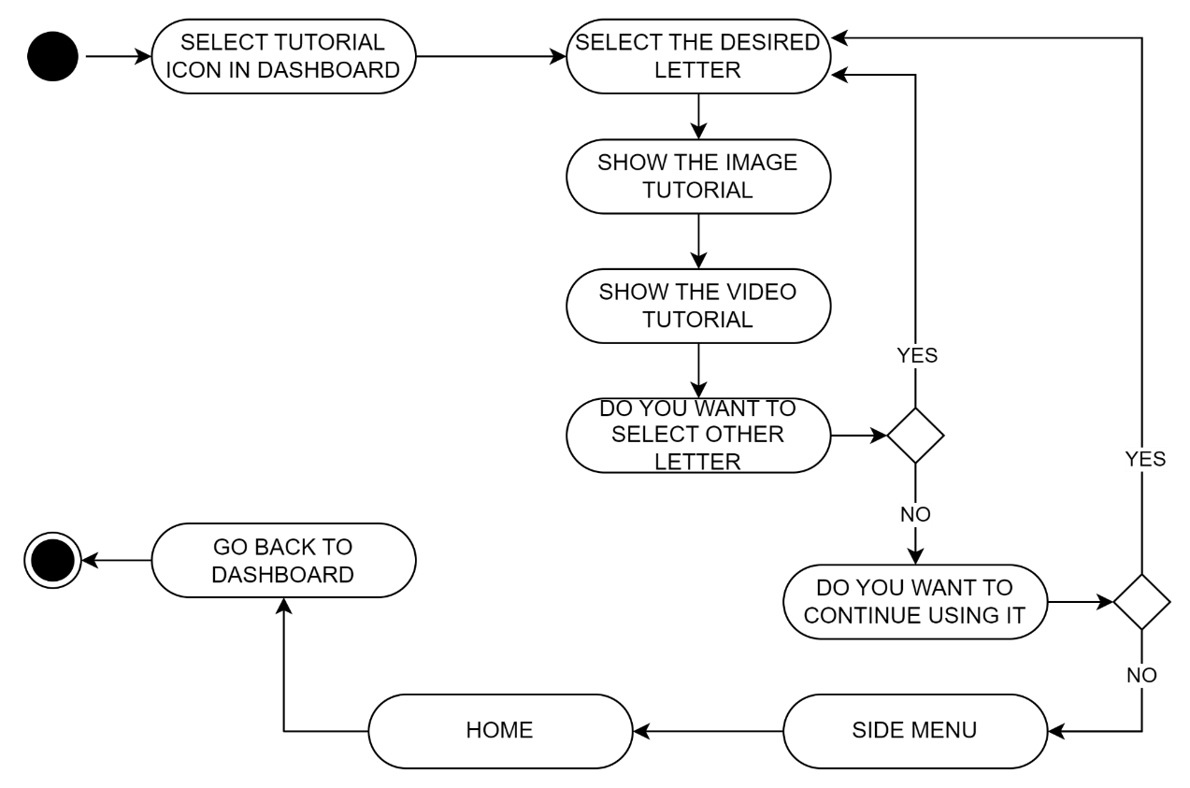These buttons include a Save button, which saves the text in the cloud, and a Download button, which allows the user to save the text in their device's storage. Upon completion, the user can navigate to the side menu, where they will find the Home button, enabling them to return to the Dashboard Activity.

*Figure 9.* Activity Diagram of Tutorial

Figure 9 depicted the activity diagram for the tutorial feature. The user could access the tutorial by selecting the corresponding button on the dashboard. Upon entering the tutorial, the user was presented with the option to choose which letter they wished to practice. Subsequently, the system displayed an image illustrating the correct stroke order for writing the chosen letter, along with a video tutorial showcasing the letter being written.

To explore tutorials for other letters, the user could click on buttons labeled from A to Z, allowing them to access equivalent tutorials for each letter of the alphabet. This feature provided users with a comprehensive learning experience for improving their letter writing skills.

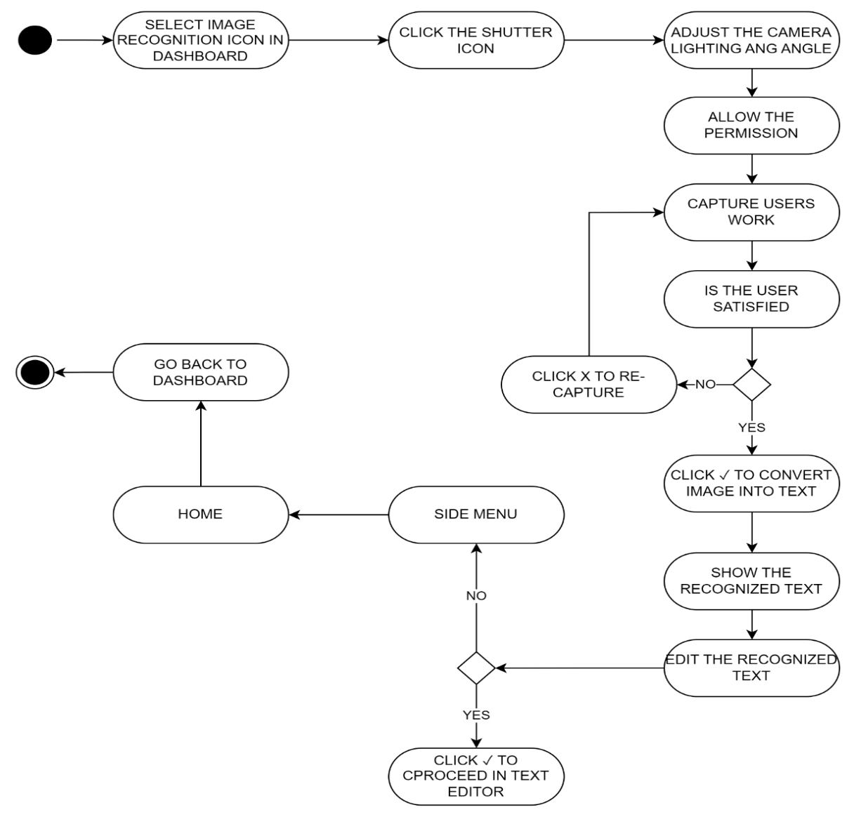Using a side menu would prompt the user to the dashboard Activity by simply clicking the Home button.

*Figure 10*. Activity Diagram of Image Recognition

Figure 10 depicted the activity diagram for the Image Recognition feature. To utilize the Image Recognition functionality, the user was required to select the Image Recognition button. This action enabled them to capture an image of their handwriting. The system then processed the captured image and converted it into text, which could be transferred to the Text Editor Activity for further editing.

The user had the flexibility to make multiple attempts in order to achieve their desired output. They could try different handwriting samples or make adjustments as needed until they were satisfied with the results.

In order to return to the Dashboard Activity, the user could access the side menu and simply click the Home button. This allowed for smooth navigation between the Image Recognition feature and the main dashboard.

## **Database Design**

The database design for the developed Filipino Cursive Recognition and Writing Assistant using Natural Language Processing and Artificial Neural Network consisted of a Firebase representation of three entities: the Filipino Dictionary, Profiles, and Thesaurus. These entities were utilized to store, add, and retrieve necessary data in the application.

Figure 11 showed the representation of the firebase structure of the developed system. It has three (3) tables: Filipino Dictionary, Profiles, Thesaurus. The Filipino dictionary table consisted of three fields: word, parts of figure of speech and definition. The Profile table was composed of the user’s details such as name, birthday, school/organization, email address, password, and is_disabled. And the Thesaurus which has the word, its synonyms, and antonyms.

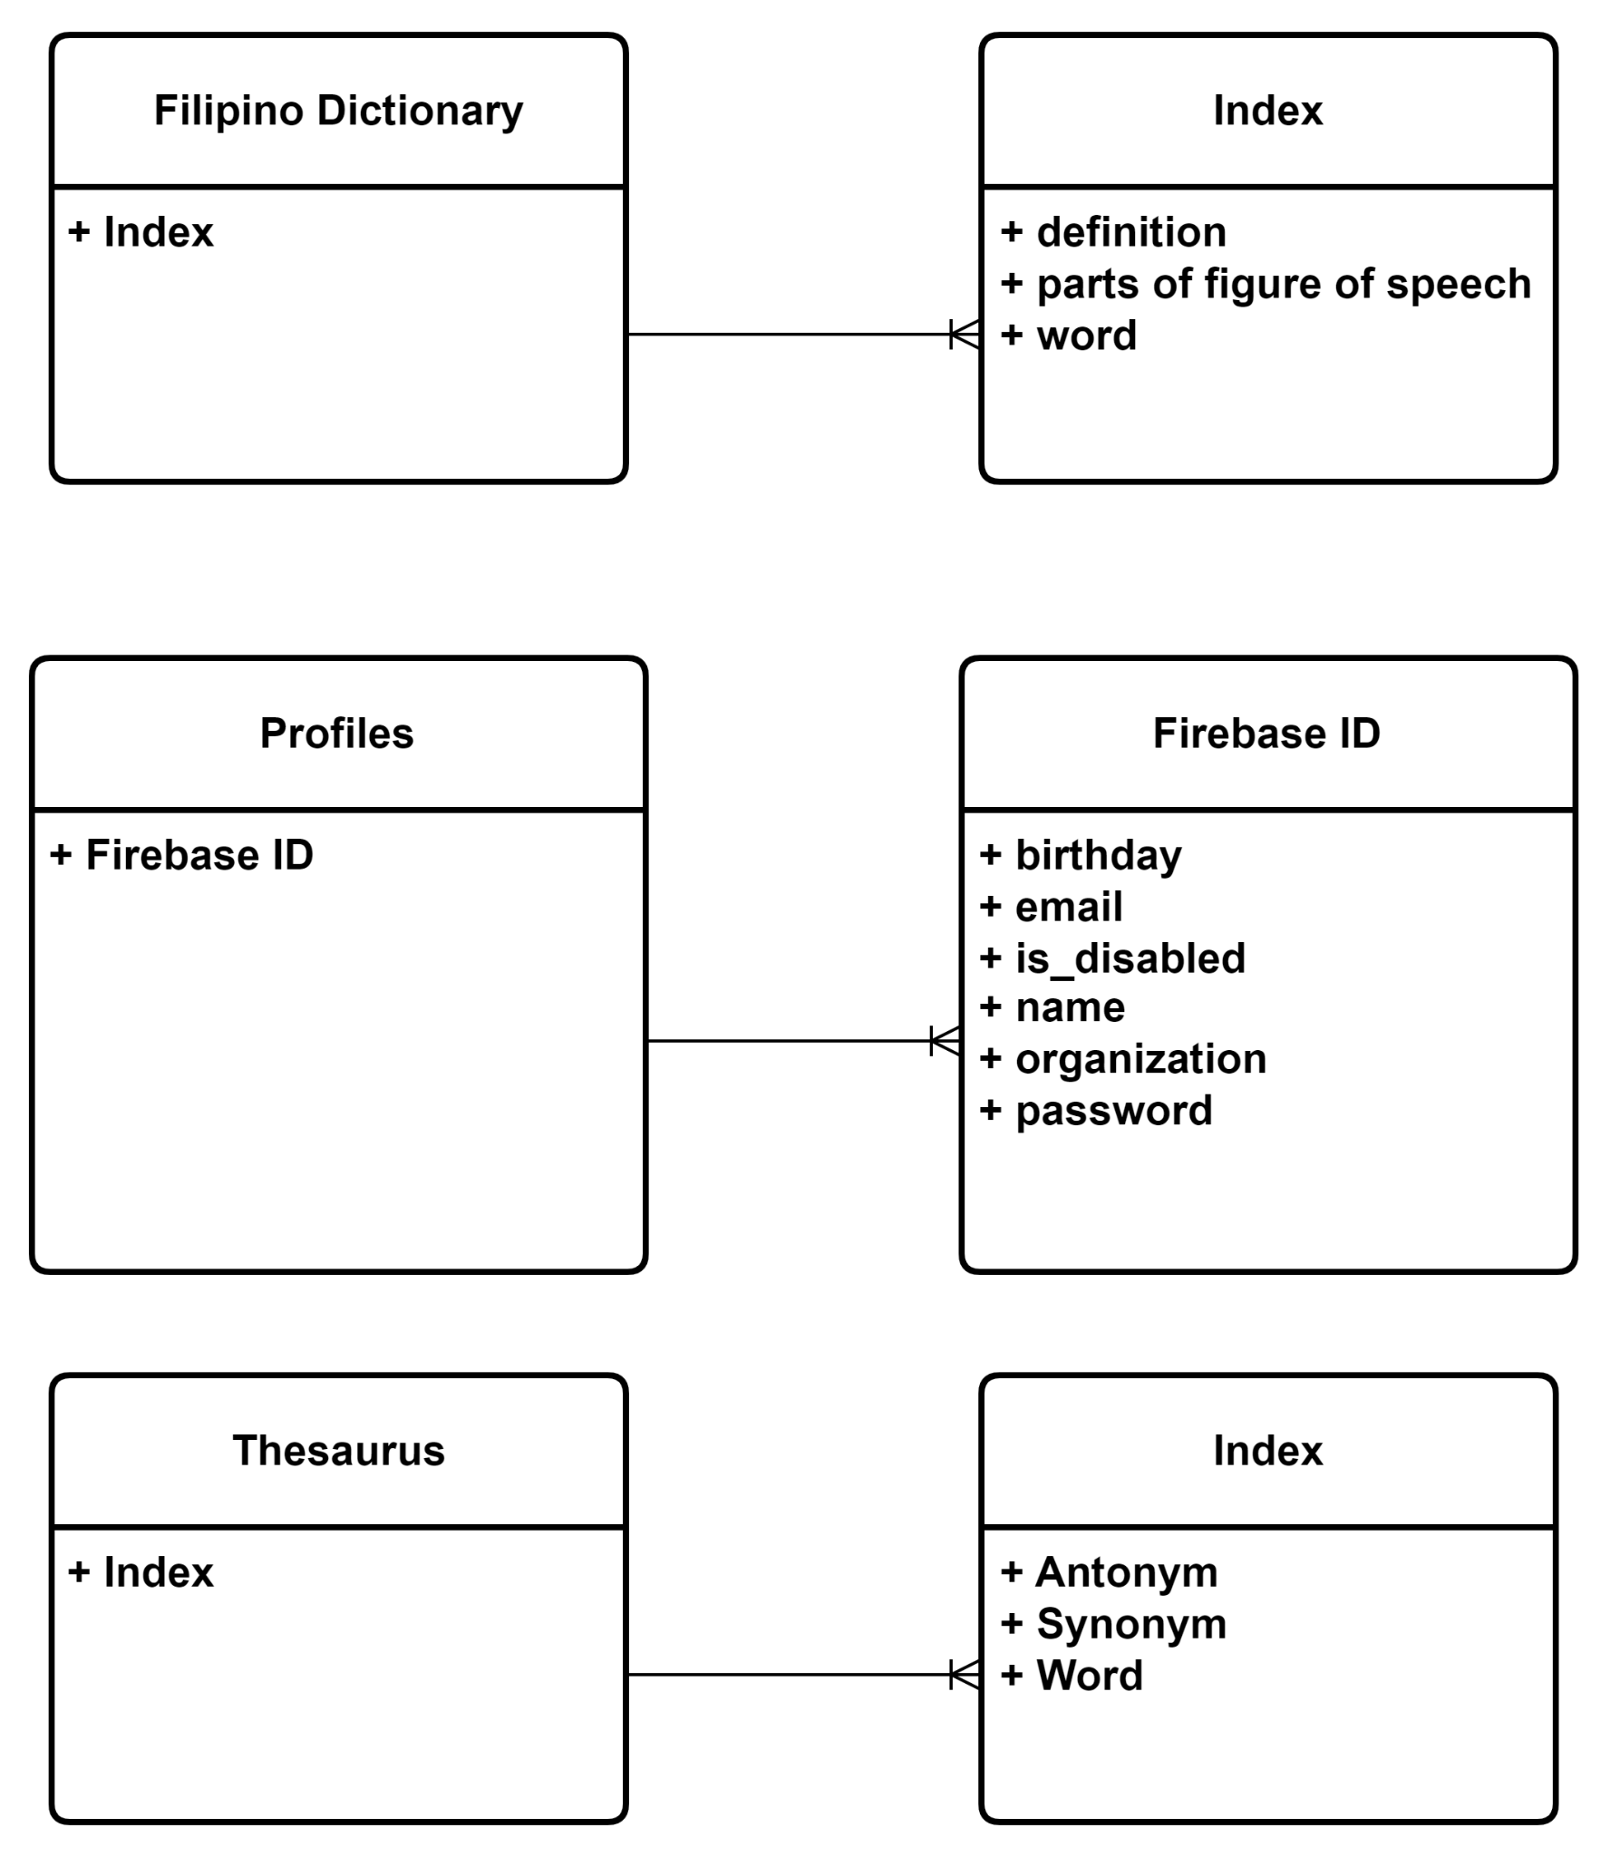

*Figure 11.* Database Structure

**Data Dictionary**

According to Techopedia in 2020, a data dictionary was a form of a table that contained a database's metadata. It was a collection of information regarding the attributes or fields of a specific data set. A data dictionary was also known as a metadata repository that stored information about other database objects, including data ownership, data relationships to other objects, and other data.

*Table 1*. Dictionary Table

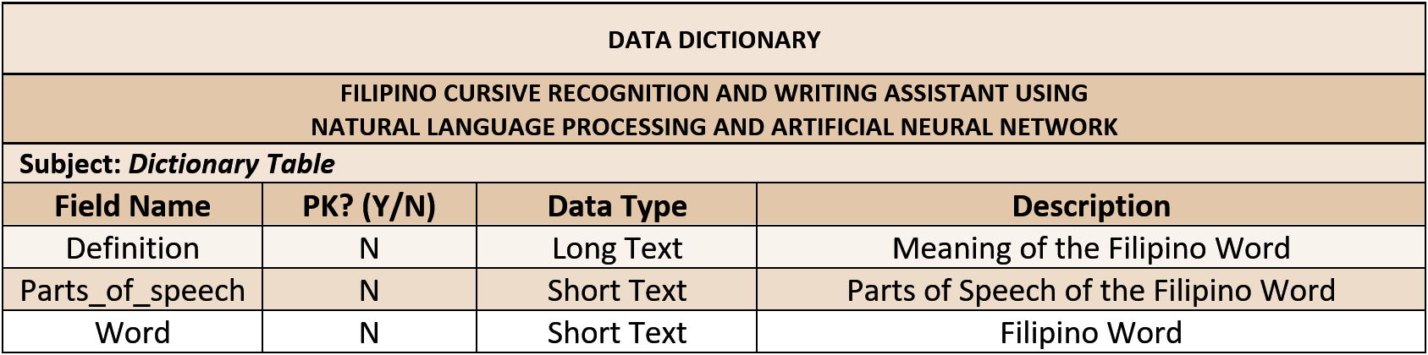

Table 1 showed the Dictionary Table of the developed system. This table stored the Filipino words for the dictionary feature of the developed system. The Dictionary Table consisted of the following fields: meaning, parts_of_speech, word, and the primary key which was the word_id.

*Table 2*. Documents Table

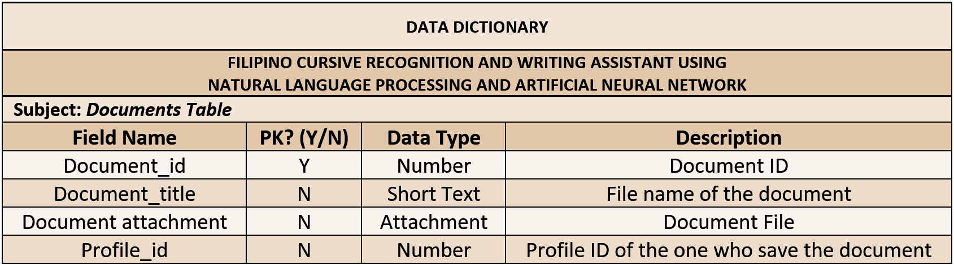

Table 2 illustrated the documents table. This table was the one that handled the saving of user’s documents into the database. The Documents Table consisted of four (4) fields namely document_attachment, document_title, profile_id, and the primary key which was the document_id.

*Table 3.* Profiles Table

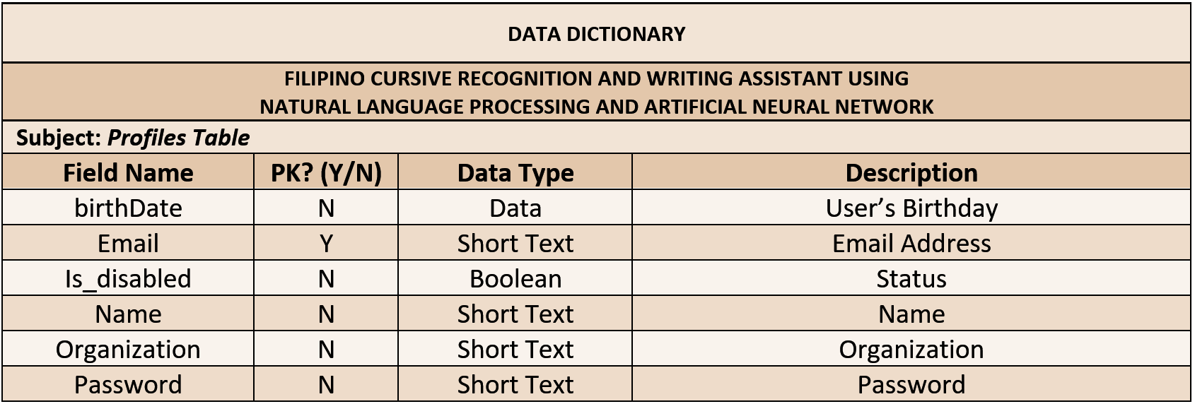

Table 3 presented the fields needed in the Profiles Table. Specifically, the profiles table had a total of six (6) fields namely birthDate, email which is the primary key, is_disabled, name, organization, and password.

*Table 4*. Thesaurus Table

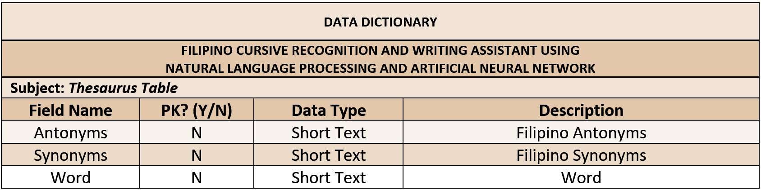

Table 4 showed the thesaurus table that handles the list of antonyms and synonyms of the Filipino words. This table consisted of three (3) fields namely antonyms, synonyms, and the primary key which was the word.

## **Project Development**

The developed system, Filipino Cursive Recognition and Writing Assistant using Natural Language Processing and Artificial Neural Network, was developed using a Modified Waterfall Model.

**Modified Waterfall Model**

         According to tutorialspoint (n.d.), the Modified Waterfall Model was the first introduced process model. It was also known as a linear-sequential life cycle model. In addition, it was considered a classical model popularly used in software engineering and product development (The Economic Times, 2022). The concept of this model highlighted the logical progression of different steps (Lewis, n.d.). Moreover, the Modified Waterfall Model had six (6) phases. Each of these phases had a series of tasks and objectives. Lastly, the output of one phase was used as the input for the next phase. The study used a modified waterfall model which consisted of six (6) phases: Planning and Requirements Analysis, Designing of the system, Development (coding), Testing and Debugging, Deployment, and Maintenance.

Figure 12 demonstrated the Modified Waterfall model and the phases used by the researchers. The model included Planning and Requirements Analysis Phase, Designing of System Phase, Development Phase, Testing and Debugging Phase, Deployment phase, and Maintenance.

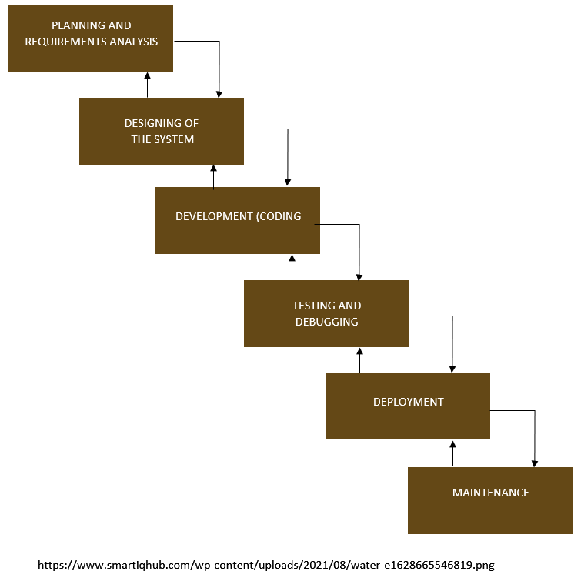

*Figure 12.* Modified Waterfall Model

1. **Planning and Requirement Analysis Phase**

        According to tutorialspoint (n.d.), in the Planning and Requirement Analysis Phase, all the potential system requirements were captured and documented in a requirement specification document. During this stage, the proponents stated the expectations of the project, including who would use the system, how the user would use the developed system, and information that would be needed related to the software. Lastly, this phase handled the defining and planning of the project without mentioning specific processes.

In this phase, the researchers discussed the title of the system and the concepts required to finish it. The researchers conducted brainstorming and walkthroughs to understand the possible requirements. In addition, the researchers also thought of the problems that the developed system answered through its system capabilities. Furthermore, the researchers set the system limitations and the project's significance to the users.

1. **Design Phase**

According to tutorialspoint (n.d.), the system design phase handled the analysis of the requirement specification. The project members also prepared for the system's design. In this phase, the project members specified the hardware and software requirements during the creation of the system design. The listed requirements helped in defining the overall system architecture. Lastly, the output of this phase was the design specification document that mainly outlined the technical design requirements of the system.

In the Design Phase, the researchers showed the system architecture by creating different diagrams. The researchers constructed three (3) diagrams for project design: (1) Database Diagram, (2) Use Case Diagram, and (3) Activity diagram. In addition, the researchers also established the database design using a Non-Relational Database or NoSQL called Firebase.

1. **Development Phase**

The development phase progressed to the stage of the Modified Waterfall model wherein the source code was created. The creation of source code was dependent on the models, logic, and requirements stated in the preceding phases. Commonly, the system was developed into smaller components before combining and implementing it together. From this phase, the researchers created the developed system according to its capabilities.

1. **Testing and Debugging Phase**

The testing phase happened after the coding or development phase. In this phase, the quality assurance, unit, system, and beta tests took place. The testing team got the source code from the project team. These testers reported issues that may need to be resolved and caused a forced repeat of the coding stage as part of debugging. However, if the system passed the tests given by the testers, the next phase commenced.

In the study, the testing phase was already conducted by asking for the evaluation of the respondents.

1. **Deployment Phase**

After the testing phase, the deployment process came next. The program had to be installed in a production environment at the conclusion of the deployment phase before end users could begin using it. The developers and other important stakeholders could interact with the new product at this stage to ensure it functioned properly in the production environment (Software Development Approaches by Mad Devs: Deployment Stage, n.d.). The system was now fully developed and is deployed.

1. **Maintenance**

After the testing and deployment phase, support and maintenance were provided for the developed system. This was done to ensure that the system was running smoothly. In addition, if the admin or the user of the developed system encountered bugs or errors during use, fixing them was the objective of this phase.

**Gantt Chart**

A Gantt chart, according to Lyons (2018), was one of the most popular means of displaying activities against time. A Gantt chart was represented by bars. The start, duration, and termination dates of an activity were indicated in the location and length of the bars. Furthermore, Gantt charts were used to track project timetables and were very useful in project management (instagantt, n.d.). Furthermore, the Gantt chart displayed and informed the user when and what activities needed to be completed. This chart also displayed the projected project's progress, how a group of activities may have been dependent on other groups of occupations, how important duties were, and how resources were used within a project.

Figure 13 presented the Gantt Chart of the developed Filipino Cursive Recognition and Writing Assistant using Natural Language Processing and Artificial Neural Network. In the study, the proponents used a Modified Waterfall Model which comprised six (6) phases. The initial phase was the Requirements Analysis Phase. In this phase, the proponents prepared all the requirements needed to start the study like titles and concepts, possible users, system capabilities, limitations, and significance of the study. In the Design phase, the proponents created the database design, system data flow, and Users Interface Design. After this, the implementation of the developed system started. In this phase, the proponents built the system based on the approved system capabilities, data flow diagrams, and system designs.

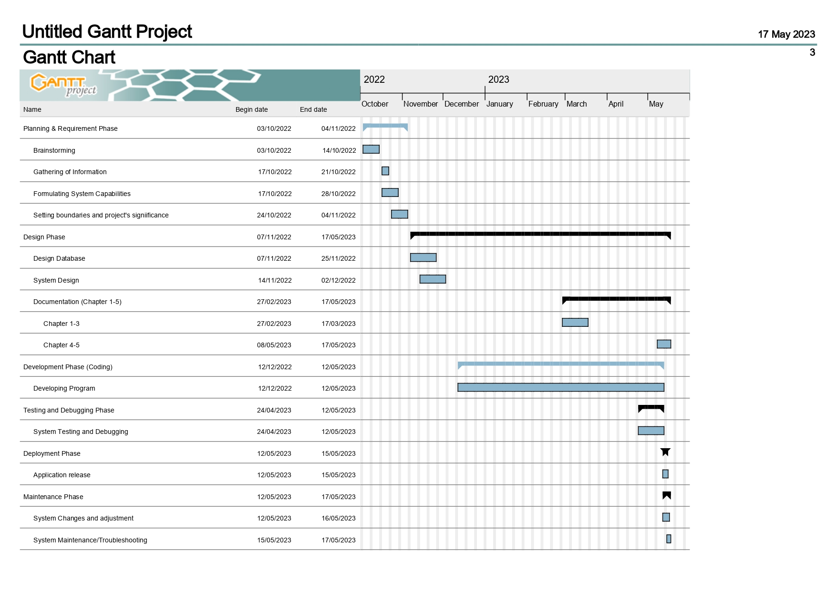

*Figure 13.* Gantt Chart

## **Operation and Testing Procedure**

In the Operation and Testing Procedure, the proponents decided to run a variety of testing procedures such as unit testing, graphical user interface testing, and performance testing. Each of these testing processes was discussed briefly.

1. **Unit Testing**

Software testing help (2022) stated that unit testing was the process of testing a single software component or module. It was usually done by programmers rather than testers since it necessitated a thorough understanding of the internal program design and code. It might also have needed the creation of test driver modules or test harnesses.

Moreover, TechTarget Contributor (2019), stated that unit testing was a software development process in which the smallest testable elements of a program, known as units, were evaluated separately and independently for appropriate performance. Software developers and Quality Assurance personnel used this testing approach during the development process. Unit testing's major goal was to separate written code in order to test and verify if it performed as expected.

The users tested the system to guarantee that it was free of errors. Unit testing was necessary to ensure that the system accomplished what they anticipated it to do and what it was required to do.

1. **Graphical User Interface Testing**

According to software testing help (2022), the goal of GUI testing was to ensure that the GUI met the requirements of the said customer. The application's anticipated user interface was described in the detailed design document and GUI mockup screens.

Furthermore, Hamilton (2021) stated that GUI testing was a sort of software testing that examined the product's graphical user interface. The goal of Graphical User Interface (GUI) Testing was to guarantee that software programs' capabilities performed as expected by inspecting displays and controls such as menus, buttons, icons, and other functional elements.

1. **Performance Testing**

Software testing help (2022) stated that this terminology was frequently interchanged with the words, "stress" and "load" testing. The purpose of performance testing was to see if the system satisfied the performance criteria. This testing was done with a variety of performance and load tools.

Moreover, Hamilton (2021) stated that performance testing was a software testing method for evaluating a software application's speed, response time, stability, dependability, scalability, and resource utilization under a certain workload. Performance testing's main goal was to find and resolve performance bottlenecks in software applications. In addition, the focus of Performance Testing was to see if a software program reacted rapidly. The software application's scalability defined the highest user load it could take. Finally, stability was tested to see if the application remained stable under different loads. The performance testing used an evaluation that is based on the software product quality models of ISO 25010:2011. These models encompassed Functional Suitability, Performance Efficiency, Compatibility, Usability, Reliability, Security, Maintainability, and Portability. The criteria established ensured that the system fulfilled the project’s specific requirement. Furthermore, the proponents took measures to ensure that the developed system operates efficiently and fulfills the performance prerequisites of its intended users. Moreover, the testing procedures employed the prescribed test script form provided below.

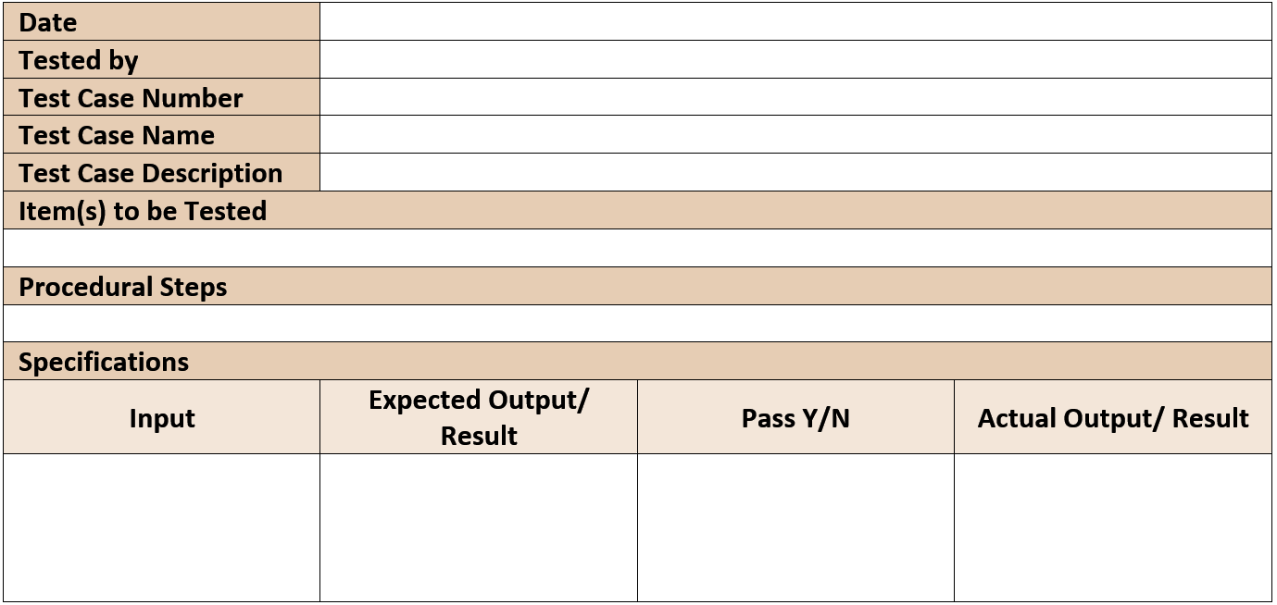*Table 5*. Test Script Form

**Evaluation Procedure**

The proponents performed the following objectives throughout the evaluation and was use based on the software product quality models of ISO 205010:2011. The evaluators of the developed system comprised the following: five (5) software professionals, three (3) software development professors, seven (7) working professionals in any field of work, and eighty-five (85) students from Elementary to College.

1. The researchers explained the concept, instructions, and operation of the system's development to the respondents.
2. The researchers set up the system and gave the respondents the opportunity to test the developed system.
3. The researchers provided survey forms to the respondents to evaluate the effectiveness of the developed system.
4. The researchers collected the survey forms from the respondents to calculate the total rating of the developed system.
5. The researchers used a numerical scale and an analogous interpretation from Likert’s scale to interpret the overall rating.

*Table 6*. Likert’s Scale

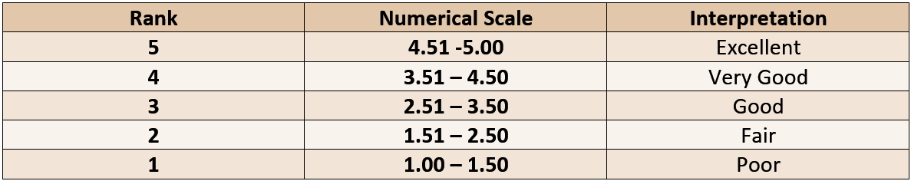

# 

# **Chapter 4**

## **RESULTS AND DISCUSSION**

This chapter contains the project description, project structure, project capabilities and limitations, test results and project evaluation conducted by the proponents.

## **Project Description**

          The Filipino Cursive Recognition and Writing Assistant was a mobile application designed to assist users in learning and writing Filipino cursive letters, as well as ensuring proper basic grammar and spelling in the Filipino language. The application was created using Android Studio and utilized Natural Language Processing and Artificial Neural Network algorithms to recognize basic Filipino grammar structures and spellings, as well as Filipino cursive letters. The developed system was intended for students and also for users, especially those who were not familiar with the Filipino language, particularly Tagalog. The developed system could be used by an administrator for the web-based maintenance module. Users could also access the developed system throughout the entire mobile application.

The primary purpose of the developed system was to provide an easy and effective way to assist the users in terms of writing in the Filipino language, particularly Tagalog. The system could assist users in checking basic grammatical structures and spelling and providing a Filipino dictionary and a thesaurus of Filipino words' synonyms and antonyms. Furthermore, the application would aid the users in writing Filipino cursive by providing images and video tutorials and a simulation that would enable the users to practice cursive handwriting. While the system was still limited to a small number of Filipino words in its database, it aimed to expand its database in the future to include more words, idioms, and expressions. It was exclusive only to the Filipino language, especially Tagalog; other dialects in the Philippines were not included. And the developed system was only available online, which required an internet connection to access the system.

## **Project Structure**

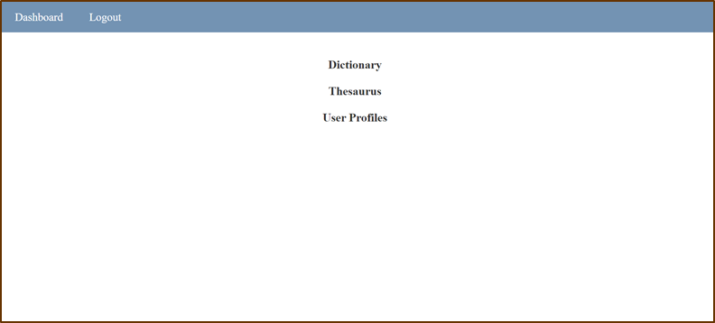

*Figure 14.* Maintenance Module: Dashboard

Figure 14 displayed the Maintenance Module's Dashboard. This interface was exclusively for admins, and it allowed them to select the desired transaction they wished to perform, which included managing the Dictionary, Thesaurus, and User Profiles. The admin could quickly navigate and select the module they wished to access and maintain from the dashboard.

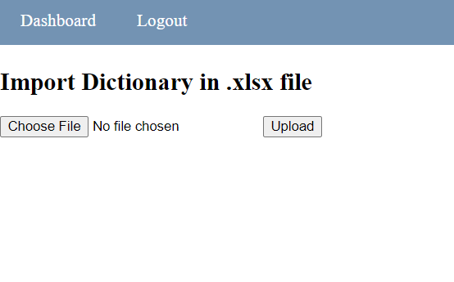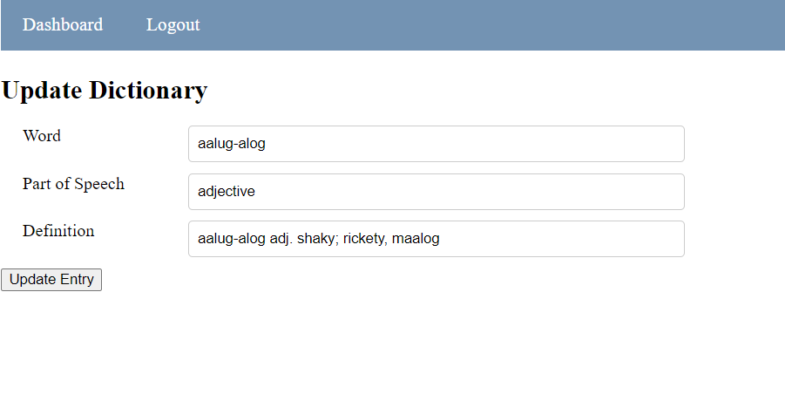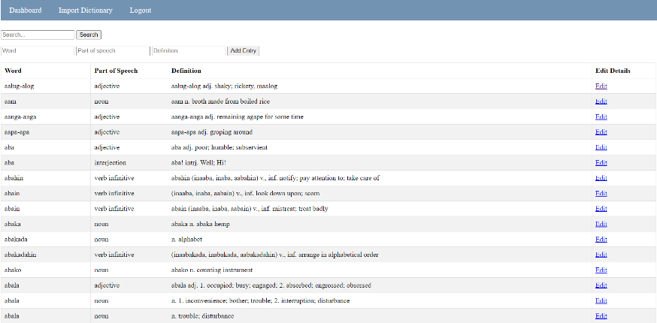

*Figures 15.* Maintenance Module: Dictionary

Figure 15 presented the Maintenance Module's Dictionary. This view displayed and stored the list of words that the administrator could add and edit. It gave the administrator the authority to manage and modify dictionary entries, ensuring their precision and appropriateness.

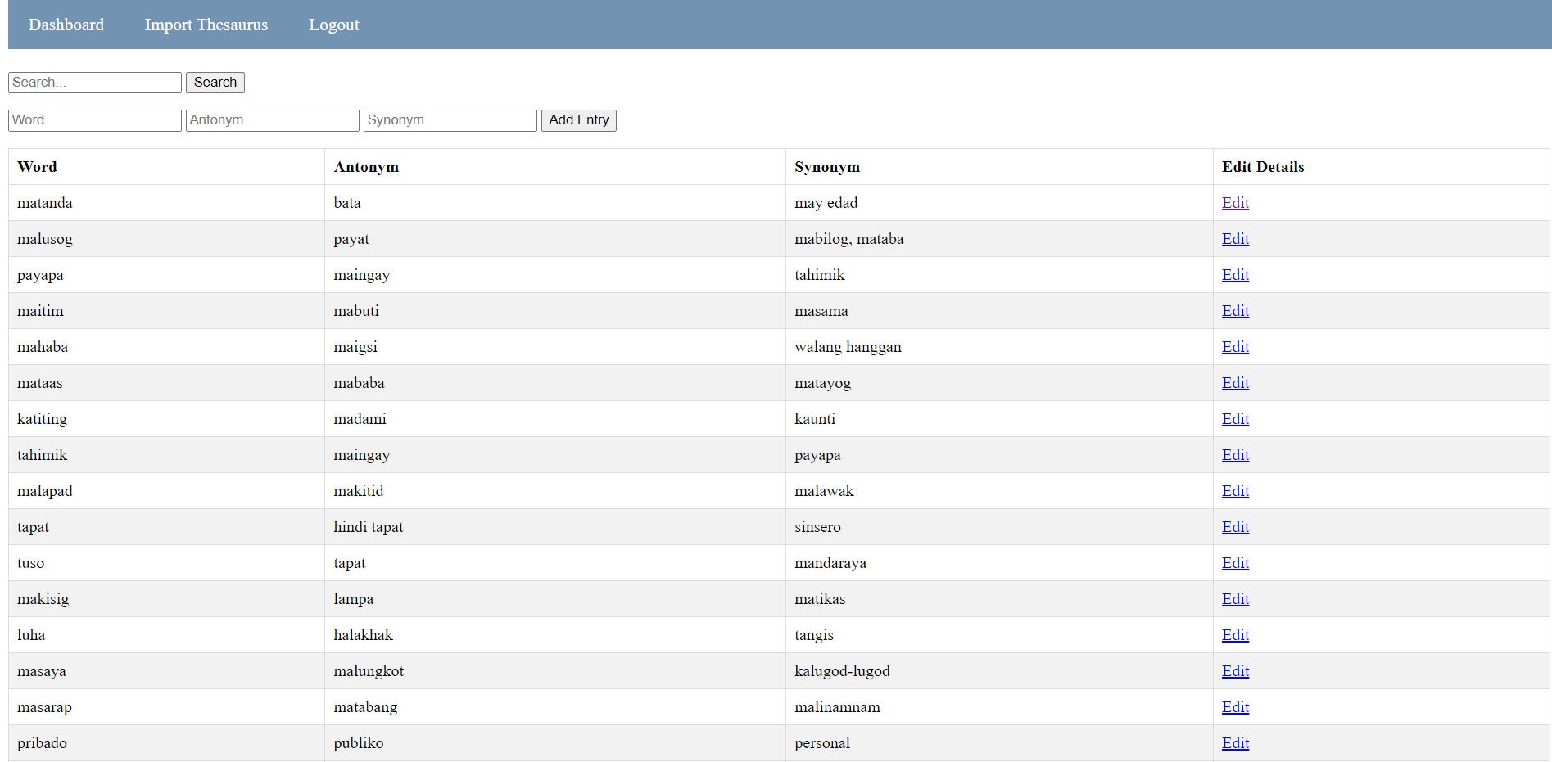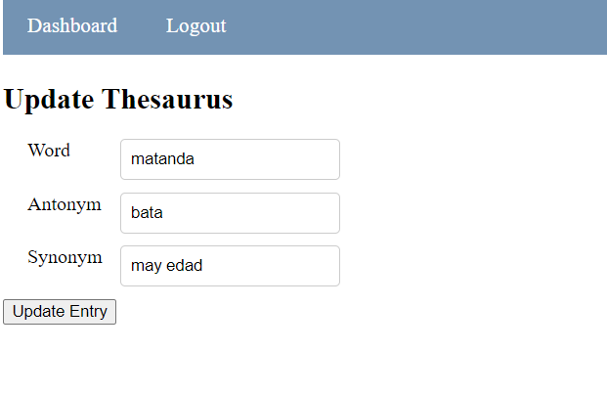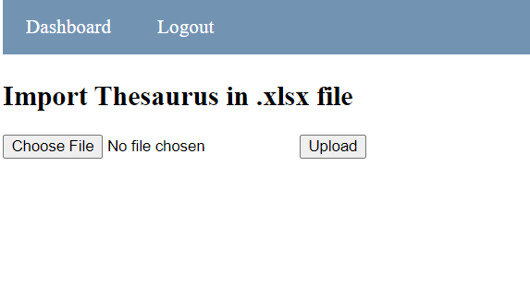

*Figures 16*. Maintenance Module: Thesaurus

Figure 16 presented the Maintenance Module's Thesaurus. This view displayed and stored the list of words that the administrator could add and edit. It gave the administrator the authority to manage and modify thesaurus entries, ensuring their precision and appropriateness.

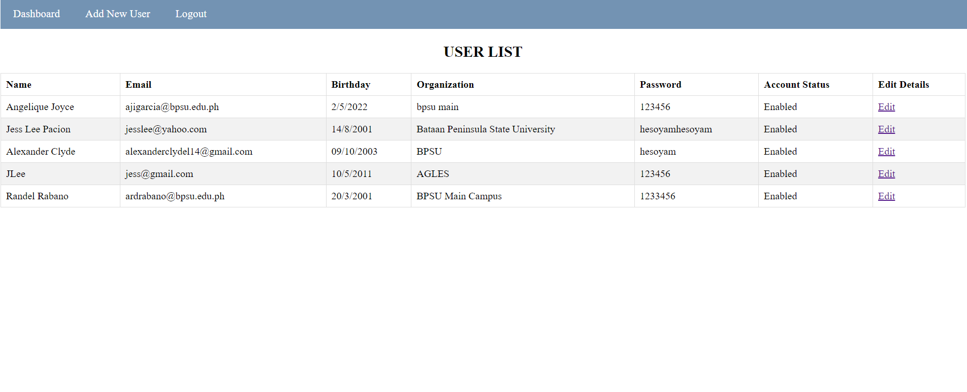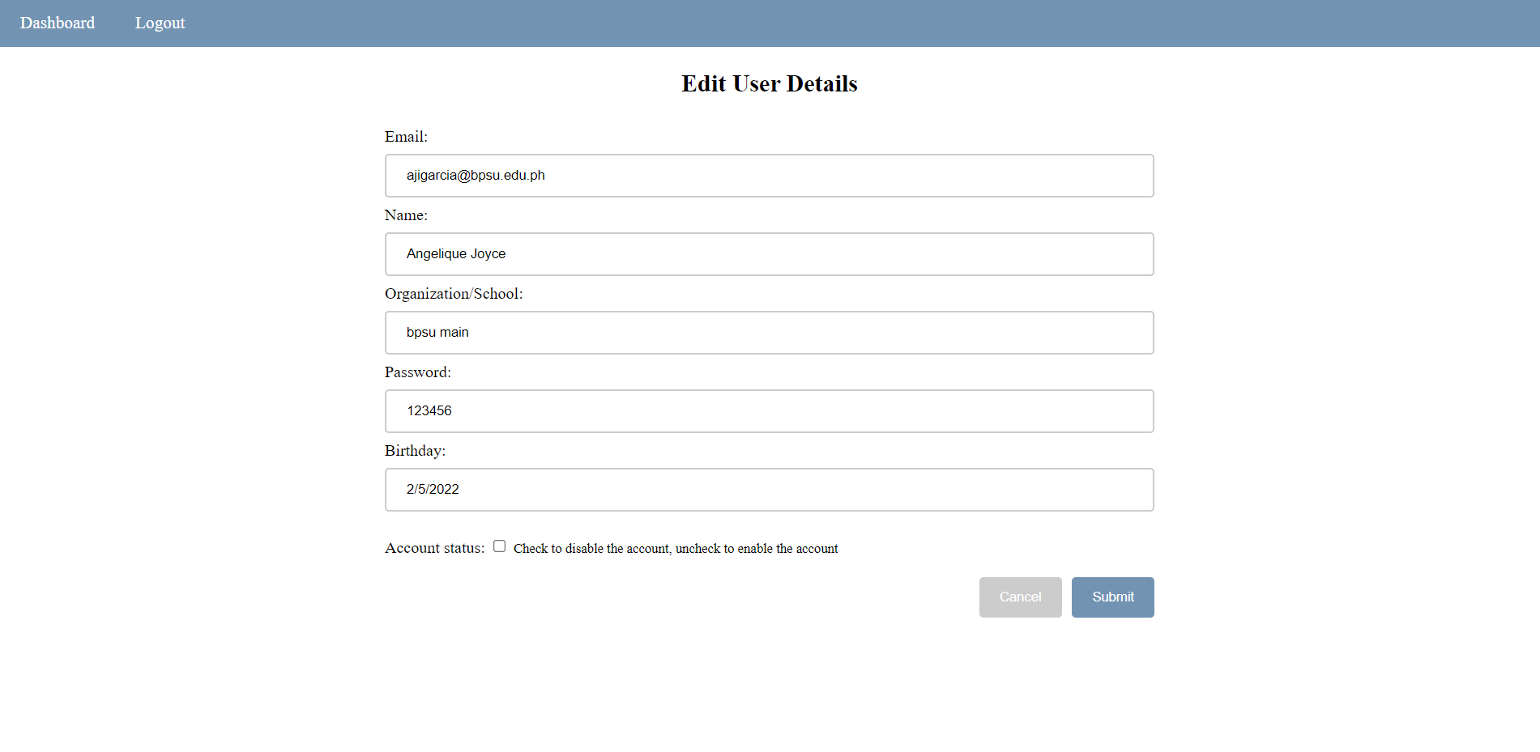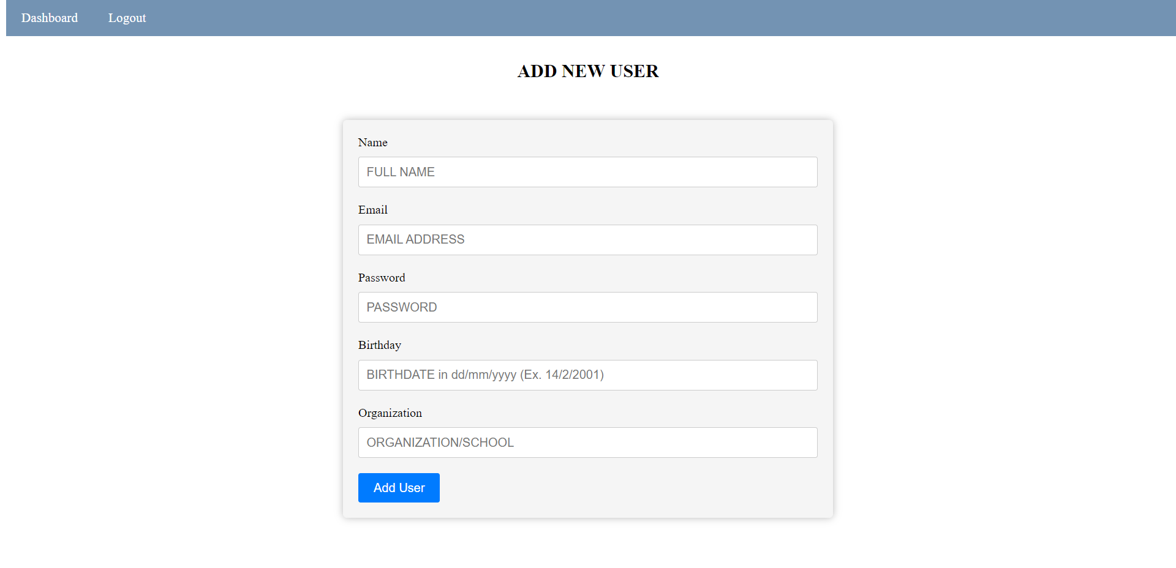

*Figures 17.* Maintenance Module: User Profiles

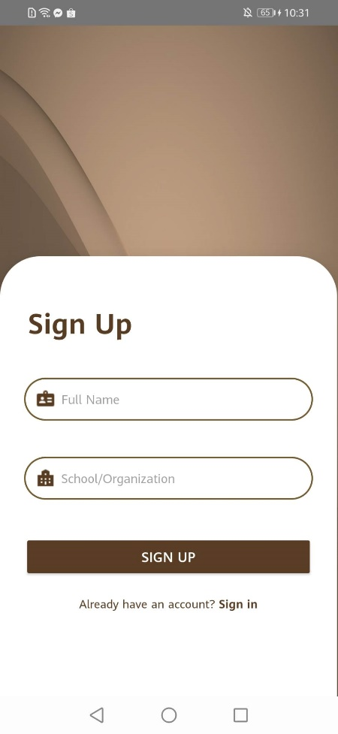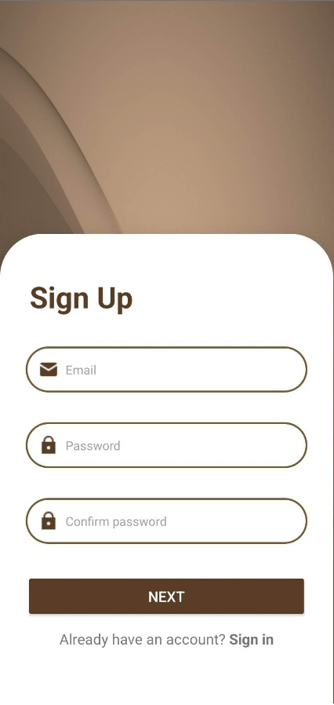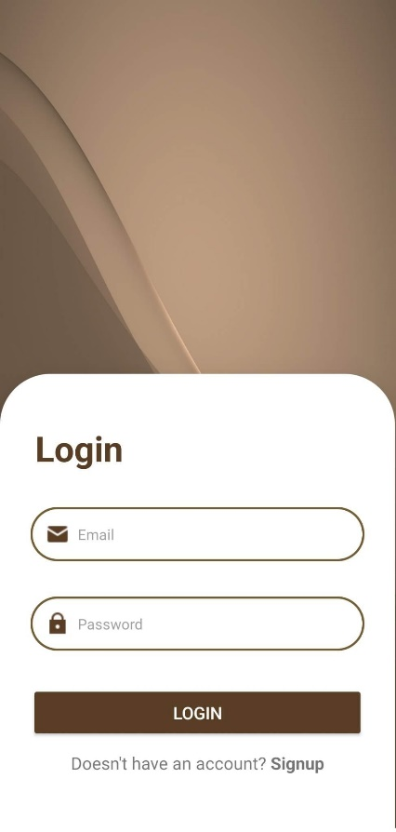Figure 17 presented the Maintenance Module's User's Profile. This view displayed the list of profiles that the administrator could add, edit, enable, and disable. It gave the administrator the authority to manage and modify user's profile entries.

*Figures 18.* Login and Sign Up

Figure 18 presented depict the user interface structure for the Login and Sign Up functionalities of the system. This marks the starting point of user activity within the system. During the login process, the user is required to input their registered email and password to gain access to the entire system's contents. On the other hand, the sign-up process involves user registration in the system to utilize the application. The necessary information to be provided during sign-up includes the user's Email, Password, Confirm Password, Full Name, and School or Organization affiliation.

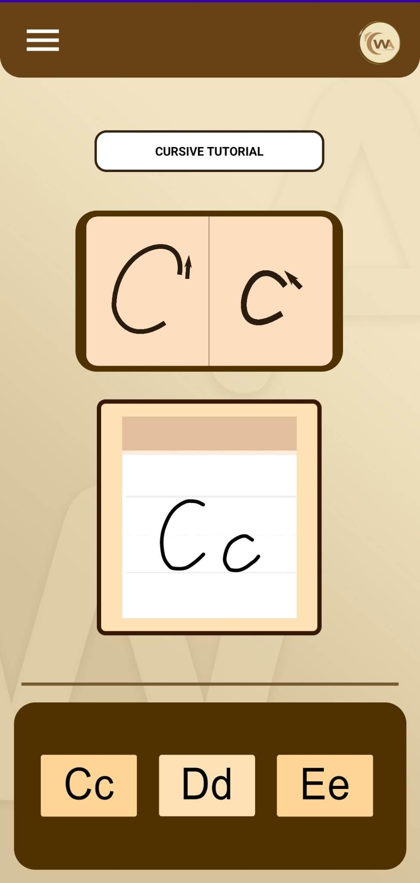

*Figure 19.* Tutorial Module

Figure 19 illustrated the Tutorial Module of the system. It showcased the display of image and video tutorials designed to assist users in learning how to write cursive letters by observing and following the tutorials.

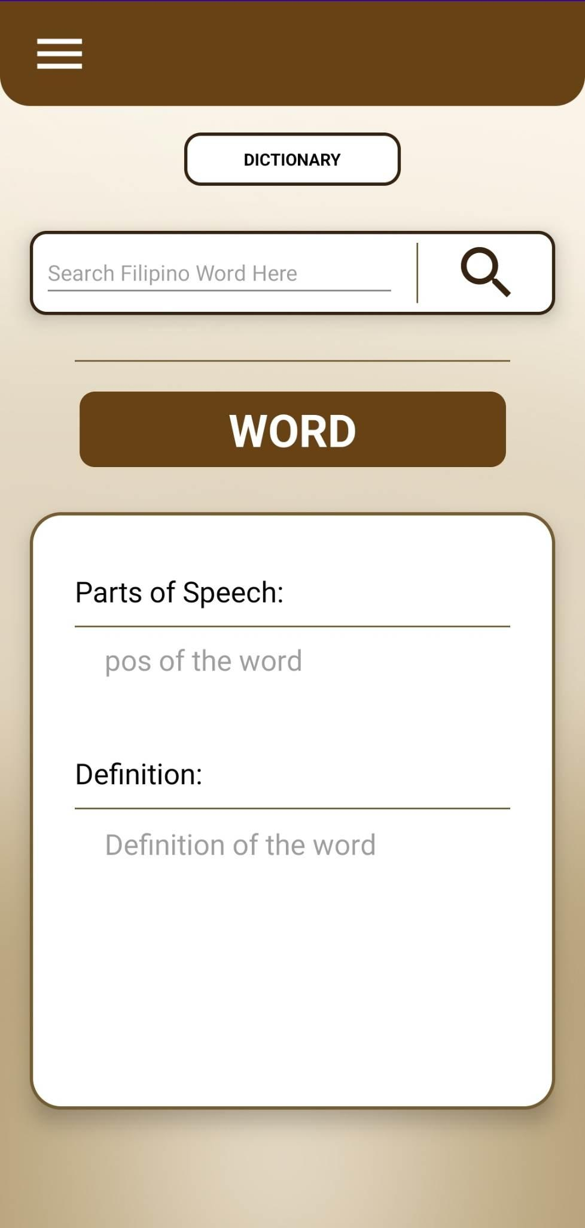

*Figure 20.* Dictionary Module

Figure 20 presented the Dictionary Module of the system. This module enables users to search and display Filipino words along with their corresponding parts of speech and definitions. With a vast database of 45,000 Filipino words, users can conveniently perform searches using the Dictionary Module.

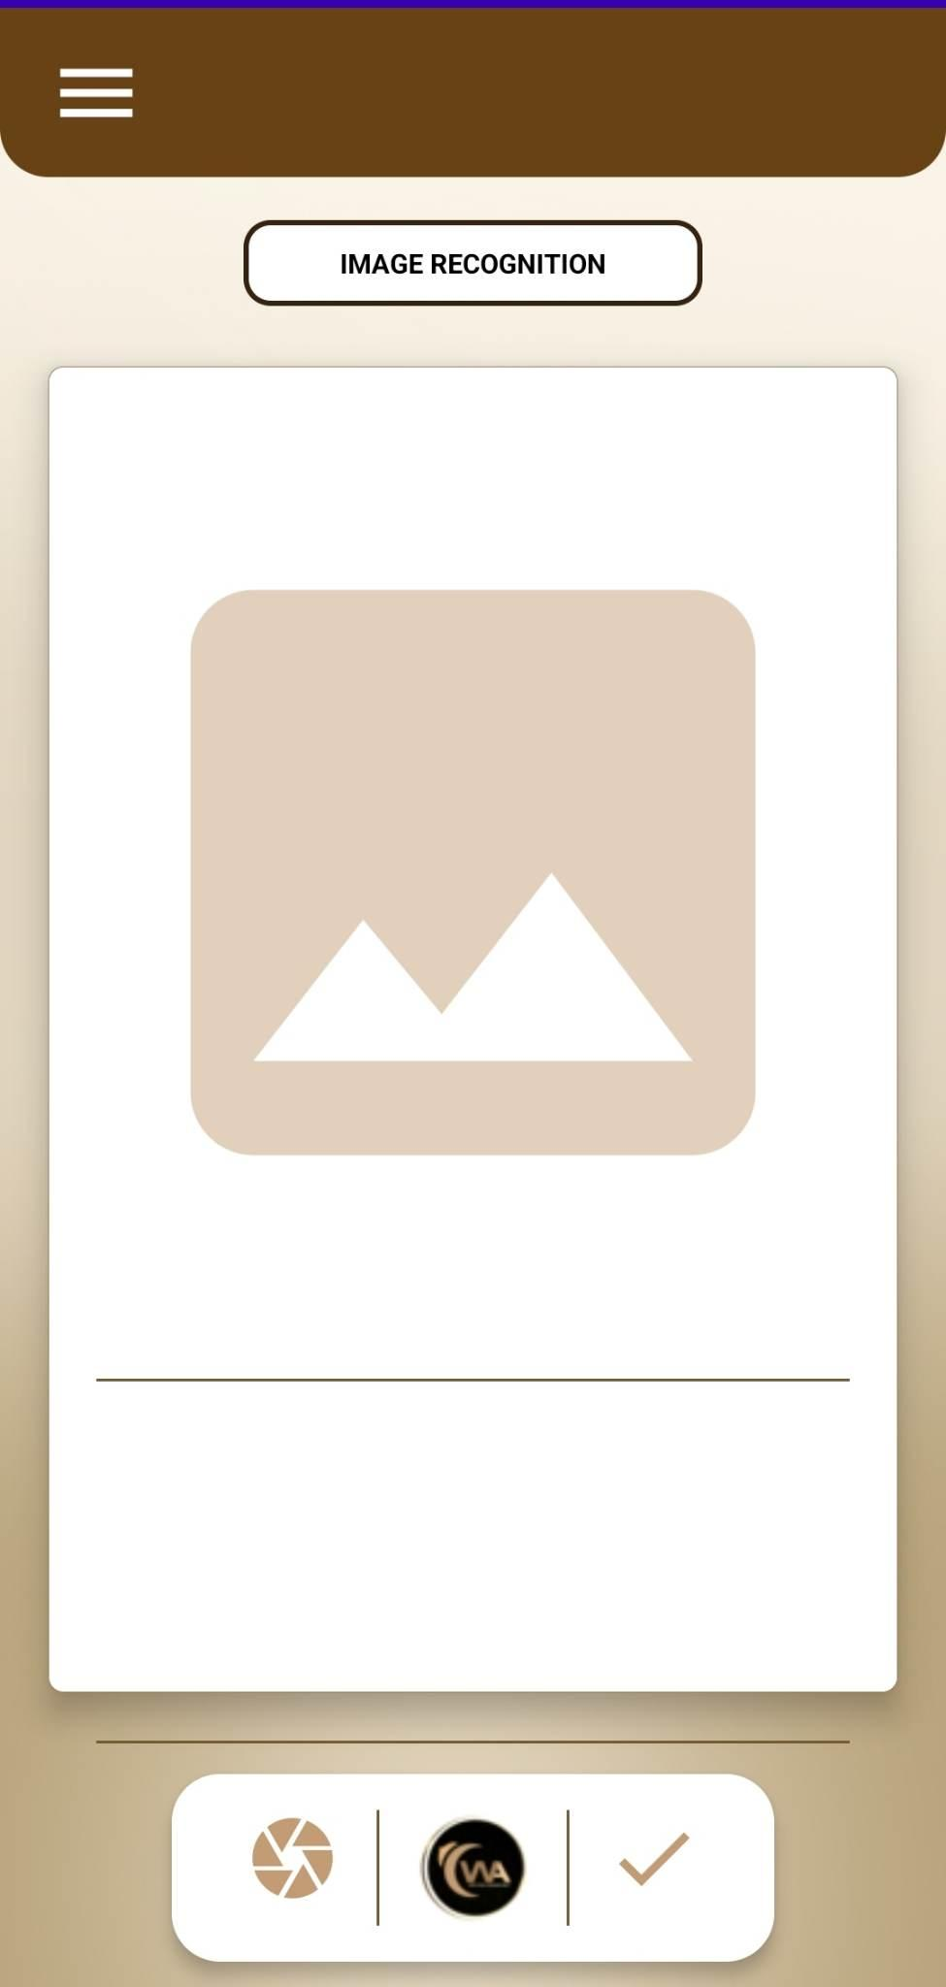

*Figure 21.* Image Recognition Module

Figure 21 showcased the Image Recognition module of the system. This module is capable of capturing cursive handwriting and converting it into a text string. Additionally, it facilitates the transferring of the recognized text into the Text Editor Module.

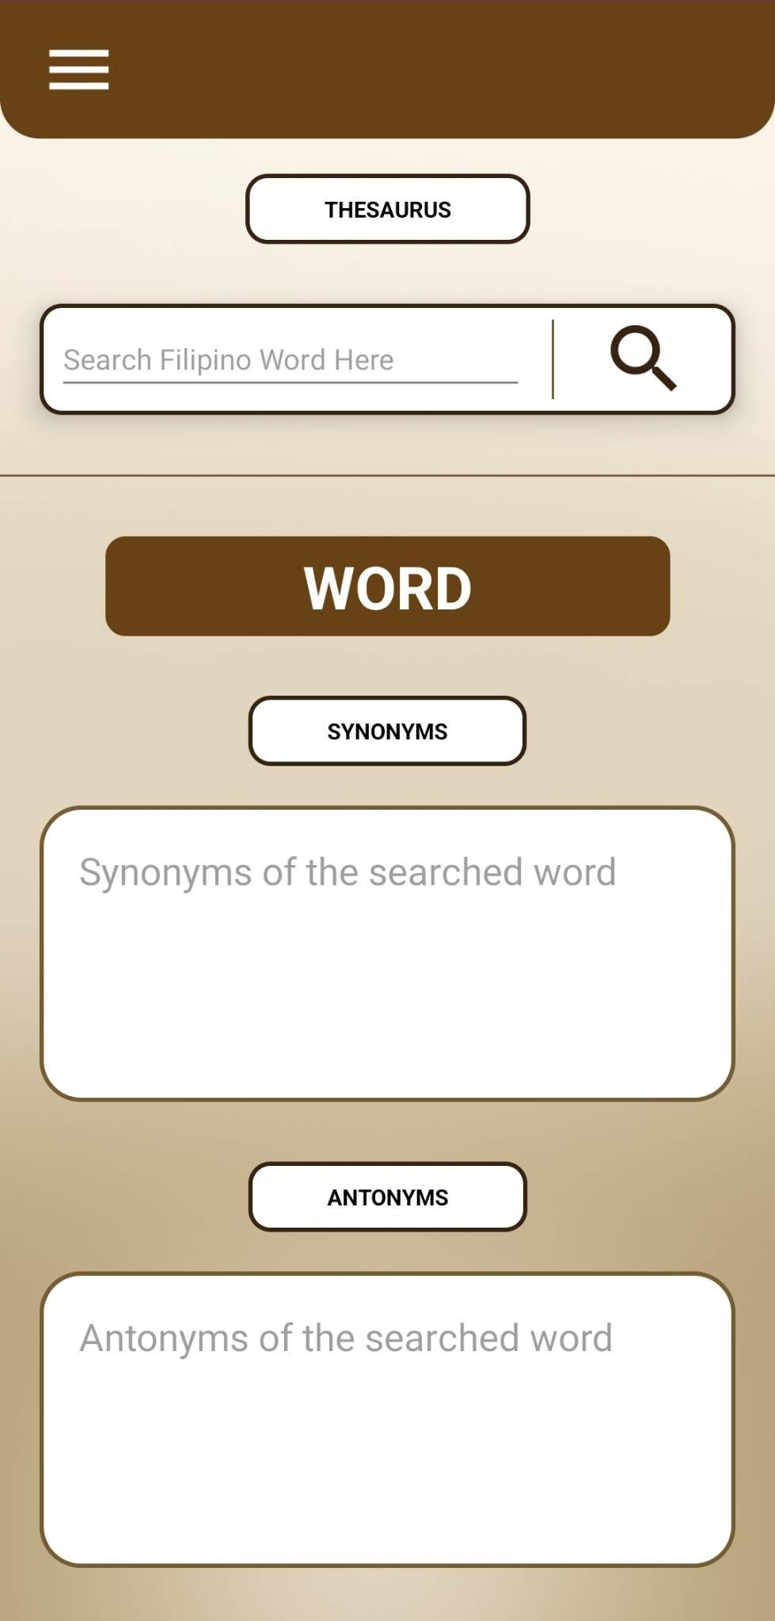

*Figure 22.* Thesaurus Module

Figure 22 illustrated the Thesaurus Module of the system. This module possessed the capability to provide synonyms and antonyms for the searched Filipino words. It assisted users in expanding their vocabulary and finding alternative words with similar or opposite meanings.

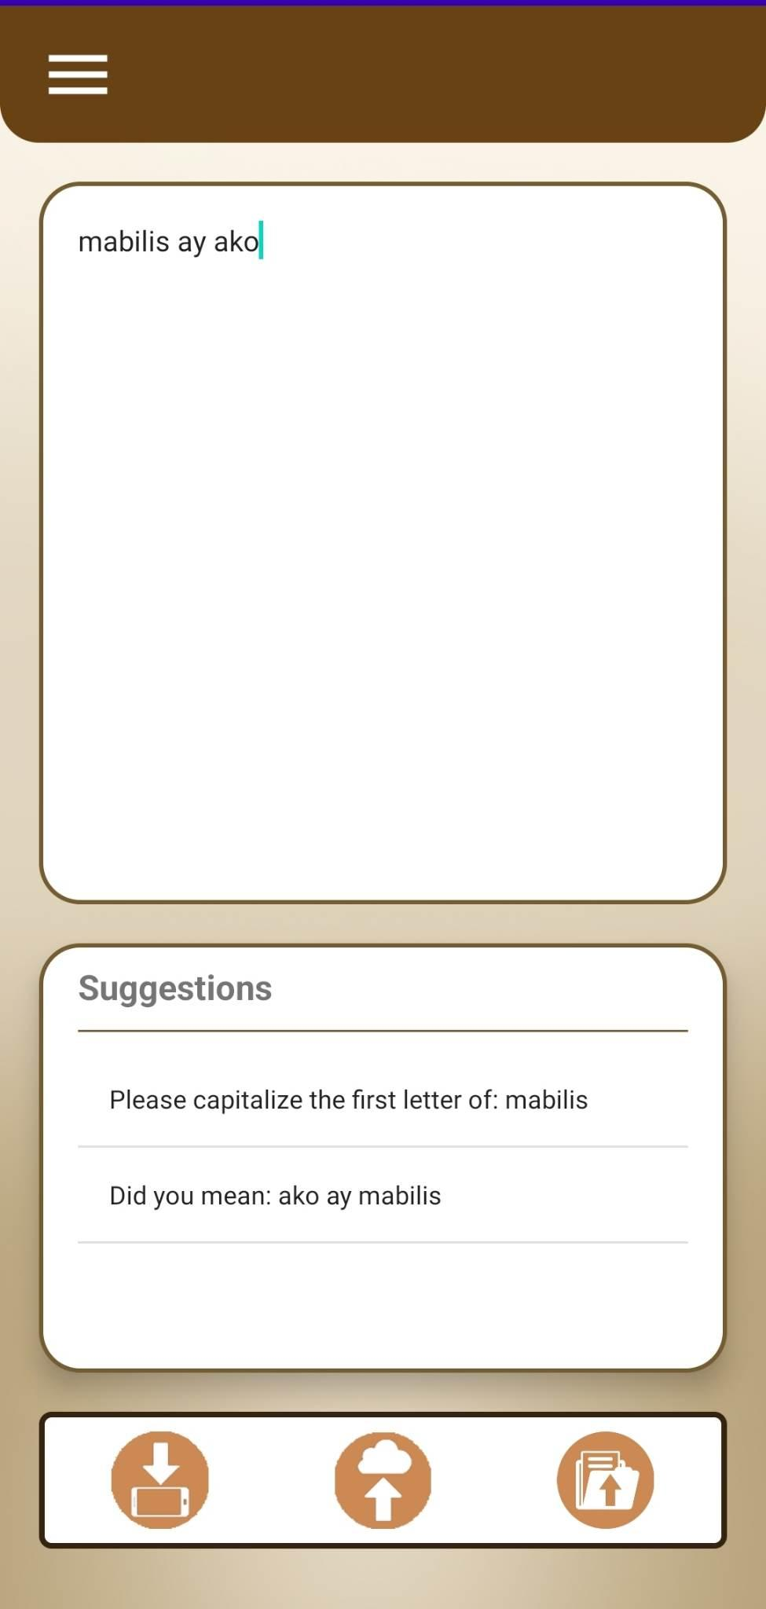

*Figure 23.* Natural Language Processing Module

Figure 23 depicted the Natural Language Processing Module. This module was designed to assist users in checking basic grammar structures and spellings in their written works. It provided users with helpful assistance by making suggestions and modifications to improve the correctness and clarity of their work.

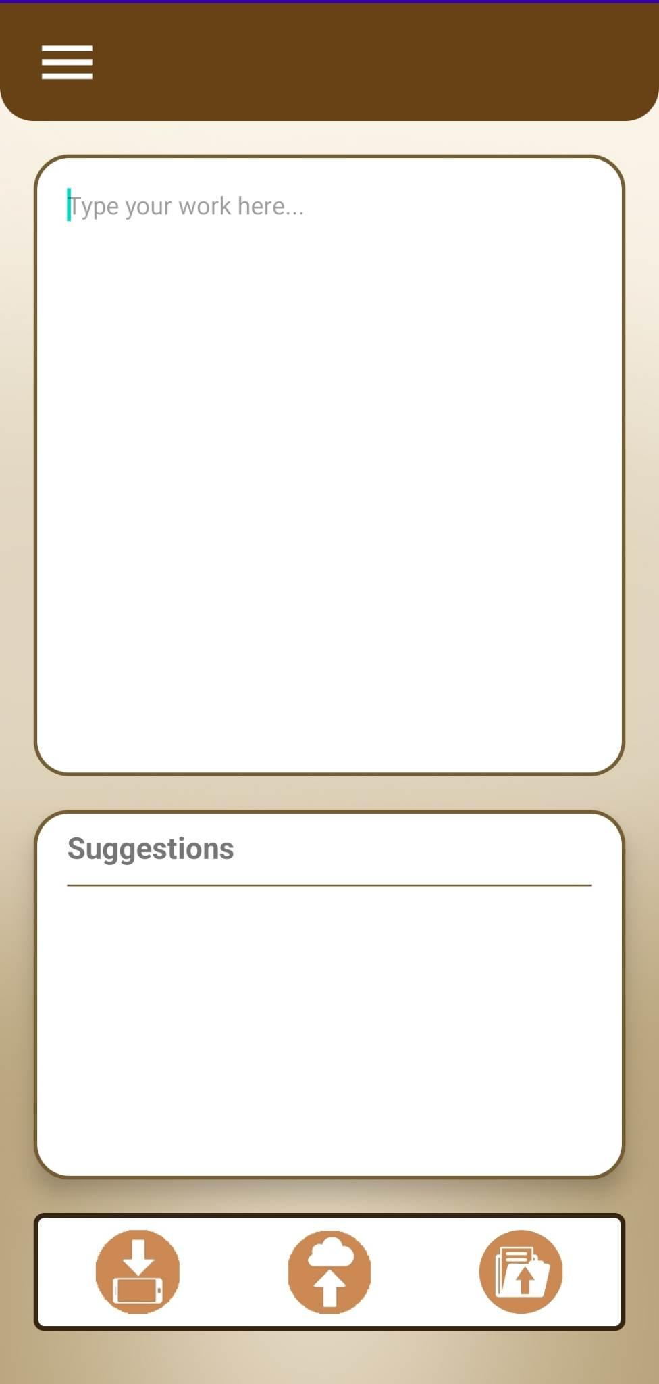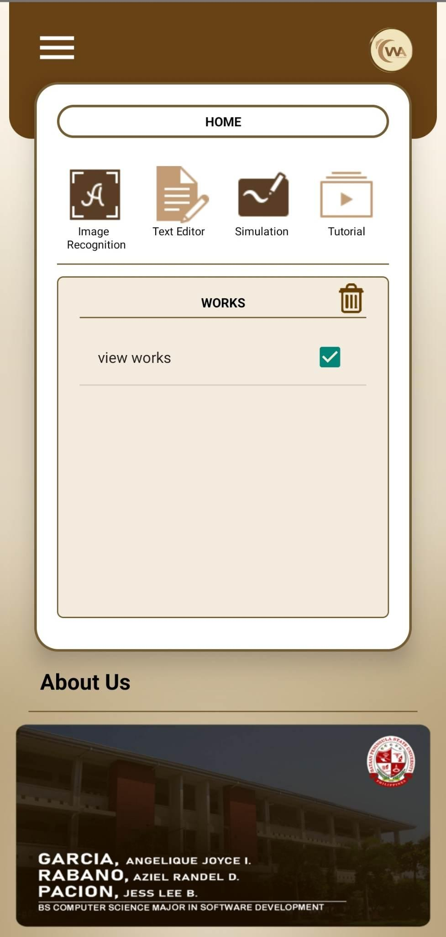

*Figure 24.* Data Save/Upload Module

Figure 24 demonstrated the functionalities of uploading, downloading, and saving user's works within the system. This module allowed users to upload their text files, download their completed works, and save them in Firebase, enabling easy access and viewing in the Dashboard Activity. The three buttons located below the Text Editor Activity corresponded to the Download, Save, and Upload features of the system, giving users easy ways to properly manage and handle their written works.

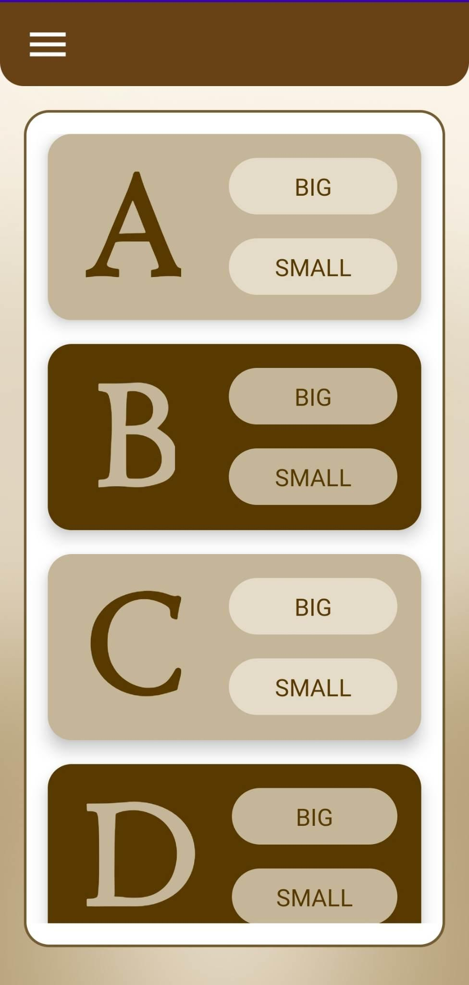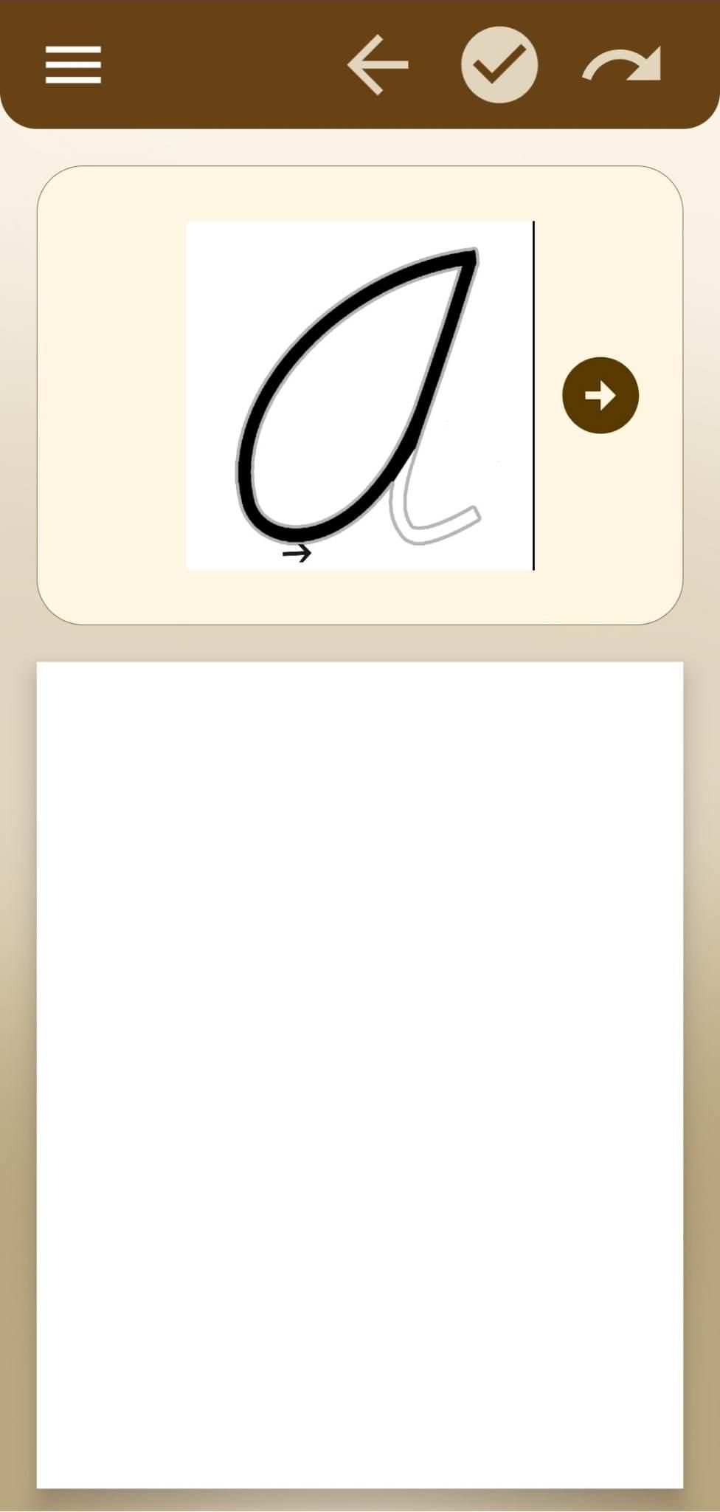

*Figures 25.* Simulation Module

Figure 25 illustrated the Simulation Module of the system. This module included a letter picker with buttons for selecting small and capital letters. It provided users with a simulation environment where they could practice their cursive handwriting skills by writing their chosen cursive letters on the system's canvas. Additionally, the module featured video tutorials that offered assistance and guidance on the correct stroke and formation of the cursive letters, aiding users in improving their penmanship.

## **Project Capabilities and Limitations**

The following are the capabilities of the developed Filipino Cursive Recognition and Writing Assistant using Natural Language Processing and Artificial Neural Network:

1. Storing and maintaining the user’s information, dictionary, and thesaurus through the Maintenance Module;
2. Searching and displaying Filipino words with their meanings through the Dictionary Module;
3. Providing synonyms, and antonyms through the Thesaurus Module;
4. Showing an image and video tutorial on how to write a Filipino cursive letter through Cursive Tutorial Module;
5. Providing a simulation feature to assist the users in writing Filipino cursive through the Simulation Module;
6. Recognizing the correct basic grammar structure and spellings using Natural Language Processing Algorithm;
7. Allowing the user to upload their text file, download to device storage and store the data in Firebase, enabling to view the output through the Data Save/Upload Module; and
8. Converting cursive handwriting into a text document using Image Recognition.

The following are the limitations of the developed Filipino Cursive Recognition and Writing Assistant using Natural Language Processing and Artificial Neural Network.

1. The developed system was exclusively designed only for Filipino language, particularly for Tagalog;
2. The developed system necessitates the utilization of a camera with a minimum resolution of at least 12 megapixels or above and depends on lighting conditions, distance, and camera angles to produce optimal output.
3. The developed system is limited to re-arranging sentences with errors within a range of 3 to 5 words, provided that the words conform to the patterns registered in the system.
4. The developed system exclusively accommodates only .txt file formats.
5. The developed system is exclusively designed for Android users; not applicable for Apple Devices, and is only available online.

## **Test Results**

The proponents of the study employed a series of system’s performance testing procedures to assess the system's capabilities as outlined in the study's objectives. This is to ensure that the developed system is properly functioning. The evaluation process was conducted by the proponents of the study, who utilized performance test cases to thoroughly examine the system's performance and determine if it met the desired criteria. Through this evaluation, the researchers sought to gain valuable insights into the system's effectiveness and identify any areas that required further refinement.

*Table 7*. Maintenance Test Script

|  |  |  |  |
| --- | --- | --- | --- |
| Date | May 17, 2023 | | |
| Tested By | Angelique Joyce Garcia | | |
| Test Case Number | 1 | | |
| Test Case Name | Maintenance | | |
| Test Case Description | This will allow the administrator to maintain the user's information, dictionary, and thesaurus. | | |
| Item(s) to be tested | | | |
| 1 | Login Page | | |
| 2 | View Dictionary Records | | |
| 3 | Search Word in Dictionary | | |
| 4 | Add single entry of Dictionary Record | | |
| 5 | Import Dictionary in .xlsx format | | |
| 6 | Edit and update Dictionary Record | | |
| 7 | View Thesaurus Records | | |
| 8 | Search Word in Thesaurus | | |
| 9 | Add single entry of Thesaurus Record | | |
| 10 | Import Thesaurus in .xlsx format | | |
| 11 | Edit and update Thesaurus Record | | |
| 12 | Add new user | | |
| 13 | Edit and Update user details | | |
| 14 | Enable/disable user account | | |
| 15 | Logout Page | | |
| Procedural Steps | | | |
| 1 | The admin needs to input correct credentials in the login page. | | |
| 2 | In the Dictionary page, the system will display all the records of the dictionary in the database. | | |
| 3 | The admin can search a word in the search bar. | | |
| 4 | The admin can add a new single record in the database. | | |
| 5 | The admin can import the dictionary in excel file format. | | |
| 6 | The admin can edit and update dictionary records. | | |
| 7 | In Thesaurus page, the system will display all the records of thesaurus in the database. | | |
| 8 | The admin can search a word in the search bar. | | |
| 9 | The admin can add a new single record in the database. | | |
| 10 | The admin can import thesaurus in excel file format. | | |
| 11 | The admin can edit and update thesaurus record. | | |
| 12 | In the User Profiles page, the system will display all the users in the system. | | |
| 13 | The admin can add new users. | | |
| 14 | The admin can update and edit user details as well as enable or disable user accounts. | | |
| 15 | The admin can logout in the maintenance. | | |
| Specifications | | | |
| Input | Expected Output/Result | Pass Y/N | Actual Result/Output |
| Username and Password | 1. If the input credentials match the registered credentials in the system, the admin can access the system by clicking the Login Button. | Y | The system gives access once the admin provided correct details in the Login Page |
| 2. The admin cannot access the system if the credentials are wrong and the system will display an error message saying, ‘Invalid username or password'. | Y | It shows an error message that says, 'Invalid username or password'. |
| Dictionary Word, Parts of Speech, Definition | 1. If any of the word, parts of speech, and definition does not have a value, the addition of a single entry will not proceed. Instead, the system will ask the user to fill out the fields. | Y | All the fields are required and will not be able to continue adding a single-entry record if there is a missing field. |
| 2. If the word is already existing in the database, the system will display an error saying, 'The word you are trying to add already exists in the dictionary'. | Y | The error message was displayed when the proponent tried to add a word that already exists in the dictionary. |
| 3. If the word does not exist in the dictionary and all the fields (word, parts of speech, definition) have values, the single entry will be appended at the end of the dictionary. | Y | The new single dictionary record was appended at the end of the dictionary. |
| 4.If the admin updated a Dictionary record and the word already exists in the database, the system will display an error message saying, 'The changed word already exists in the database' | Y | The error message was displayed when the proponent updated a dictionary record and tried to input a word that already exists in the dictionary. |
| 5. If the admin updated a dictionary record and the admin cleared any of the fields (word/parts of speech/definition), the system will ask the admin to fill out the fields. | Y | All the fields are required in updating a dictionary record. |
| 6. If the admin updated a dictionary record in which all the fields have values and the word does not exist in the database, the system will update that specific dictionary record in the database. | Y | The record has been updated when all the fields have values, and the word field does not exist yet in the database. |
| Dictionary in excel file format | 1. If the admin clicks the upload button without the excel file attachment, it will throw an alert that says, 'Please select a file to upload'. | Y | It shows an error message when the proponent tries to click the button upload even if there is no attachment. |
| 2. If the attachment has missing values especially in the fields in Column A, B, and C, the system will display an error message 'Field/s cannot be empty'. | Y | The error message has been displayed when the fields in the excel file are not complete. |
| 3. If the attachment has input values in other columns aside from Column A, B, and C, the system will ignore these cells and will proceed in adding the records in the database if all the constraints are satisfied. | Y | The system ignored the values in other columns. |
| 4. If the excel file has complete values in Column A, B, and C, the system will append the records at the end of the database. | Y | The system added the records in the excel file to the end of the database. |
| Thesaurus Word, Antonym, and Synonym | 1. If the word or the synonym field does not have a value, the addition of a single entry will not proceed. Instead, the system will ask the user to fill out the fields. | Y | The fields word and synonym are required. |
| 2. If the word is already existing in the database, the system will display an error saying, 'The word you are trying to add already exists in the dictionary'. | Y | The system displayed an error message when the proponent tried to add a word that already exists in the database. |
| 3. If the word does not exist in the dictionary and the fields (word and synonym) have values, the single entry will be appended at the end of the dictionary. | Y | The new single thesaurus record was added in the database. |
| 4. If the admin updated the Thesaurus record and the word already exists in the database, the system will display an error message saying, 'The changed word already exists in the database'. | Y | The system displayed an error message when the proponent tried to add a word that already exists in the database. |
| 5. If the admin updated a thesaurus record and the admin cleared the field word or synonym, the system will ask the admin to fill out the fields. | Y | The fields word and synonym are required. |
| 6. If the admin updated a thesaurus record and the fields word and synonym have values and the word does not exist in the database, the system will update that specific thesaurus record in the database. | Y | The system updated the single thesaurus record. |
| Thesaurus in excel file format | 1. If the admin clicks the upload button without the excel file attachment, it will throw an alert that says, 'Please select a file to upload'. | Y | It shows an error when the proponent tries to click the button upload even if there is no attachment. |
| 2. If the attachment has missing values in Column A and Column C, the system will display an error message 'The Word field cannot be empty'. | Y | The error message has been displayed when the fields word and synonyms in the excel file are not complete. |
| 3. If the attachment has input values in other columns aside from Column A, B, and C, the system will ignore these cells and will proceed in adding the records in the database if all the constraints are satisfied. | Y | The system ignored the values in other columns. |
| 4. If the excel file has complete values especially in Column A and C, the system will append the records at the end of the database. | Y | The system added the records in the excel file to the end of the database. |
| User Details (Full Name, Email address, password, birthdate, organization) | 1. If any of the fields in the new user page does not have value, the system will ask the admin to fill out the fields. | Y | All the fields in the add new user page are required. |
| 2. If the input email address in the add new user page is already existing in the database, the system will display an error message saying, 'The input email address already exists'. | Y | The error message has been displayed when the proponent tried to add a user in which the email address already exists in the database. |
| 3. If all the fields have values and the email address is not existing yet in the database, the creation of a new user account will be successful. | Y | A new user has been added. |
| 4. If the admin checks the check button in the edit user page, the user account will be disabled. But if the admin unchecked it, the user account will be enabled. | Y | It enables and disables the user account. |
| 5. If the admin updated the user details (name, organization/ school, birthday) and deleted the value in any of these fields, the system will ask the admin to fill out the fields. | Y | All the fields in user details are required |
| 6. If the admin updated the user details (name, organization/ school, birthday) and all the fields still have values, it will be automatically updated in the database after the admin clicked the Submit button. | Y | The user details have been updated. |

Table 7 presented the performance test script that was utilized to validate the maintenance of the developed system. All the expected functionalities were satisfactorily met and deemed functional. The testing process ensured that the web-based maintenance fulfilled the desired requirements and performed as intended.

*Table 8.* Tutorial Test Script

|  |  |  |  |  |
| --- | --- | --- | --- | --- |
| Date | | May 17, 2023 | | |
| Tested By | | Angelique Joyce I. Garcia | | |
| Test Case Number | | 2 | | |
| Test Case Name | | Tutorial | | |
| Test Case Description | | This capability displays a video tutorial on how to write cursive Filipino Alphabets. | | |
| Item(s) to be tested | | | | |
| 1 | Tutorial Letter Picker | | | |
| 2 | Image Representation on how to write cursive letters | | | |
| 3 | Video Tutorial in writing cursive letters | | | |
| 4 | Side Menu | | | |
| Procedural Steps | | | | |
| 1 | From Dashboard Activity, click the tutorial button. | | | |
| 2 | Choose a letter from the letter picker at the bottom of the activity. | | | |
| 3 | After clicking the button, the image representation as well as the video tutorial will be displayed. | | | |
| 4 | After watching, users can click the side menu to navigate to other activities. | | | |
| Specifications | | | | |
| Input | Expected Output/Result | | Pass Y/N | Actual Result/Output |
| Letter Picker | 1. If the user is not yet clicking anything in the letter picker, the holder for image representation will display a text 'Cursive Letter' and the video holder will just be plain black. | | Y | The activity displays the text and the video holder as expected. |
| 2. If the user clicked a letter from the letter picker, the image representation and the video should be automatically displayed. | | Y | The image and the video tutorial changed in corresponds with the letter chosen. |
| Side Menu | 1. If the user clicks the side menu button at the top left of the activity, the side menu should be shown and allows the user to navigate to other activities. | | Y | The side menu was displayed and the buttons inside it were all functional. |

The performance test script presented in the table 8 pertained to the tutorial capability of the developed system. This capability aimed to display a video tutorial demonstrating the process of writing a Filipino cursive letter. Based on the results obtained, it can be concluded that all functionalities within the tutorial capability worked successfully, showcasing the system's effective delivery of the intended tutorial feature.

*Table 9.* Dictionary Test Script

|  |  |  |  |  |  |
| --- | --- | --- | --- | --- | --- |
| Date | | | May 17, 2023 | | |
| Tested By | | | Angelique Joyce I. Garcia | | |
| Test Case Number | | | 3 | | |
| Test Case Name | | | Dictionary | | |
| Test Case Description | | | This feature allows the searching and displaying Filipino words and its meaning. | | |
| Item(s) to be tested | | | | | |
| 1 | Dictionary Search Bar | | | | |
| 2 | Containers that display dictionary details | | | | |
| 3 | Side Menu | | | | |
| Procedural Steps | | | | | |
| 1 | From Dashboard Activity, click the dictionary button. | | | | |
| 2 | Search a Filipino word in the search bar | | | | |
| 3 | After clicking the Filipino searched word, the containers for Filipino word, definition, and parts of speech should display the corresponding details based on the searched word. | | | | |
| 4 | Then, the user can click the side menu to navigate to other activities. | | | | |
| Specifications | | | | | |
| Input | | Expected Output/Result | | Pass Y/N | Actual Result/Output |
| Search Bar | | 1. When the user types the Filipino word to be searched, there should be a scroll view list that will display the searched word in the database. | | Y | The list scroll view was displayed as the proponent typed in the search bar. |
| Dictionary Containers | | 1. If the user clicks the word from the search bar, the containers of dictionary activity will display the details that correspond to the searched word. | | Y | The items in the list were clickable, and the text views changed automatically. |
| Side Menu | | 1. If the user clicks the side menu button at the top left of the activity, the side menu should be shown and allows the user to navigate to other activities. | | Y | The side menu was displayed and the buttons inside it were all functional. |

Table 9 presented the results of the performance evaluation conducted on the Dictionary feature of the proposed system. The findings indicated that the functionalities of the dictionary were functioning correctly and produced the expected outputs.

*Table 10.* Image Recognition Test Script

|  |  |  |  |  |  |
| --- | --- | --- | --- | --- | --- |
| Date | | | May 17, 2023 | | |
| Tested By | | | Angelique Joyce I. Garcia | | |
| Test Case Number | | | 4 | | |
| Test Case Name | | | Image Recognition | | |
| Test Case Description | | | This capability allows the user to take a picture of their handwritten cursive work and the system will automatically convert it into text. | | |
| Item(s) to be tested | | | | | |
| 1 | Capture Button | | | | |
| 2 | Device's Camera | | | | |
| 3 | Converted text container | | | | |
| 4 | Continue Button | | | | |
| 5 | Side Menu | | | | |
| Procedural Steps | | | | | |
| 1 | From Dashboard Activity, click the image recognition button. | | | | |
| 2 | Click the capture button to start the device's camera. | | | | |
| 3 | Capture the handwritten work. | | | | |
| 4 | Click the check button to proceed in converting the captured image to text. | | | | |
| 5 | Click the check button in the Image Recognition activity so that the recognized text will be put in the text editor. | | | | |
| 6 | Then, the user can click the side menu to navigate to other activities. | | | | |
| Specifications | | | | | |
| Input | | Expected Output/Result | | Pass Y/N | Actual Result/Output |
| Capture Button | | 1. When the user clicks the capture button located at the bottom left of the activity's interface, it should ask the user permission to access the camera and after giving access to the system, it should start the camera. | | Y | Upon the initial usage of the system, the application requested permission to access the camera. Once the camera permission was granted, the camera started. |
| Device's Camera | | 1. When the camera is working, the user can capture a photo of their handwritten work and by clicking the check button at the upper right of the screen, it will be redirected back to the image recognition activity. | | Y | The capturing of an image was successfully executed, and upon clicking the check button, the system seamlessly redirected back to the corresponding activity. |
| Converted Text Container | | 1. The container for the converted text should display the recognized text of the model. | | Y | The textview displayed the text recognized from the captured image. |
| Continue Button (Check icon) | | 1. If the user clicked the continue button at the bottom right of the activity's interface, the system should be redirected to the text editor wherein the converted text is displayed. | | Y | After clicking the check button, the system was redirected to the text editor activity. |
| Side Menu | | 1. If the user clicks the side menu button at the top left of the activity, the side menu should be shown and allows the user to navigate to other activities. | | Y | The side menu was displayed, and the buttons inside were all functional. |

Table 10 displayed the results of the performance evaluation conducted by the proponent on the image recognition feature of the developed system. Based on this evaluation, it was determined that all the expected functionalities of this capability were successfully implemented and performed as intended.

*Table 11.* Thesaurus Test Script

|  |  |  |  |  |  |
| --- | --- | --- | --- | --- | --- |
| Date | | | May 17, 2023 | | |
| Tested By | | | Angelique Joyce I. Garcia | | |
| Test Case Number | | | 5 | | |
| Test Case Name | | | Thesaurus | | |
| Test Case Description | | | This feature allows the searching and displaying Filipino words and its corresponding synonym and antonyms. | | |
| Item(s) to be tested | | | | | |
| 1 | Thesaurus Search Bar | | | | |
| 2 | Containers that display thesaurus details | | | | |
| 3 | Side Menu | | | | |
| Procedural Steps | | | | | |
| 1 | From Dashboard Activity, click thesaurus button. | | | | |
| 2 | Search a Filipino word in the search bar. | | | | |
| 3 | After clicking the Filipino searched word, the containers for Filipino word, antonym, and synonym should display the corresponding details based on the searched word. | | | | |
| 4 | Then, the user can click the side menu to navigate to other activities. | | | | |
| Specifications | | | | | |
| Input | | Expected Output/Result | | Pass Y/N | Actual Result/Output |
| Search Bar | | 1. When the user types the Filipino word to be searched, there should be a scroll view list that will display the searched word in the database. | | Y | The list scroll view was displayed as the proponent typed in the search bar. |
| Thesaurus Containers | | 1. If the user clicked the word from the search bar, the containers of thesaurus activity will display the details that correspond to the searched word. | | Y | The items in the list were clickable, and the text views changed automatically. |
| Side Menu | | 1. If the user clicks the side menu button at the top left of the activity, the side menu should be shown and allows the user to navigate to other activities. | | Y | The side menu was displayed, and the buttons inside were all functional. |

Table 11 described evaluation result for the performance of the thesaurus feature in the proposed system. Following the procedure, the obtained result indicates that the expected output of this feature aligned with the actual output of the developed system.

*Table 12*. Text Editor Test Script

|  |  |  |  |  |  |
| --- | --- | --- | --- | --- | --- |
| Date | | | May 17, 2023 | | |
| Tested By | | | Angelique Joyce I. Garcia | | |
| Test Case Number | | | 6 | | |
| Test Case Name | | | Text Editor | | |
| Test Case Description | | | This allows the user to check their basic grammar sentences. Also, it allows the user to upload their text file, download to device storage and store the text file in the database. | | |
| Item(s) to be tested | | | | | |
| 1 | Text Area | | | | |
| 2 | Suggestion List | | | | |
| 3 | Download to Device button | | | | |
| 4 | Save to database button | | | | |
| 5 | Upload button | | | | |
| 6 | Side Menu | | | | |
| Procedural Steps | | | | | |
| 1 | From Dashboard Activity, click the text editor button. | | | | |
| 2 | Type Filipino sentences in the text area. | | | | |
| 3 | Look at the suggestion list below the text area to see if there are any suggestions in the work. | | | | |
| 4 | After editing, the user can download the work into their device storage by clicking the left button at the bottom of the activity. | | | | |
| 5 | The user can also save their work to the database by clicking the center button located at the bottom part of the activity. | | | | |
| 6 | The user can upload existing work by clicking the rightmost button at the bottom of the activity. | | | | |
| 7 | Then, the user can click the side menu to navigate to other activities. | | | | |
| Specifications | | | | | |
| Input | | Expected Output/Result | | Pass Y/N | Actual Result/Output |
| Text Area | | 1. When the user clicks the text area, the keyboard should show and will allow the user to type their work. | | Y | The text area is editable. |
| Suggestion List | | 1. If the user types a Filipino sentence, the suggestion list located below the text area should automatically display the suggestions regarding the user's work (if there are any). | | Y | The suggestion list was displayed after the proponent entered a Filipino sentence into the system. The list comprised the grammar and spelling checker features of the system. |
| Download to Device | | 1. If the user clicked the download to device button for the first time, the system should ask the user's permission to access the device's storage. | | Y | The system asks for storage permission when the download button is clicked. |
| 2.If the user clicks the download to device button, there should be a dialog box that will pop up to ask the user about the file name of the text file. | | Y | The dialog box that asked for a file name popped up. |
| 3. If the user entered the desired file name, there should be a toast saying that the saving file is successful and the location is in the Downloads. | | Y | The toast was displayed. |
| 4. If the user entered a filename that is already existing in the Downloads folder of the device, there should be a dialog box that will inform the user that the file already exists and ask the user if the system will overwrite the file or not. | | Y | The dialog box that asked to overwrite a file popped up. |
| Save to database | | 1. If the user clicks the save to database button, there should be a pop-up dialog box that will ask the user for the file name of their work. | | Y | The dialog box that asked for a file name popped up. |
| 2. After saving the file, there should be a toast saying that the file is saved. | | Y | The toast was displayed. |
| 3. When the user opens a file from the view works in the dashboard activity and then clicks the 'Save to Database' button in the text editor, a dialog box will appear asking the user if they want to overwrite the saved text file. | | Y | The dialog box that asked to overwrite a file popped up. |
| Upload Button | | 1. When the user clicks the upload button, the file manager should open, and the user can select the files that are in the .txt format. | | Y | When the proponent clicked the upload button, only the text files were allowed to be uploaded. |
| 2. After selecting a text file from the device's storage, the system must be automatically redirected to text editor activity and the content of the text file should be displayed in the text area. | | Y | The system was redirected to the text editor and the text area has the content of the uploaded text file. |
| Side Menu | | 1. If the user clicks the side menu button at the top left of the activity, the side menu should be shown and allows the user to navigate to other activities. | | Y | The side menu was displayed, and the buttons inside were all functional. |

Table 12 pertained to the evaluation of the text editor activity within the developed project. The evaluation was carried out by the proponent, who proceeded to test the features of the activity. Subsequent to the evaluation, the results were gathered, revealing that all the expected outputs were successfully matched by the actual outputs of the developed system.

*Table 13.* Simulation Test Script

|  |  |  |  |  |
| --- | --- | --- | --- | --- |
| Date | | May 17, 2023 | | |
| Tested By | | Angelique Joyce I. Garcia | | |
| Test Case Number | | 7 | | |
| Test Case Name | | Simulation | | |
| Test Case Description | | This capability provides a simulation feature to assist the user in writing Filipino cursive letters. | | |
| Item(s) to be tested | | | | |
| 1 | Letter Picker | | | |
| 2 | Canvas | | | |
| 3 | Video Tutorial | | | |
| 4 | Next/Back Button (Video tutorial) | | | |
| 5 | Back button | | | |
| 6 | Redo Button | | | |
| 7 | Check Button | | | |
| 8 | Result Dialog Box | | | |
| 9 | Back Button in Dialog Box | | | |
| 10 | Side Menu | | | |
| Procedural Steps | | | | |
| 1 | From Dashboard Activity, click the simulation button. | | | |
| 2 | Pick a letter and its capitalization. | | | |
| 3 | Watch the video and click the next button to see the next step in writing the letter. | | | |
| 4 | Try to do it on the canvas. | | | |
| 5 | Check the user's work by clicking the check button at the top right of the activity. | | | |
| 6 | Return to the letter picker by clicking the return button at the top of the activity. | | | |
| 7 | Clear the canvas by clicking the redo button at the rightmost button at the top of the activity. | | | |
| 8 | Then, the user can click the side menu to navigate to other activities. | | | |
| Specifications | | | | |
| Input | Expected Output/Result | | Pass Y/N | Actual Result/Output |
| Letter Picker | 1. The letter picker should be scrollable. | | Y | The letter picker was scrollable. |
| 2. The button for capitalization (Big and Small) in the letter picker should be clickable. | | Y | The buttons for capitalization were functional. |
| Canvas | 1. The canvass located at the bottom part of the activity should allow the user to write anything on it. | | Y | The proponent was able to write on the canvas. |
| Video Tutorial | 1. A step-by-step video tutorial should be automatically displayed at the top of the activity. | | Y | There were video tutorials at the top of the activity. |
| Next/Back Button (Video Tutorial) | 1. The first video should correspond to the first step in writing the Filipino Cursive Letter. Also, the back button should not be visible in the screen | | Y | The initial video displayed was the first step in composing the letter. The back button was not visible. |
| 2. When the user clicks the next button, the video display should be changed to the next video step. | | Y | The video was changed when the next button was clicked, and the sequence of the videos was also correct. |
| 3. When the user clicks the back button, the video display should be changed to the previous video step. | | Y | The video was changed to the previous video when the back button was clicked. |
| 4. When the video displayed is the last step in writing the letter, the next button should disappear leaving the back button showing only. | | Y | The next button was not visible when the last video step was displayed. |
| Back Button | 1. When the user clicks the back button located at the topmost part of the activity, the system should be redirected to the letter picker. | | Y | The system was redirected to letter picker. |
| Redo Button | 1. When the user clicks the redo button which is the rightmost button at the top of the activity, the canvas should be cleared. | | Y | The canvas was cleared. |
| Check Button | 1. When the user clicks the check button, there should be a pop-up dialog box showing the grade of the user based on their work. | | Y | There was a dialog box popped up that showed the grade of the user. |
| Result Dialog Box | 1. The result dialog box should display the grade obtained by the user as well as an image of their work. | | Y | The dialog box displayed the grade of the user. |
| Back Button in Dialog Box | 1. When the user clicks the back button in the dialog box, the system should be returned to the simulation activity where the canvas and the video tutorial is shown. | | Y | The system was returned to the canvas activity. |
| Side Menu | 1. If the user clicks the side menu button at the top left of the activity, the side menu should be shown and allows the user to navigate to other activities. | | Y | The side menu was displayed, and the buttons inside were all functional. |

Table 13 presented the performance evaluation for the Simulation Activity. The results indicated that this activity was functional and met the expected output.

## **Project Evaluation**

The Filipino Cursive Recognition and Writing Assistant using Natural Language Processing and Artificial Neural Network conducted an evaluation that is based on the software product quality models of ISO 25010:2011. These models encompassed Functional Suitability, Performance Efficiency, Compatibility, Usability, Reliability, Security, Maintainability, and Portability. The criteria established ensured that the system fulfilled the project’s specific requirement. The evaluators of the developed system comprised the following: five (5) software professionals, three (3) software development professors, seven (7) working professionals in any field of work, and eighty-five (85) students from Elementary to College.

The proponents performed the following objectives throughout the evaluation. First, the researchers explained the concept, instructions, and operation of the system's development to the respondents. Second, the researchers set up the system and gave the respondents the opportunity to test the developed system. Third, the researchers provided survey forms to the respondents to evaluate the effectiveness of the developed system. Forth, the researchers collected the survey forms from the respondents to calculate the total rating of the developed system. And lastly, the researchers used a numerical scale and an analogous interpretation from Likert’s scale to interpret the overall rating. The Likert scale employed in the evaluation assigned equivalent values to each score. The highest rating, denoted as 5, represented "Excellent." Following that, a score of 4 corresponded to "Very Good," while a score of 3 indicated "Good." Additionally, a score of 2 denoted "Fair," and the lowest score of 1 represented "Poor."

*Table 14.* Evaluation of Software Quality: Functional Suitability

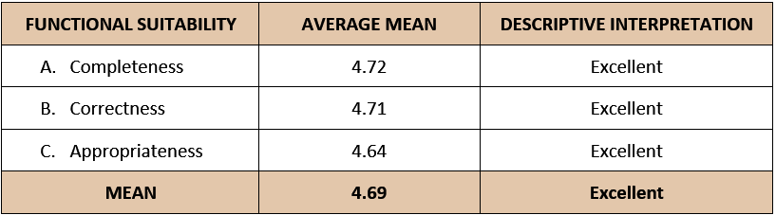

Table 14 provided an evaluation of software quality, specifically focusing on functional suitability. The data depicted in the table indicates that the system attained an overall mean score of 4.69, indicating an Excellent rating. Within the category of Functional Suitability, three (3) subsidiary aspects can be identified. The first aspect is completeness, which demonstrated an average score of 4.72. The second aspect is correctness, with an average score of 4.71. Lastly, the aspect of appropriateness obtained an average score of 4.64. All three aspects have achieved an Excellent rating based on their respective results.

*Table 15.* Evaluation of Software Quality: Performance Efficiency

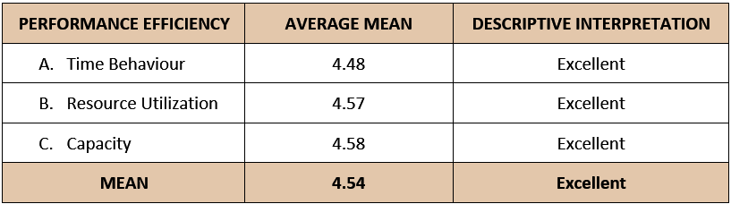

Table 15 provided an evaluation of software quality, specifically focusing on performance efficiency. The data depicted in the table indicates that the system attained an average mean score of 4.54, indicating an Excellent rating. In the Performance Efficiency category, three (3) subsidiary aspects can be distinguished. The first aspect is Time Behavior, which exhibited an average score of 4.48. The second aspect is Resource Utilization, which obtained an average score of 4.57. Lastly, the aspect of Capacity achieved an average score of 4.58. All three aspects have attained an Excellent rating based on their respective results.

*Table 16.* Evaluation of Software Quality: Compatibility

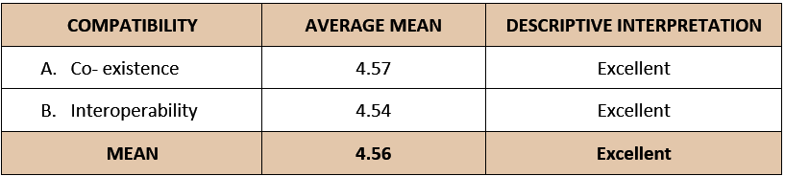

Table 16 provided an evaluation of software quality, specifically focusing on compatibility. The data depicted in the table indicates that the system attained an average mean score of 4.56, indicating an Excellent rating. Within the Compatibility category, two (2) subsidiary aspects can be discerned. The first aspect is Coexistence, which demonstrated an average score of 4.57. The second aspect, Interoperability, achieved an average score of 4.54. Both aspects have attained an Excellent rating based on their respective results.

Table 17 provided an evaluation of software quality, specifically focusing on usability. The data depicted in the table indicates that the system attained an average mean score of 4.63, indicating an Excellent rating. Within the Usability category, six (6) subsidiary aspects can be distinguished. The first aspect is Appropriateness Recognizability, which exhibited an average score of 4.66. The second aspect, Learnability, achieved an average score of 4.56. The third aspect, Operability, obtained an average score of 4.68. User error protection scored 4.62, while User Interface Aesthetics received a rating of 4.63. Lastly, Accessibility achieved an average score of 4.6. All of these aspects have attained an Excellent rating based on their respective results.

*Table 17.* Evaluation of Software Quality: Usability

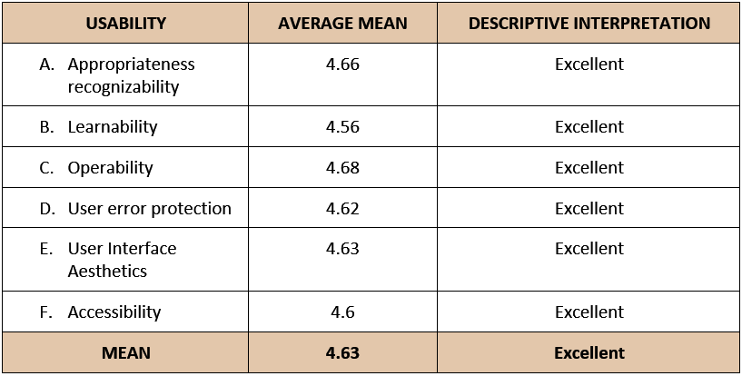

Table 18 provided an evaluation of software quality, specifically focusing on reliability. The data depicted in the table indicates that the system attained an average mean score of 4.55, indicating an Excellent rating. In the Reliability category, four (4) subsidiary aspects can be identified. The initial aspect is Maturity, which displayed an average score of 4.64. The second aspect, Availability, attained an average score of 4.52. The third aspect, Fault Tolerance, obtained an average score of 4.57. Lastly, Recoverability achieved an average score of 4.46. Each of these aspects has achieved an Excellent rating based on their respective results.

*Table 18.* Evaluation of Software Quality: Reliability

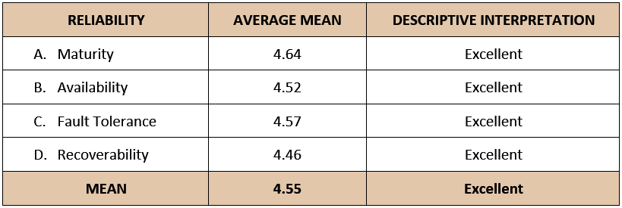

*Table 19.* Evaluation of Software Quality: Security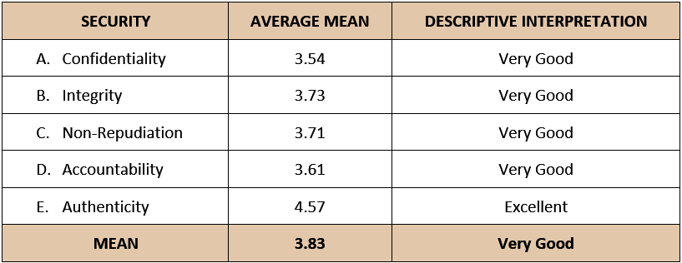

Table 19 provided an evaluation of software quality, specifically focusing on security. The data depicted in the table indicates that the system attained an average mean score of 3.83, indicating a very good rating. Within the Security category, there are five aspects, four of which achieved a Very Good rating, while the remaining aspect attained an Excellent rating. The first aspect, Confidentiality, obtained an average score of 3.54. The next aspect, Integrity, achieved an average score of 3.73. Non-Repudiation received an average score of 3.71, and Accountability scored 3.61. Lastly, the aspect of Authenticity achieved an average score of 4.57.

*Table 20.* Evaluation of Software Quality: Maintainability

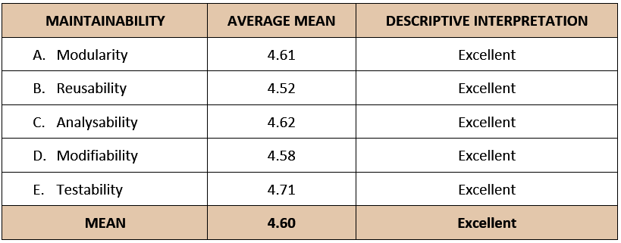

Table 20 provided an evaluation of software quality, specifically focusing on maintainability. The data depicted in the table indicates that the system attained an average mean score of 4.60, indicating an Excellent rating. In the Maintainability category, five (5) subsidiary aspects can be identified. The initial aspect is Modularity, which displayed an average score of 4.61. The second aspect, Reusability, attained an average score of 4.52. The third aspect, Analysability, obtained an average score of 4.62. Modifiability achieved an average score of 4.58. Lastly, Testability got 4.71. Each of these aspects has achieved an Excellent rating based on their respective results.

*Table 21.* Evaluation of Software Quality: Portability

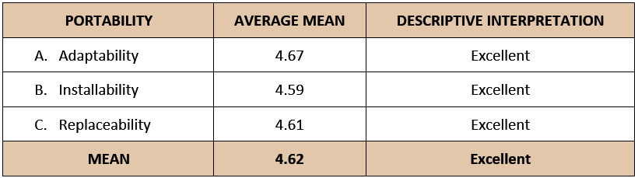

Table 21 provided an evaluation of software quality, specifically focusing on portability. The data depicted in the table indicates that the system attained an average mean score of 4.62, indicating an Excellent rating. In the Portability category, three (3) subsidiary aspects can be identified. The initial aspect is Adaptability, which displayed an average score of 4.67. The second aspect, Installability, attained an average score of 4.59. The third aspect, Replaceability, obtained an average score of 4.61. Each of these aspects has achieved an Excellent rating based on their respective results.

Table 22 provided an overall result of the project evaluation for the developed system, conducted in accordance with the ISO 25010:2011 standard. The evaluation yielded an overall average score of 4.50, indicating a Very Good rating. The evaluation results demonstrated that the Filipino Cursive Recognition and Writing Assistant using Natural Language Processing and Artificial Neural Network, satisfied the necessary requirements for evaluation. The capabilities of the developed system exhibited a very good performance, meeting the expectations of the respondents and rendering it highly suitable for tasks pertaining to writing in the Filipino Language. With such very good results, the system holds substantial potential in providing significant assistance to its target users.

*Table 22.* Summary of Project Evaluation

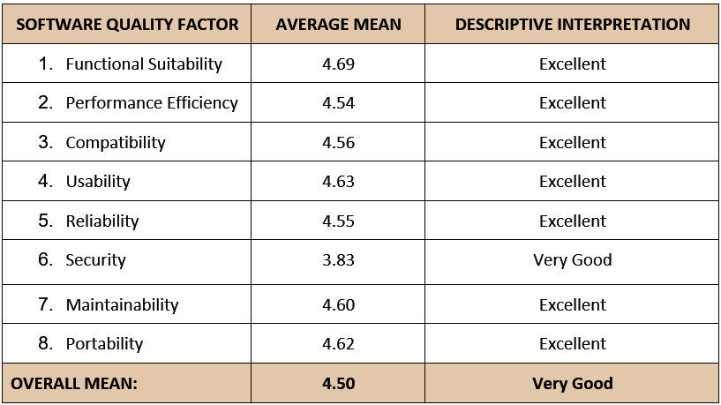

# **Chapter 5**

**SUMMARY OF FINDINGS, CONCLUSIONS, AND RECOMMENDATIONS**

This chapter included the discussion of summary of findings, conclusions, and recommendations.

**Summary of Findings**

Based on the analysis of data, the findings are as follows:

1. On the result of the evaluation of the Filipino Cursive Recognition and Writing Assistant using Natural Language Processing and Artificial Neural Network:
   1. ISO Quality Evaluation Criteria for Functional Suitability got an average mean of 4.69 with a descriptive interpretation of Excellent. The result substantiated that the developed system adequately supports and accomplishes designated tasks and user objectives, resulting in accurate outcomes.
   2. ISO Quality Evaluation Criteria for Performance Efficiency got an average mean of 4.54 with a descriptive interpretation of Excellent. The results of the evaluation indicate that the developed system exhibits reduced processing time for each module's operations and offers quicker loading times when moving in between various activities within the system.
   3. ISO Quality Evaluation Criteria for Compatibility got an average mean of 4.56 with a descriptive interpretation of Excellent. The outcomes indicate that the developed system effectively operates as intended and successfully accomplishes its designated tasks within a shared hardware or software environment.
   4. ISO Quality Evaluation Criteria for Usability got an average mean of 4.63 with a descriptive interpretation of Excellent. The results provide evidence that the system under consideration possesses the capability to be employed by individuals with specific characteristics or requirements, thereby enabling them to effectively pursue predetermined objectives within a carefully defined environment.
   5. ISO Quality Evaluation Criteria for Reliability got an average mean of 4.55 with a descriptive interpretation of Excellent. The findings reveal that the system meets the criteria for dependability during regular operation, ensuring its reliability, availability, fault tolerance and recoverability. It operates as intended, even in the presence of hardware or software limitations, promptly recovers any impacted data, and successfully restores the system to its desired state.
   6. ISO Quality Evaluation Criteria for Security got an average mean of 3.83 with a descriptive interpretation of Very Good. The results indicate that the developed system quite effectively secures users' information and data, with minimal need for improvements, but ensuring that access to data aligns with the appropriate types and levels of permissions granted to each user. With minimal suggestions, proponents made diligent efforts to enhance security measures, ensuring the utmost protection and confidentiality.
   7. ISO Quality Evaluation Criteria for Maintainability got an average mean of 4.60 with a descriptive interpretation of Excellent. The findings indicate that the developed system possesses the capability to be modified, maintained, improved, or reused in order to enhance its functionality and accommodate changes in the environment.
   8. ISO Quality Evaluation Criteria for Portability got an average mean of 4.62 with a descriptive interpretation of Excellent. The results indicate that it is portable and can adapt from specific devices.

## **Conclusions**

The following conclusions are gathered based on the evaluation:

1. The developed system was designed to be a mobile application that could recognize Filipino Cursive and could serve as a writing assistant through checking basic grammar structures and spellings of the user’s works.
2. The system was successfully created using Python, Kotlin, Android Studio, Firebase Realtime Database, Google ML Kit API, HTML, Php, CSS, and Windows Operating System for the software requirements and Mobile phone, Computer system, and Router for the hardware requirements.
3. The system was tested and improved in terms of functionality, reliability, and accuracy.
4. The performance of the developed system underwent evaluation by 100 respondents using the ISO 25010:2011 evaluation tool standard. The results revealed an overall mean rating of 4.50, indicating a Very Good performance level. This outcome demonstrated that the system effectively functions and performs well across various aspects, including funtionaly suitability, performance efficiency, compatibility, usability, reliability, security, maintainability, and portability.

## **Recommendations**

Based on the foregoing conclusions, the following are recommended for the further improvement of the project.

1. Integration of other Philippine dialects and the ancient script known as baybayin into the project.
2. To allow the user to upload different file formats.
3. To create a more accurate and maintainable Filipino spelling checker.
4. To implement a backup system and other safety precautions for the project’s information to mitigate the impact of possible downtime of database.

## **Bibliography**

Academic Guides: Grammarly: Overview. (2022). Academic Guides.

*Android Studio - javatpoint*. (n.d.). www.javatpoint.com. https://www.javatpoint.com/android-studio

BOOMTOWN, D. (2020, August 26). *WHAT DOES IT MEAN TO BE ISO /IEC 17025 ACCREDITED AND WHY IS IT IMPORTANT FOR CHEM SERVICE?* CHEM SERVICE INC. Retrieved from<https://www.chemservice.com/news/what-does-it-mean-to-be-iso-iec-17025-accredited/>

*Cascading Style Sheets*. (n.d.). https://www.w3.org/Style/CSS/Overview.en.html

Company, A. A. D. (2021, December 11). *Why Android Studio is Awesome ? - Agicent App Development Company*. Medium. https://medium.com/@agicent/why-android-studio-is-awesome-c606c94366e6

Computer Hope. (2022, December 31). What is Windows? https://www.computerhope.com/jargon/w/windows.htm

Contributor, T. (2018, October 9). *Android Studio*. Mobile Computing. https://www.techtarget.com/searchmobilecomputing/definition/Android-Studio

Contributor, T. (2019, August 15). *unit testing*. SearchSoftwareQuality. https://searchsoftwarequality.techtarget.com/definition/unit-testing#:%7E:text=Unit%20testing%20is%20a%20software,developers%20and%20sometimes%20QA%20staff.

Contributor, T. (2019, August 15). *unit testing*. SearchSoftwareQuality. https://searchsoftwarequality.techtarget.com/definition/unit-testing#:%7E:text=Unit%20testing%20is%20a%20software,developers%20and%20sometimes%20QA%20staff.

*CSS (Cascading Style Sheet) Definition*. (n.d.). https://techterms.com/definition/css

*CSS: Cascading Style Sheets | MDN*. (2022, September 25). https://developer.mozilla.org/en-US/docs/Web/CSS

Cursive - Definition, Meaning & Synonyms. (n.d.). In *Vocabulary.com*. https://www.vocabulary.com/dictionary/cursive

*Firebase Realtime Database - Javatpoint*. (n.d.). www.javatpoint.com. https://www.javatpoint.com/firebase-realtime-database

*Firebase Realtime Database*. (n.d.). Firebase. https://firebase.google.com/docs/database

Grammary, (2020, July 10). What is a Writing Assistant? - https://www.grammarly.com/blog/writing-assistant/

Hamilton, T. (2021, December 27). *GUI Testing Tutorial: User Interface (UI) TestCases with Examples*. Guru99. https://www.guru99.com/gui-testing.html

Hamilton, T. (2021, December 27). *GUI Testing Tutorial: User Interface (UI) TestCases with Examples*. Guru99. https://www.guru99.com/gui-testing.html

Heller, M. (2022, October 14). *What is Kotlin? The Java alternative explained*. InfoWorld. https://www.infoworld.com/article/3224868/what-is-kotlin-the-java-alternative-explained.html

*HTML: HyperText Markup Language | MDN*. (2023, January 18). https://developer.mozilla.org/en-US/docs/Web/HTML

https://academicguides.waldenu.edu/writingcenter/grammarly#:%7E:text=Grammarly%20is%20a%20third%2Dparty,not%20affiliated%20with%20Walden%20University.

*Importance Of Computer System - 1424 Words | Internet Public Library*. (n.d.). https://www.ipl.org/essay/Importance-Of-Computer-System-FJDXRXSWU

*Introduction to Python*. (n.d.). https://www.w3schools.com/python/python_intro.asp

*ISO/IEC 25010:2011*. (2018, March 21). ISO. Retrieved from<https://www.iso.org/standard/35733.html>

Kalita, D. (2022, April 6). *An Overview and Applications of Artificial Neural Networks*. Analytics Vidhya. https://www.analyticsvidhya.com/blog/2022/03/an-overview-and-applications-of-artificial-neural-networks-ann/

 Khurana, D., Koli, A., Khatter, K., & Singh, S. (2022, July 25). *Natural language processing: State of the art, current trends and challenges - multimedia tools and applications*. SpringerLink. Retrieved January 12, 2023, from https://link.springer.com/article/10.1007/s11042-022-13428-4

Languages, L. L. (2022, January 6). *Easy Tagalog Grammar: An Epic Guide For 2021! - Ling Learn Languages*. Medium. ps://ling-app.medium.com/easy-tagalog-grammar-an-epic-guide-for-2021-463e52cb952bhtt

*Learn MySQL Tutorial - javatpoint*. (n.d.). www.javatpoint.com. https://www.javatpoint.com/mysql-tutorial

Links, R. (n.d.). *What is mobile development?* ServiceNow. Retrieved January 15, 2023, https://www.servicenow.com/workflows/creator-workflows/what-is-mobile-development.html#:~:text=A%20mobile%20development%20platform%20is,top%20contenders%3A%20Android%20and%20iOS.

Loshin, P., & Steele, C. (2021, October 29). *ISO (International Organization for Standardization)*. SearchDataCenter. Retrieved from<https://searchdatacenter.techtarget.com/definition/ISO#:%7E:text=ISO%20(International%20Organization%20for%20Standardization)%20is%20a%20worldwide%20federation%20of,body%20representing%20each%20member%20country>.

Lutkevich, B. (2020, February 17). *HTML (Hypertext Markup Language)*. TheServerSide.com. https://www.theserverside.com/definition/HTML-Hypertext-Markup-Language

Meel, V. (2022b, August 12). *Image Recognition: The Basics and Use Cases (2022 Guide)*. viso.ai. <https://viso.ai/computer-vision/image-recognition/>

*Mobile Application Development*. (n.d.). Amazon Web Services, Inc. https://aws.amazon.com/mobile/mobile-application-development/

MongoDB. (n.d.). *What Is A Non-Relational Database?* https://www.mongodb.com/databases/non-relational

Morris, S. (2022, July 15). *What Is Python Used For? 5 Industries That Can’t Do Without It*. Skillcrush. https://skillcrush.com/blog/what-is-python-used-for/

*MySQL Tutorial*. (n.d.). https://www.w3schools.com/MySQL/default.asp

*Neural Networks*. (2021, August 4). https://www.ibm.com/ae-en/cloud/learn/neural-networks

Pepper, T. (2022, May 16). *What Is An AI Writing Assistant, And How Is It Beneficial?* Pepper Content. https://www.peppercontent.io/blog/ai-writing-assistant/

*PHP: What is PHP? - Manual*. (n.d.). https://www.php.net/manual/en/intro-whatis.php

Ptucha, R., Petroski Such, F., Pillai, S., Brockler, F., Singh, V., & Hutkowski, P. (2019). Intelligent character recognition using fully convolutional neural networks. *Pattern Recognition*, *88*, 604–613. <https://doi.org/10.1016/j.patcog.2018.12.017>

Rory, R. (2022, May 18). *What is PHP? Uses & Introduction*. Code Institute NL. https://codeinstitute.net/nl/blog/what-is-php-programming/

SPEC INDIA. (2023, January 3). Top Examples Of Popular Apps Built With Kotlin. https://www.spec-india.com/blog/top-apps-built-with-kotlin

Talend. (n.d.). *What is MySQL? Everything You Need to Know*. Talend - a Leader in Data Integration & Data Integrity. https://www.talend.com/resources/what-is-mysql/

Team, C. (2022, November 1). What Is Kotlin Used For? Codecademy News. https://www.codecademy.com/resources/blog/what-is-kotlin-used-for/

Techopedia. (2020, June 2). *Computer System*. Techopedia.com. https://www.techopedia.com/definition/593/computer-system

Techopedia. (2022, August 10). *Mobile Phone*. Techopedia.com. https://www.techopedia.com/definition/2955/mobile-phone

*Text recognition v2: supported languages | ML Kit | Google for Developers*. (n.d.). Google for Developers. https://developers.google.com/ml-kit/vision/text-recognition/v2/languages

*The Computer System*. (n.d.). https://peda.net/kenya/ass/subjects2/computer-studies/form-1/the-computer-system

The Editors of Encyclopaedia Britannica. (2022, November 25). grammar. Encyclopedia Britannica. [https://www.britannica.com/topic/gramma](https://www.britannica.com/topic/grammar)r

*What is a router, and how does it work?* (n.d.). <https://us.norton.com/blog/iot/smarter-home-what-is-router>

*What is Activity Diagram?* (n.d.). https://www.visual-paradigm.com/guide/uml-unified-modeling-language/what-is-activity-diagram/

*What is Router - javatpoint*. (n.d.). www.javatpoint.com. [https://www.javatpoint.com/route](https://www.javatpoint.com/router)r

Windows Definition. (2021, May 27). https://techterms.com/definition/windows

**APPENDIX A**

**Title Proposal**

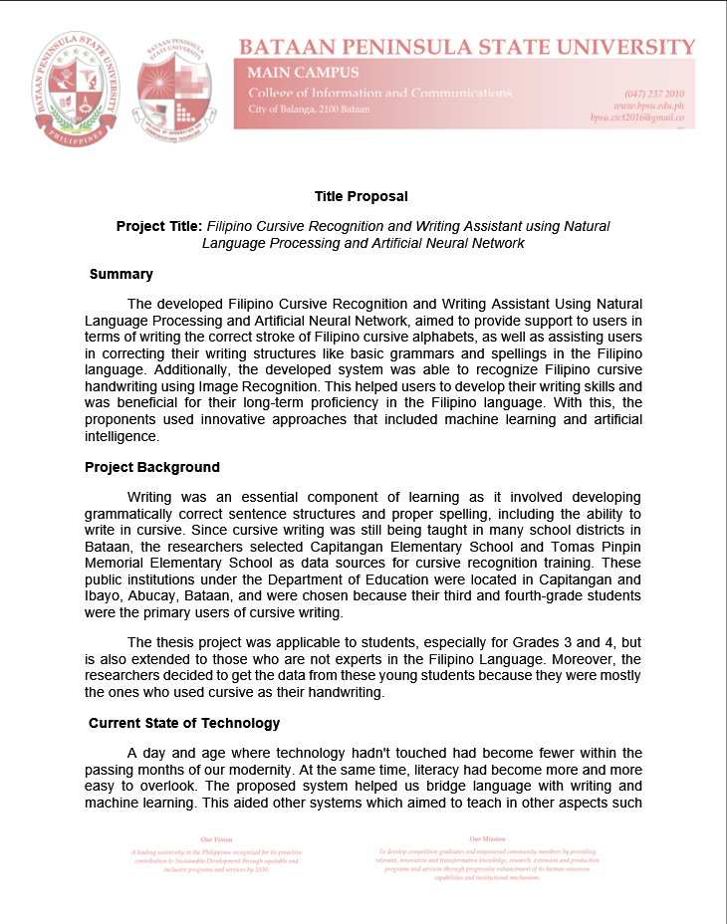

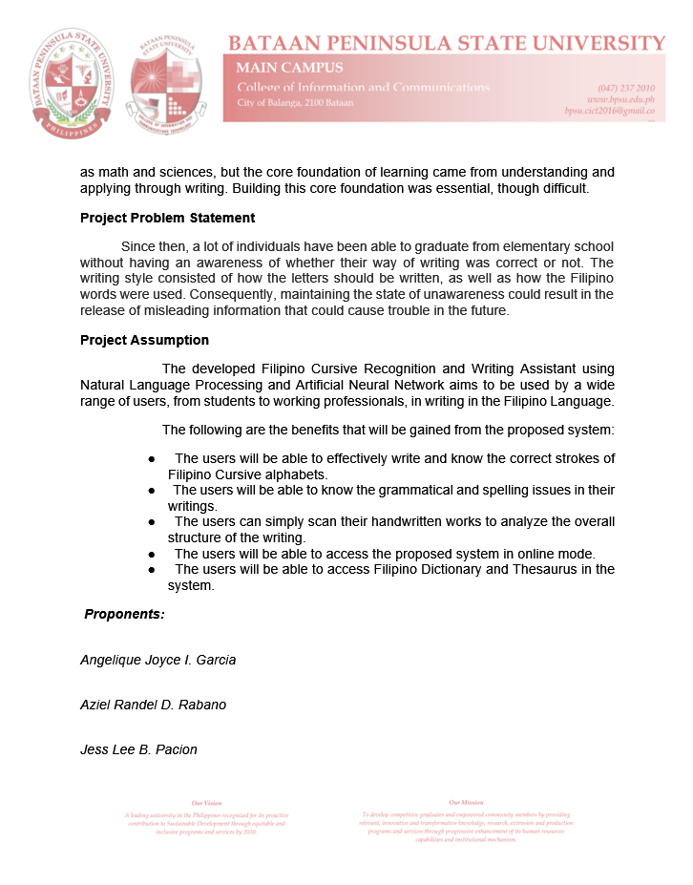

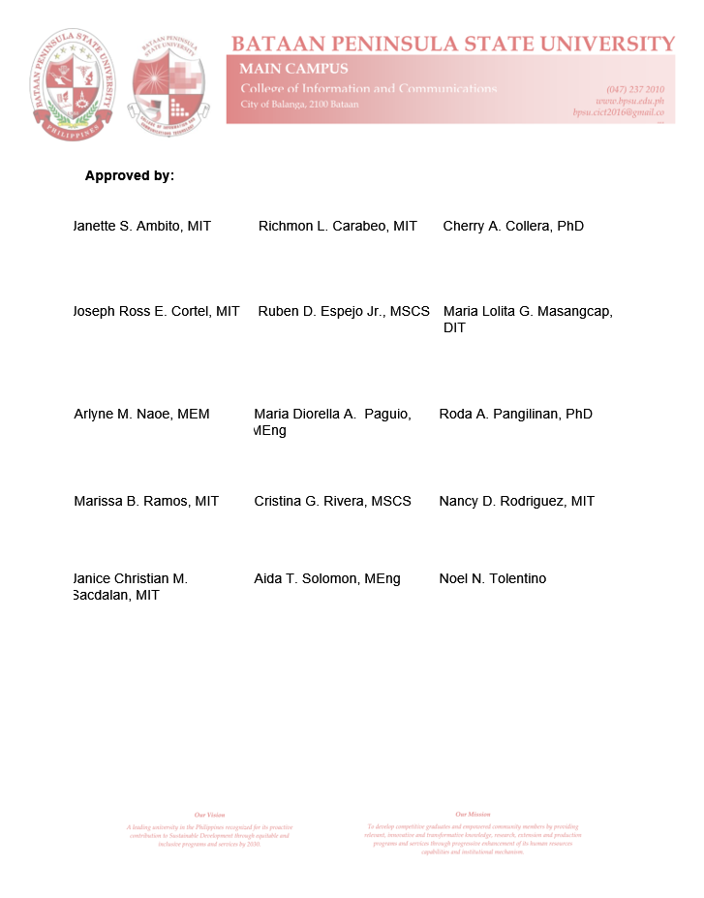

**APPENDIX B**

**Transcript of Interview**

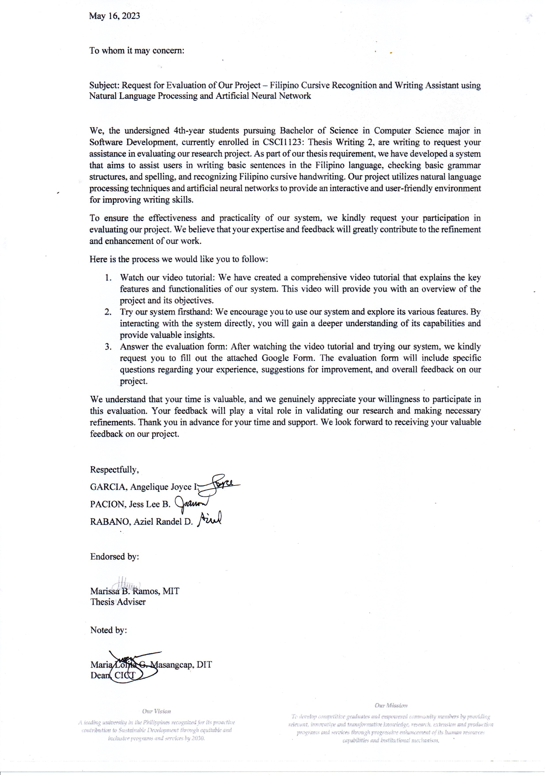

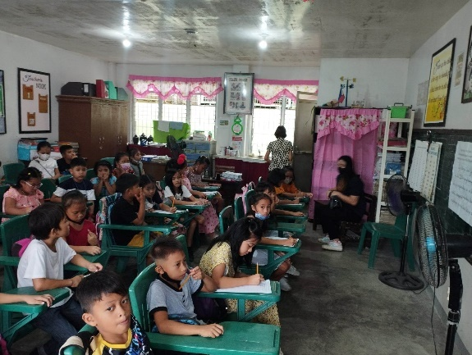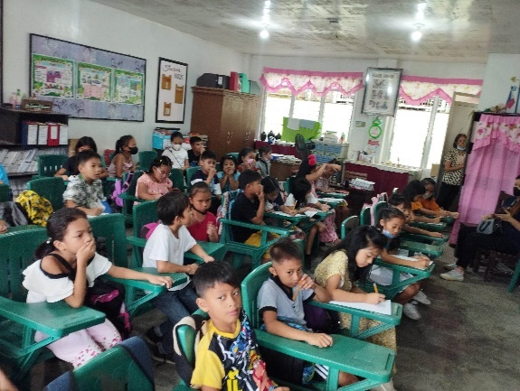

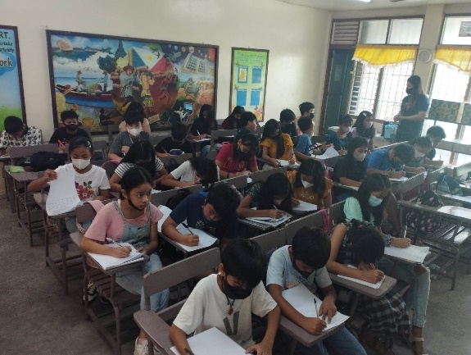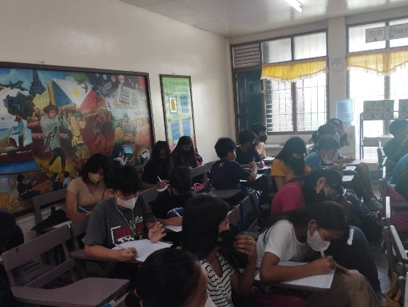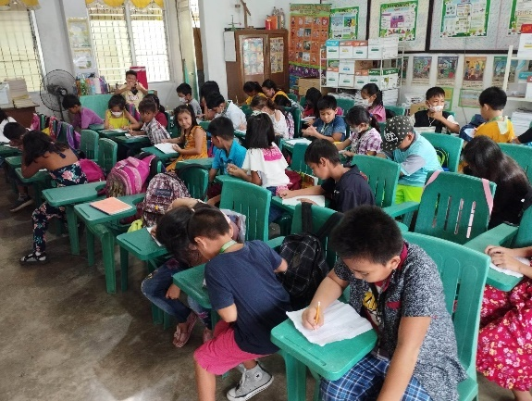

**APPENDIX C**

**Topical Outline**

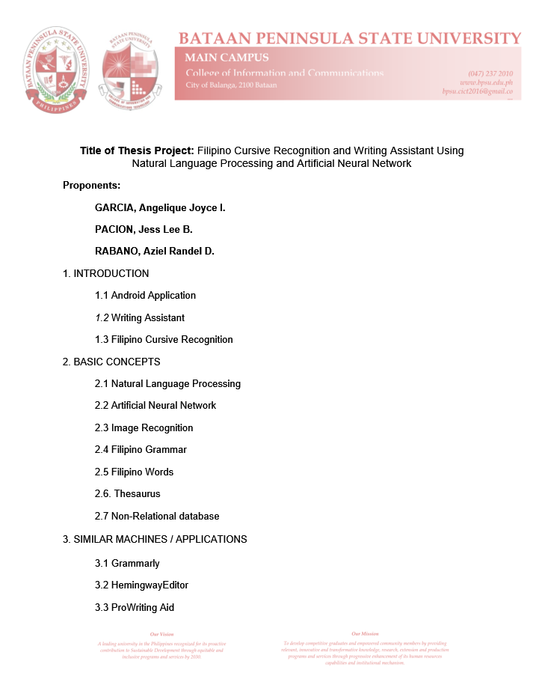

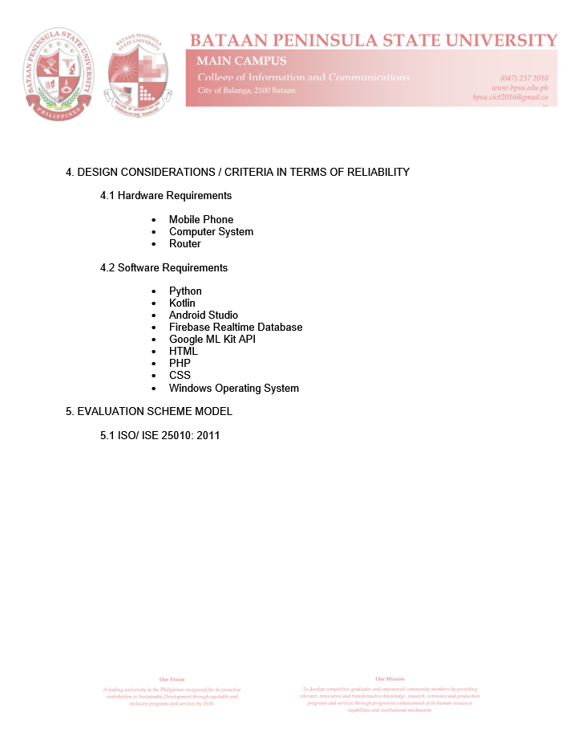

**APPENDIX D**

**Evaluation Instrument**

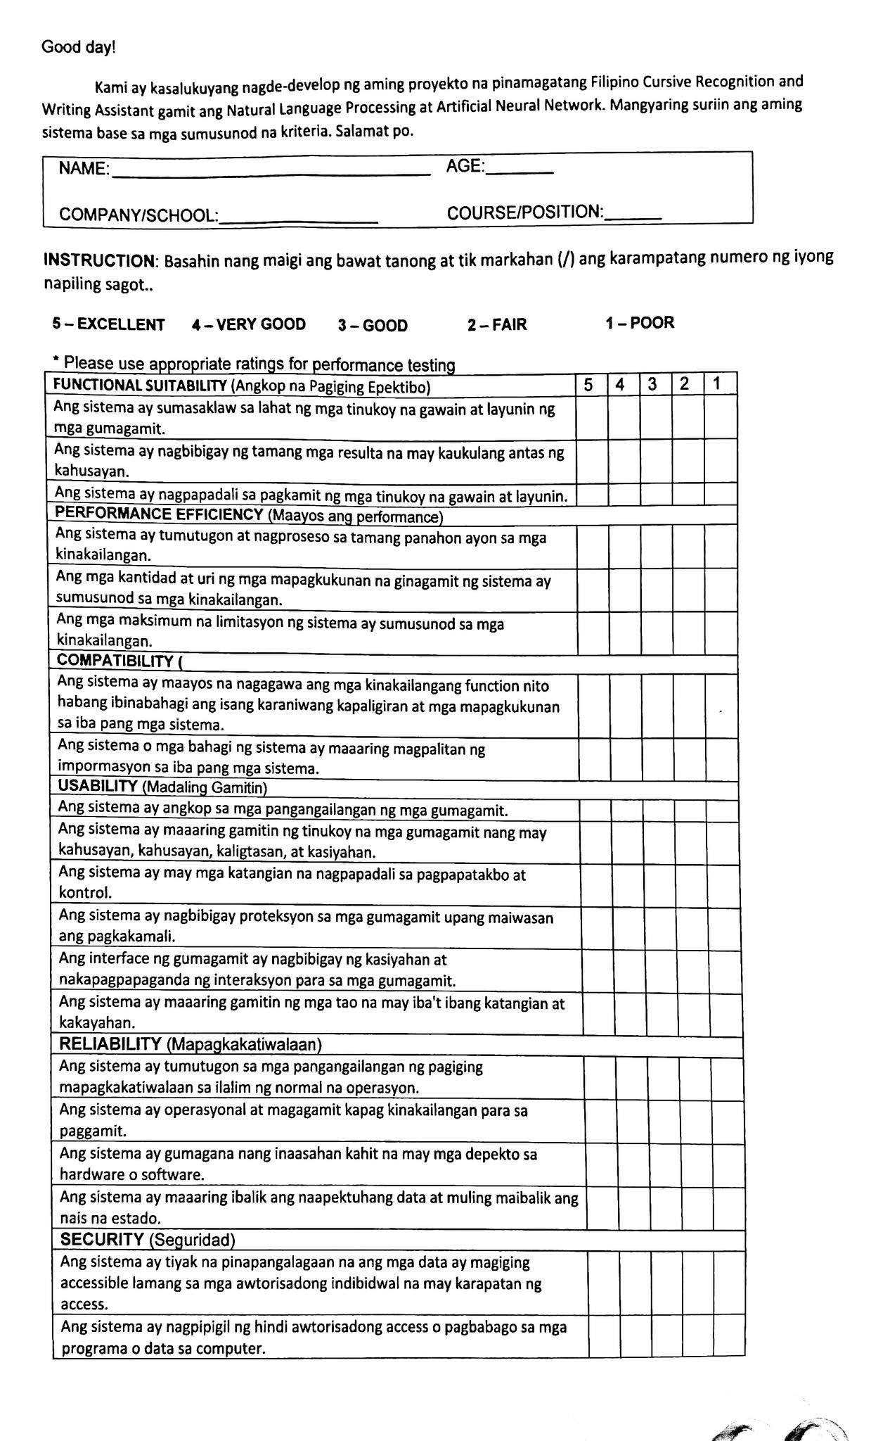

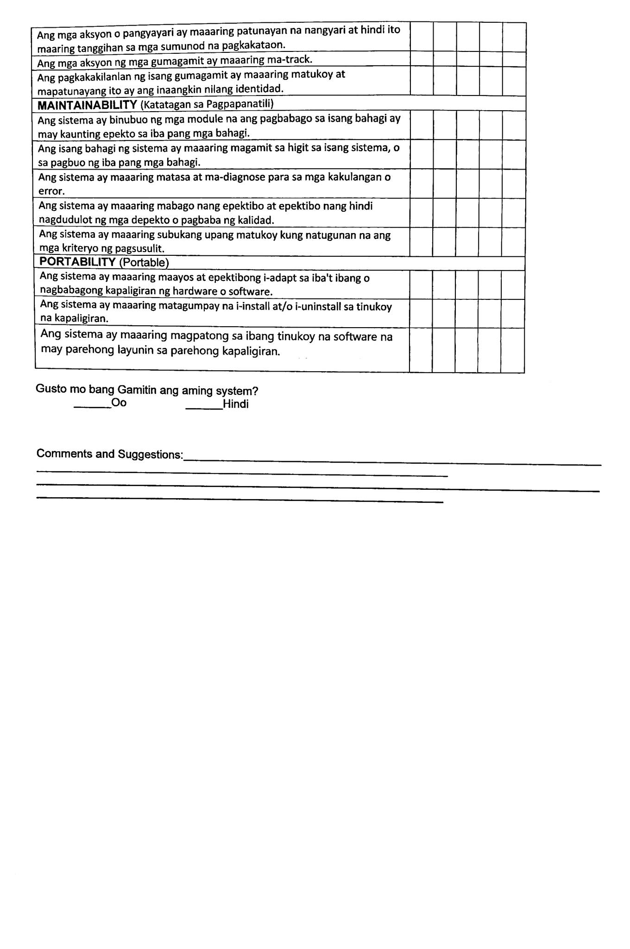

Good day!

We are currently developing our project entitled *Filipino Cursive Recognition and Writing Assistant Using Natural Language Algorithm and Artificial Neural Network*. Please evaluate our system based on the criteria below. Thank you.

|  |  |  |  |  |
| --- | --- | --- | --- | --- |
| |  |  | | --- | --- | | NAME: | AGE: | | COMPANY/SCHOOL: | COURSE/POSITION: | |

**INSTRUCTION**: Read each question carefully and check (**/**) the corresponding number of choice.

|  |  |  |  |  |  |  |  |  |  |
| --- | --- | --- | --- | --- | --- | --- | --- | --- | --- |
| **5 – EXCELLENT** | **4 – VERY GOOD** | **3 – GOOD** | **2 – FAIR** | | **1 – POOR** | | | | |
| * Please use appropriate ratings for performance testing | | | | | | | | | |
| **FUNCTIONAL SUITABILITY** | | | | 5 | | 4 | 3 | 2 | 1 |
| The system covers all the specified tasks and user objectives. | | | |  | |  |  |  |  |
| The system provides the correct results with the needed degree of precision | | | |  | |  |  |  |  |
| The system facilitates the accomplishment of specified tasks and objectives. | | | |  | |  |  |  |  |
| **PERFORMANCE EFFICIENCY** | | | | | | | | | |
| The response and processing times of the system meet the requirements. | | | |  | |  |  |  |  |
| The amounts and types of resources used by the system meet requirements | | | |  | |  |  |  |  |
| The maximum limits of the system meet requirements. | | | |  | |  |  |  |  |
| **COMPATIBILITY** | | | | | | | | | |
| The system can perform its required functions efficiently while sharing a common environment and resources with other systems. | | | |  | |  |  |  |  |
| The system or system components can exchange information to other systems. | | | |  | |  |  |  |  |
| **USABILITY** | | | | | | | | | |
| The system is appropriate to the needs of the user. | | | |  | |  |  |  |  |
| The system can be used by specified users with effectiveness, efficiency, freedom from risk and satisfaction. | | | |  | |  |  |  |  |
| The system has attributes that make it easy to operate and control. | | | |  | |  |  |  |  |
| The system protects users from making errors. | | | |  | |  |  |  |  |
| The user interface enables pleasing and satisfying interaction for the user. | | | |  | |  |  |  |  |
| The system can be used by people with the widest range of characteristics and capabilities. | | | |  | |  |  |  |  |
| **RELIABILITY** | | | | | | | | | |
| The system meets needs for reliability under normal operation. | | | |  | |  |  |  |  |
| The system is operational and accessible when required for use. | | | |  | |  |  |  |  |
| The system operates as intended despite the presence of hardware or software faults. | | | |  | |  |  |  |  |
| The system can recover affected data and re-establish the desired state. | | | |  | |  |  |  |  |
| **SECURITY** | | | | | | | | | |
| The system ensures that data are accessible only to those authorized to have access. | | | |  | |  |  |  |  |
| The system prevents unauthorized access to, or modification of, computer programs or data. | | | |  | |  |  |  |  |
| The actions or events can be proven to have taken place and cannot be rejected later. | | | |  | |  |  |  |  |
| The actions of users can be traced. | | | |  | |  |  |  |  |
| The identity of a user can be authenticated and proved to be the one claimed. | | | |  | |  |  |  |  |
| **MAINTAINABILITY** | | | | | | | | | |
| The system is composed of modules such that a change to one component has minimal impact on other components. | | | |  | |  |  |  |  |
| A system component can be used in more than one system, or in building other components. | | | |  | |  |  |  |  |
| The system can be assessed and diagnosed for deficiencies or errors. | | | |  | |  |  |  |  |
| The system can be effectively and efficiently modified without introducing defects or degrading quality. | | | |  | |  |  |  |  |
| The system can be tested to determine whether test criteria have been met. | | | |  | |  |  |  |  |
| **PORTABILITY** | | | | | | | | | |
| The system can effectively and efficiently be adapted for different or evolving hardware or software environments. | | | |  | |  |  |  |  |
| The system can be successfully installed and/or uninstalled in a specified environment. | | | |  | |  |  |  |  |
| The system can replace another specified software product for the same purpose in the same environment. | | | |  | |  |  |  |  |

Are you in favor of implementing the *Title of the System*

YES NO

Comments and Suggestions:

________________________________________________________________________________________________________________________________________________________

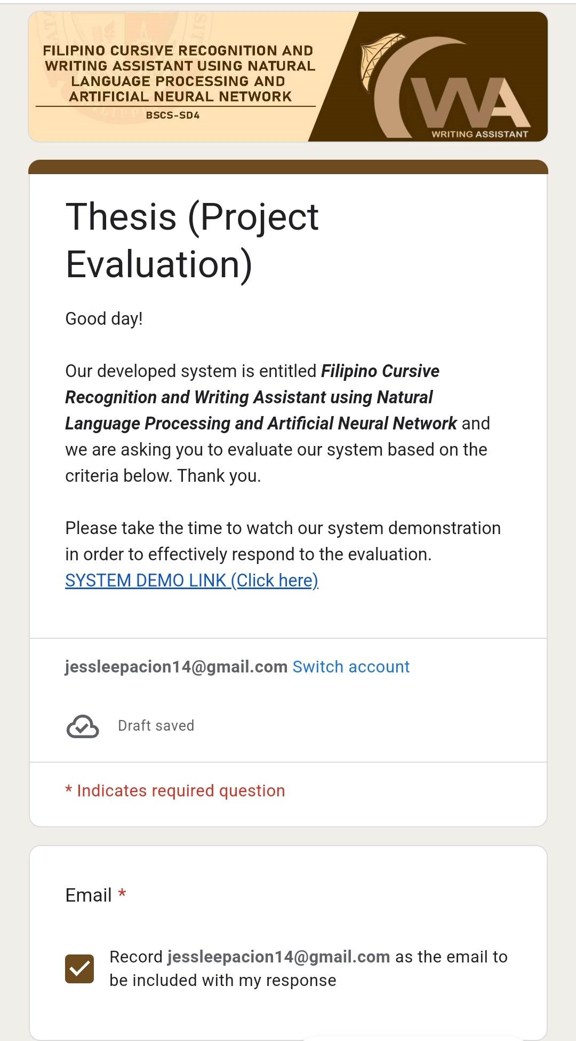 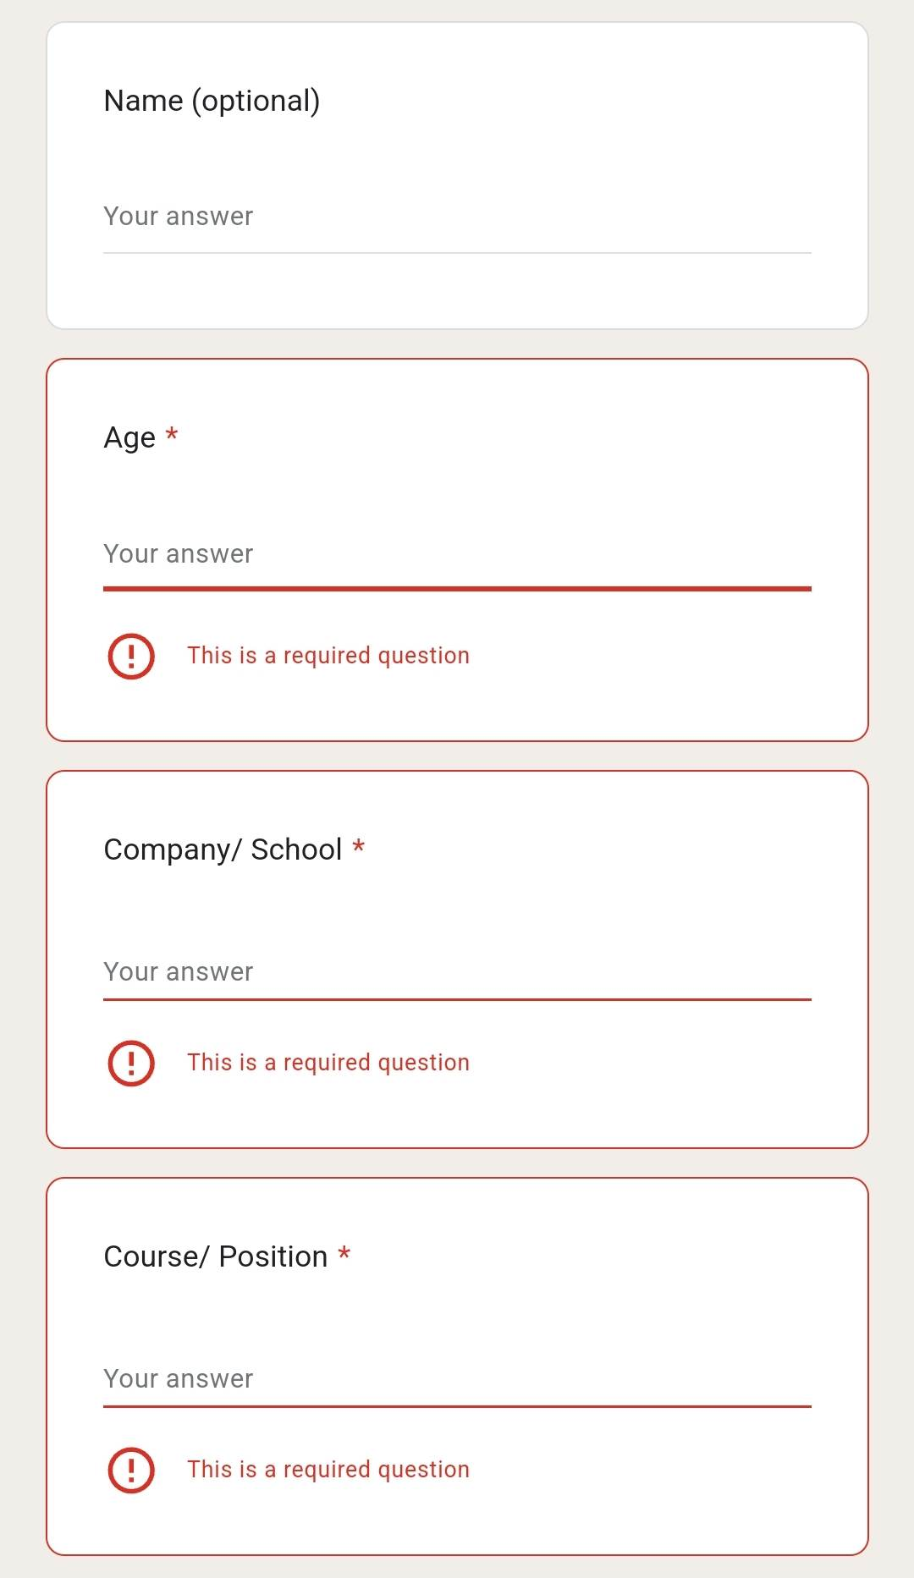

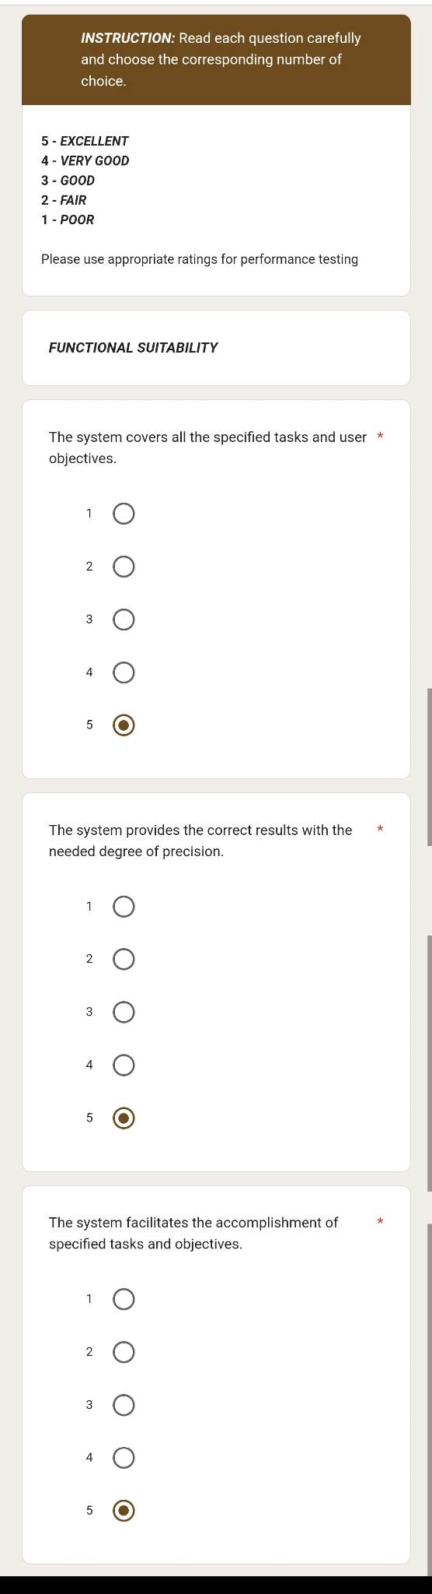 

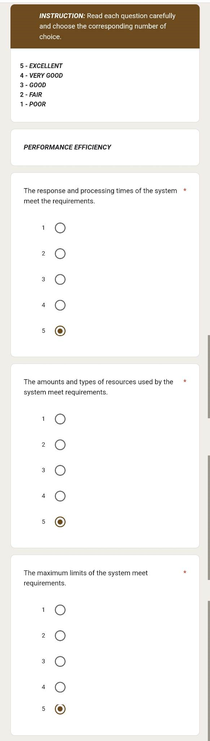 

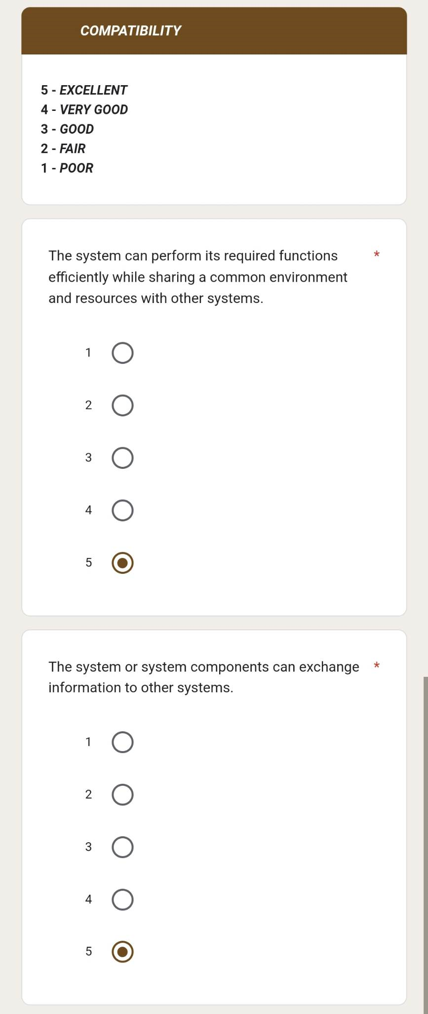

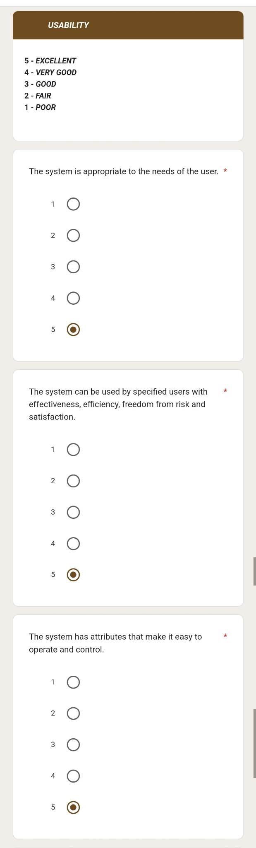 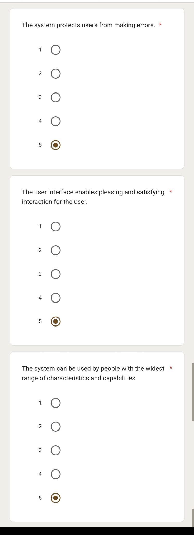

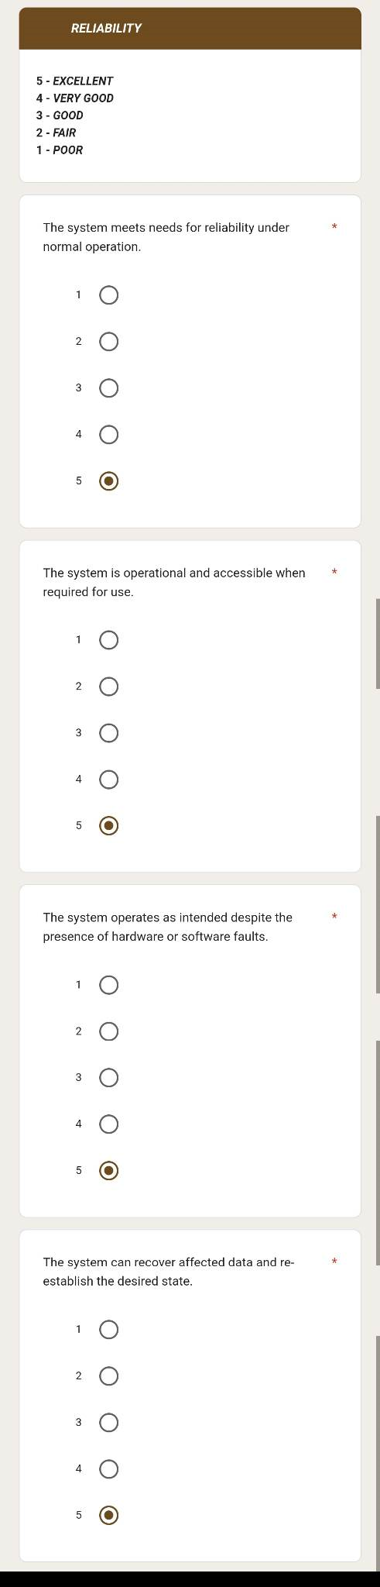 

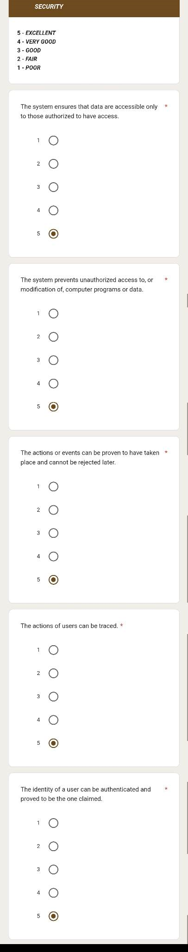 

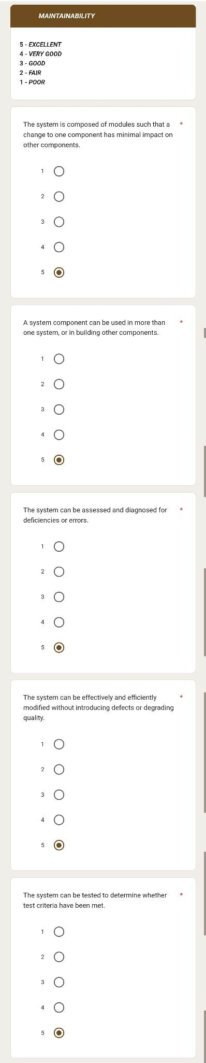 

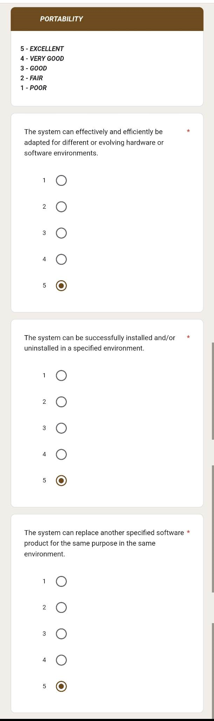 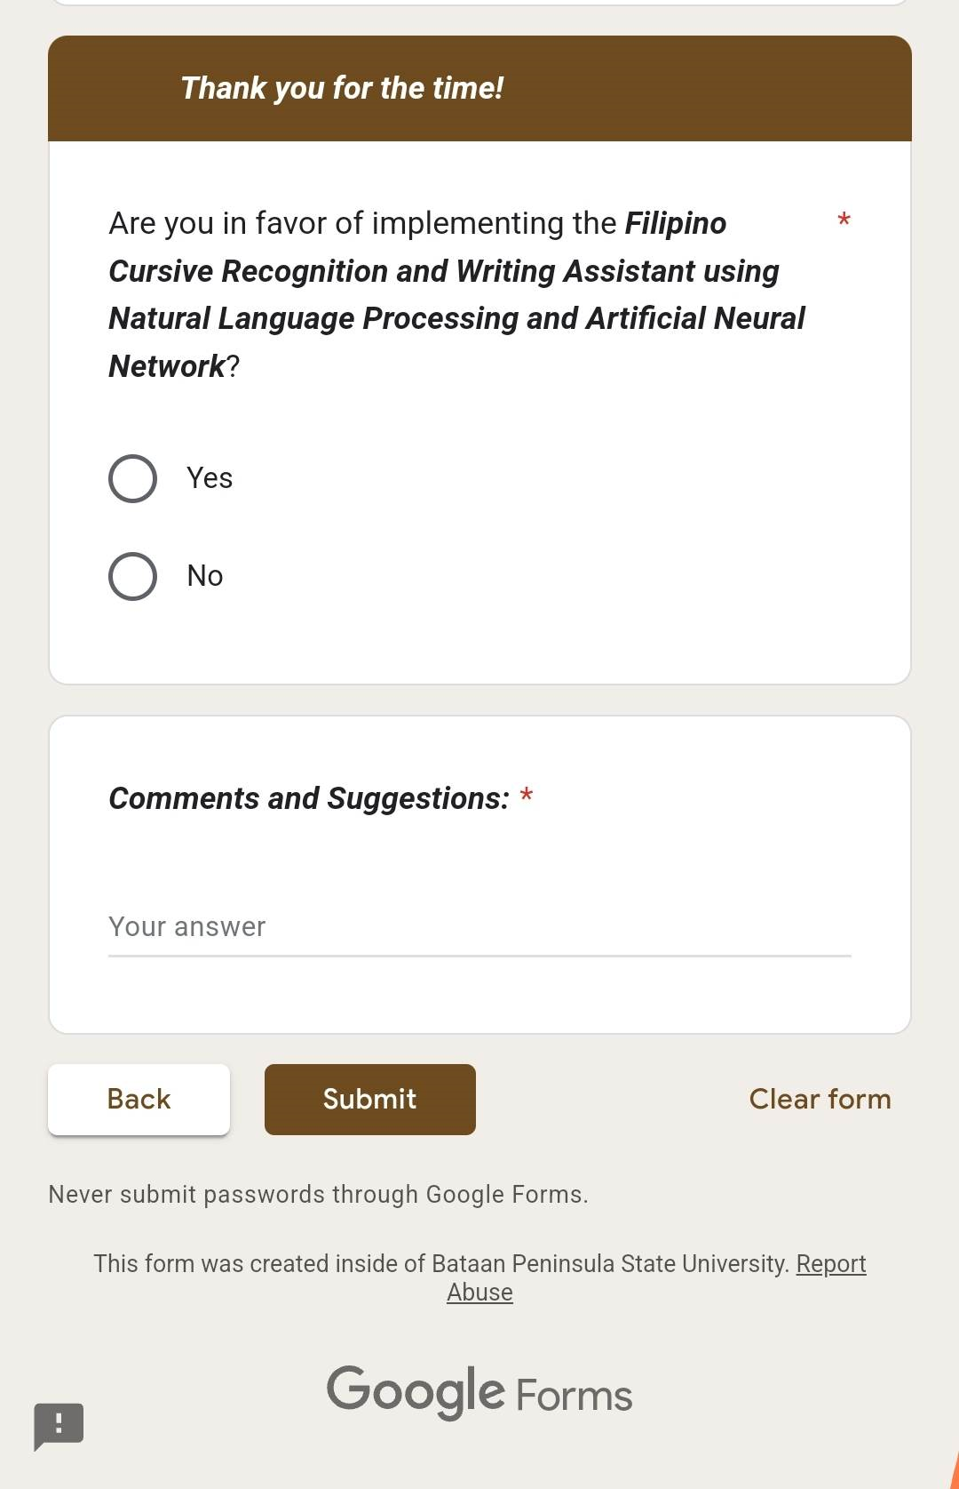

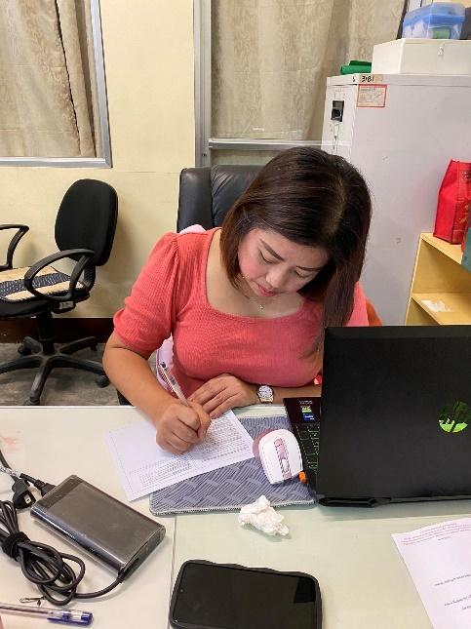 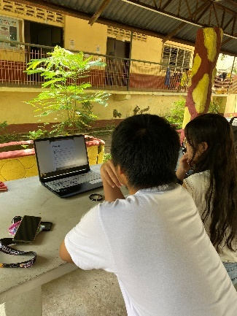 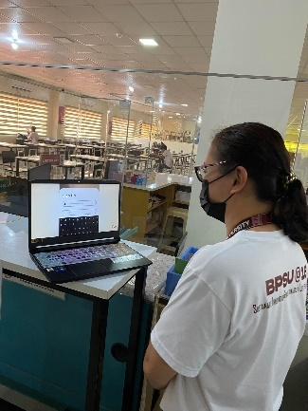

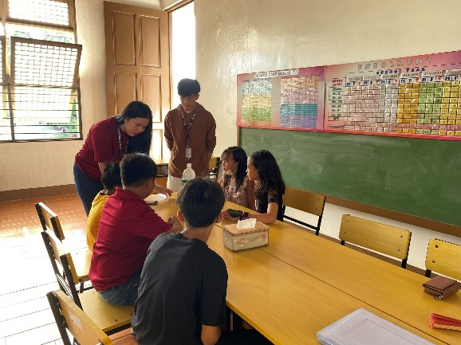 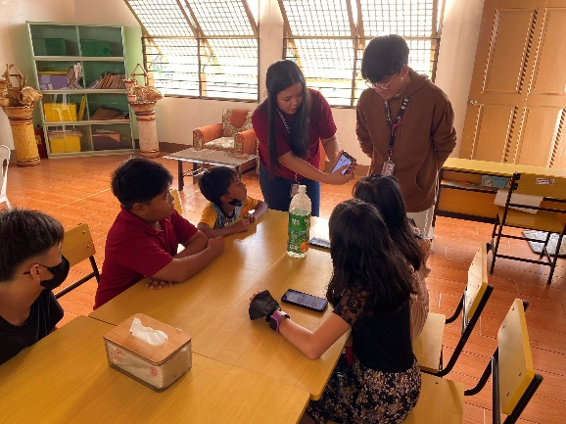

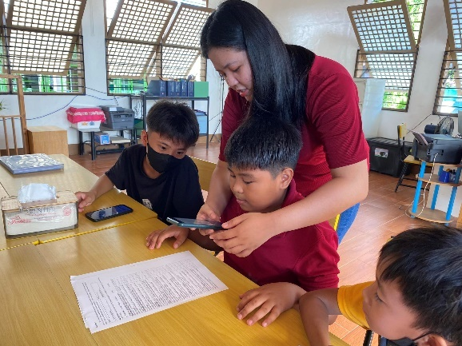 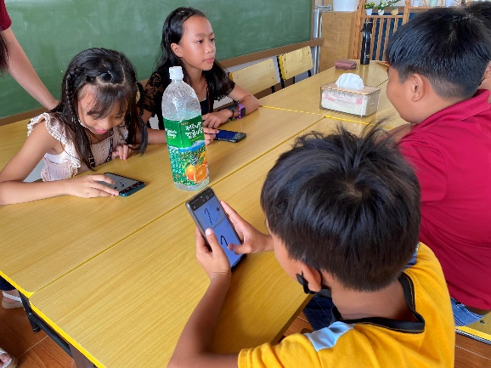

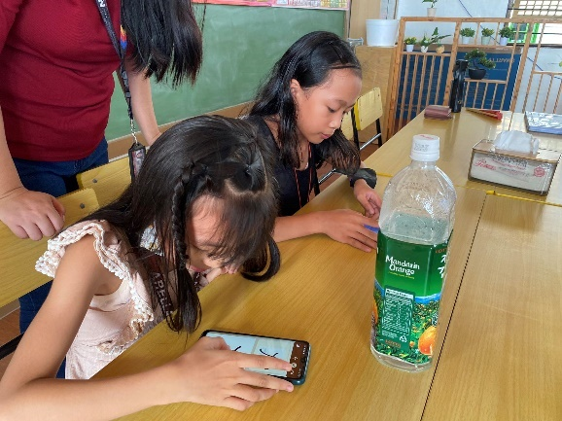 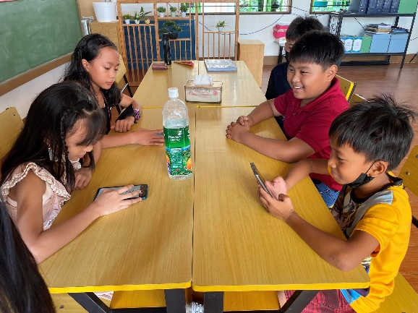

**APPENDIX E**

**Summary of Evaluation Results**

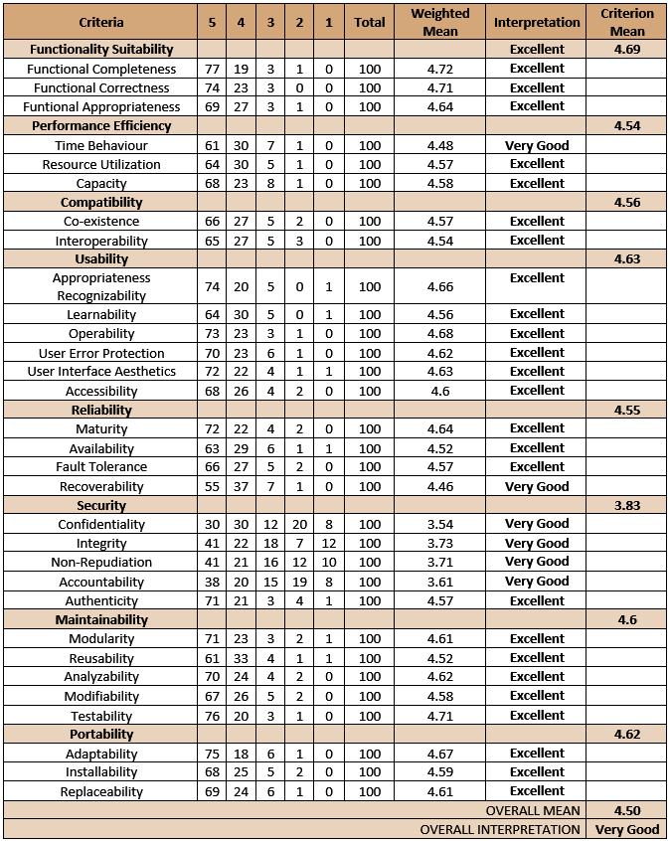

**APPENDIX F**

**Progress Report**

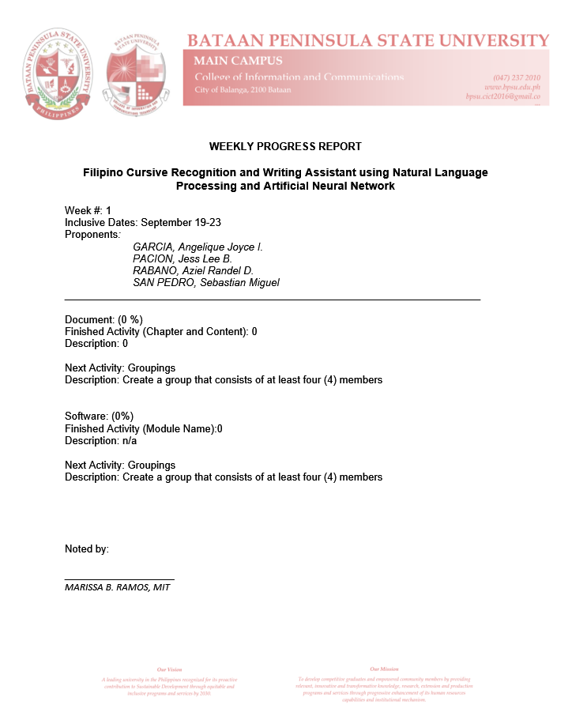

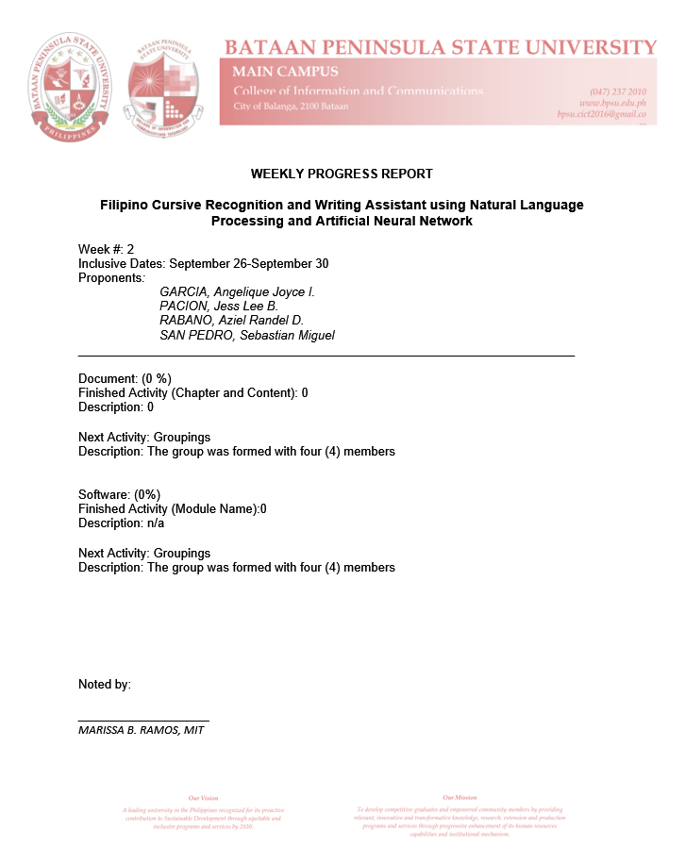

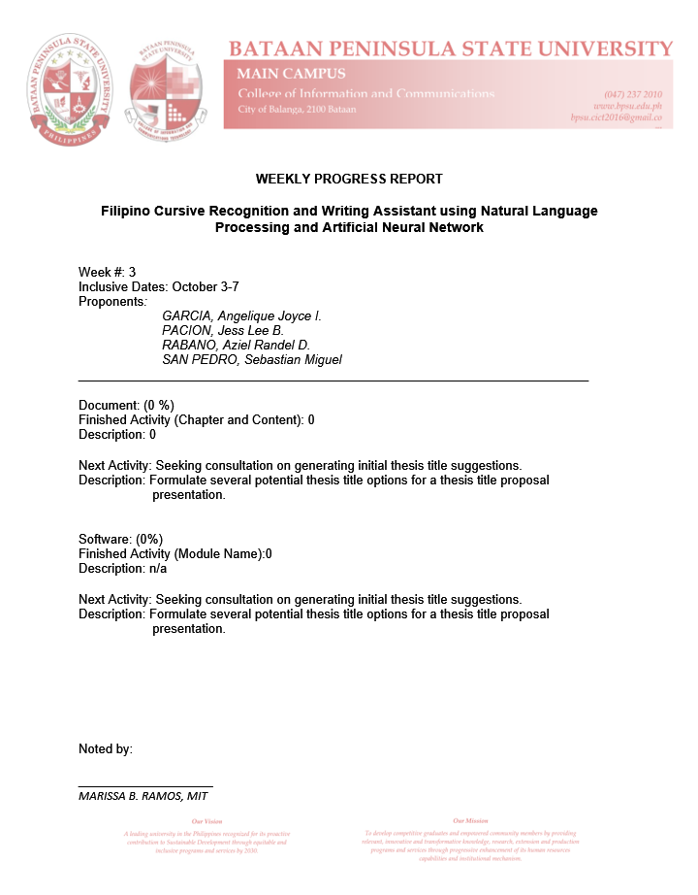

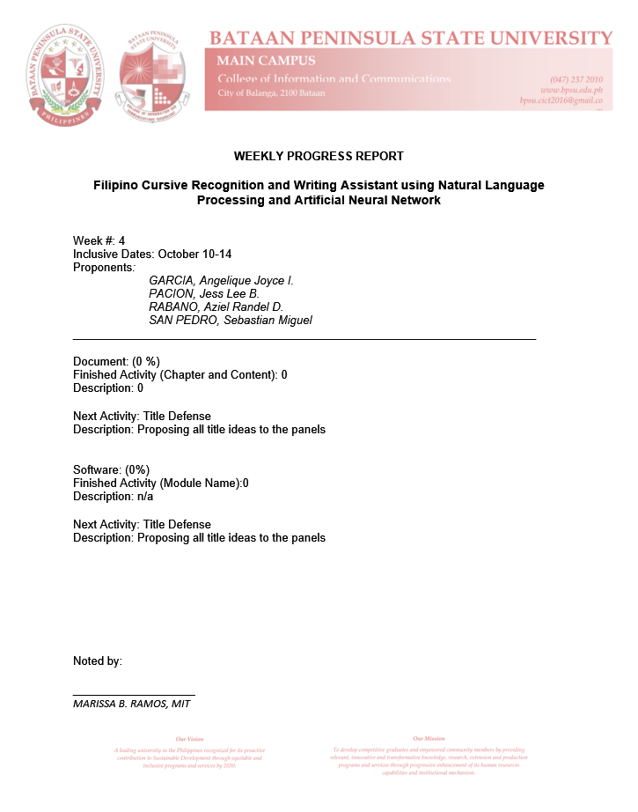

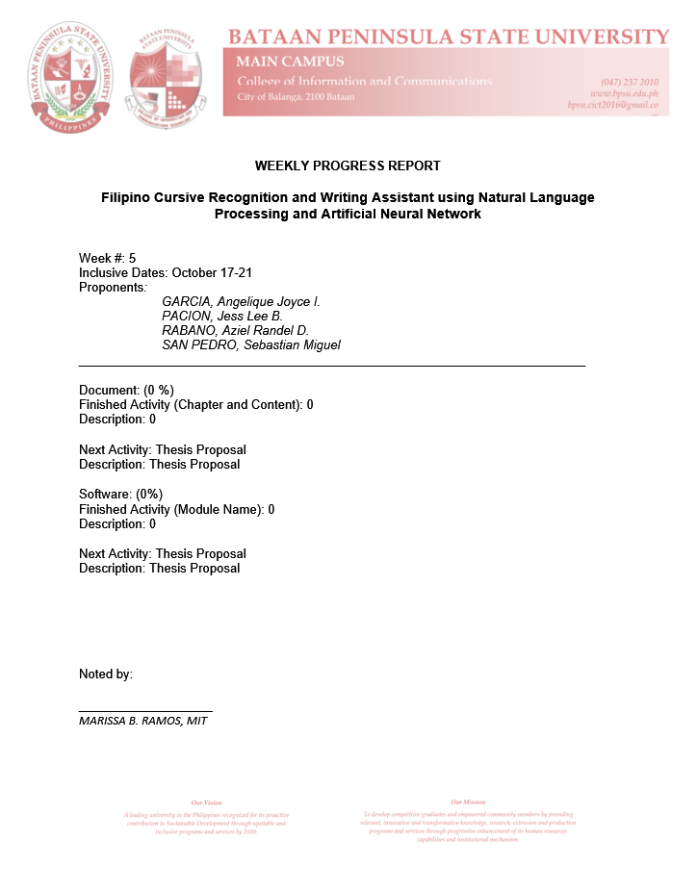

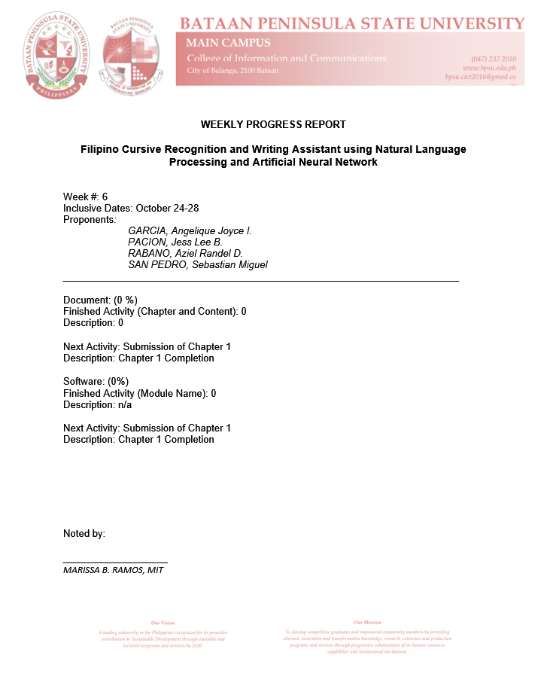

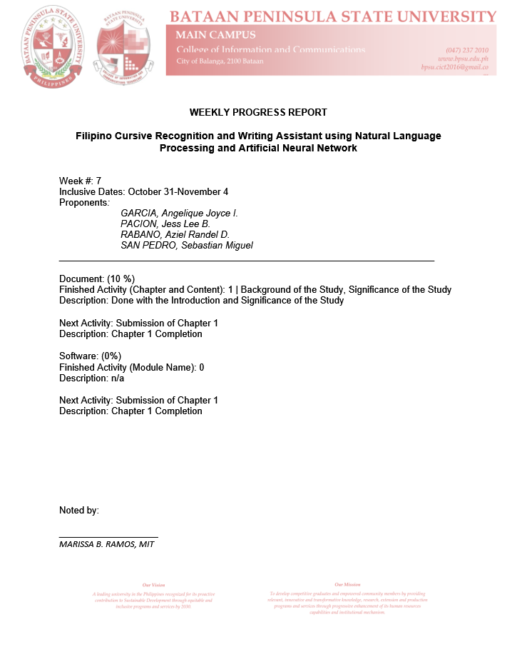

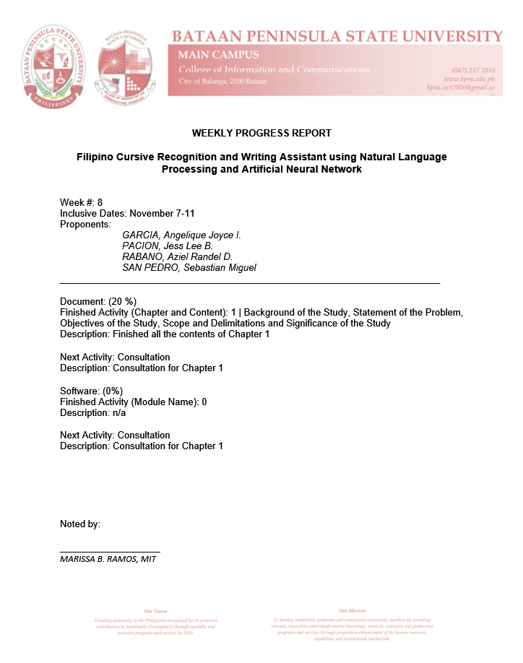

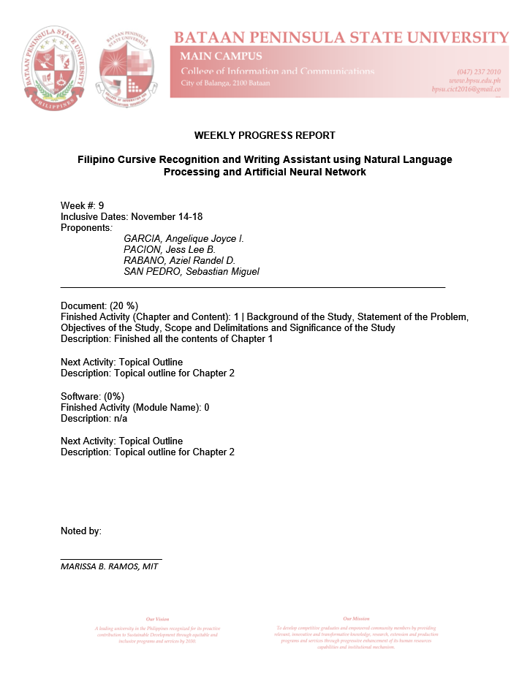

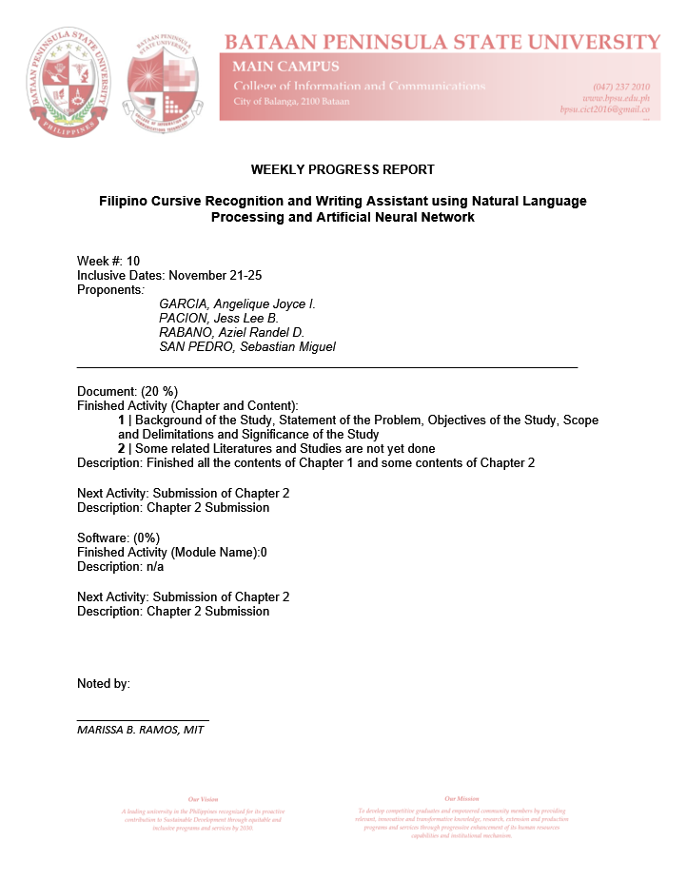

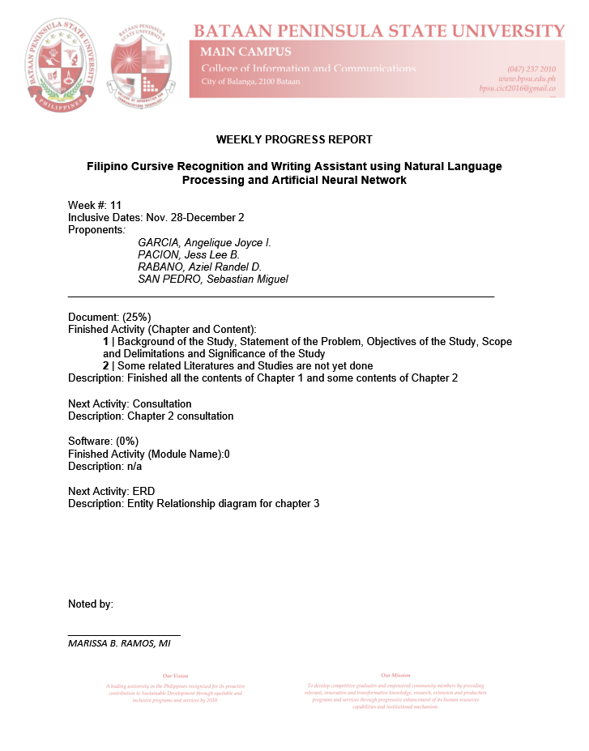

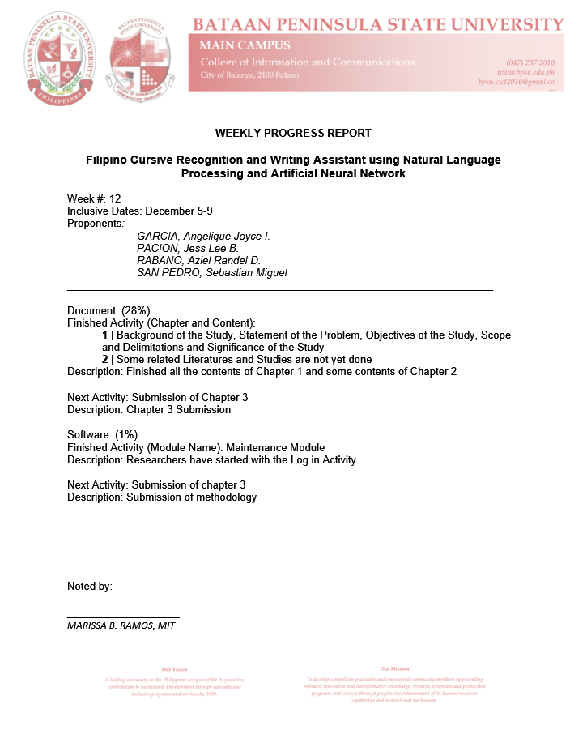

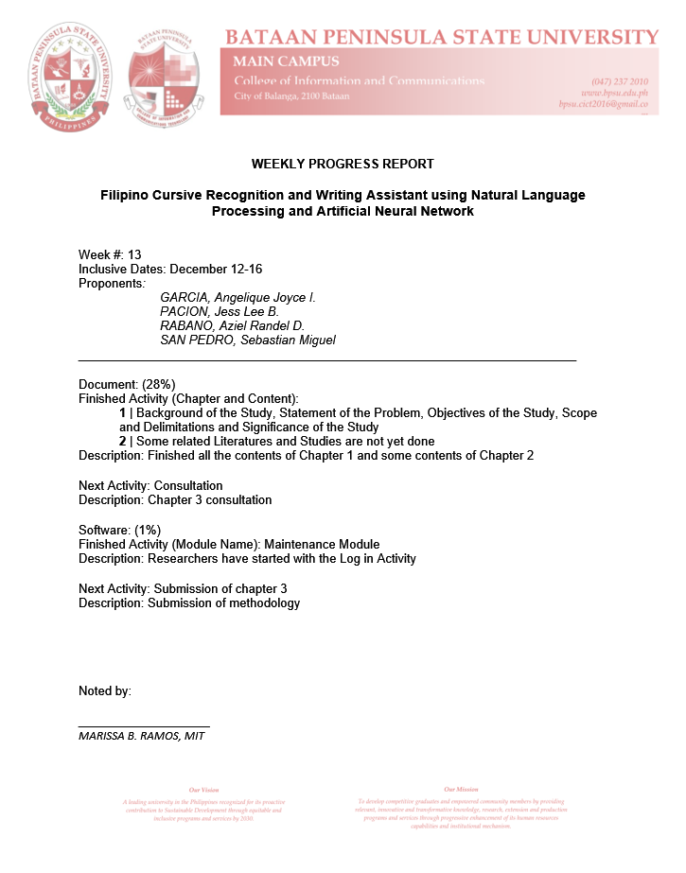

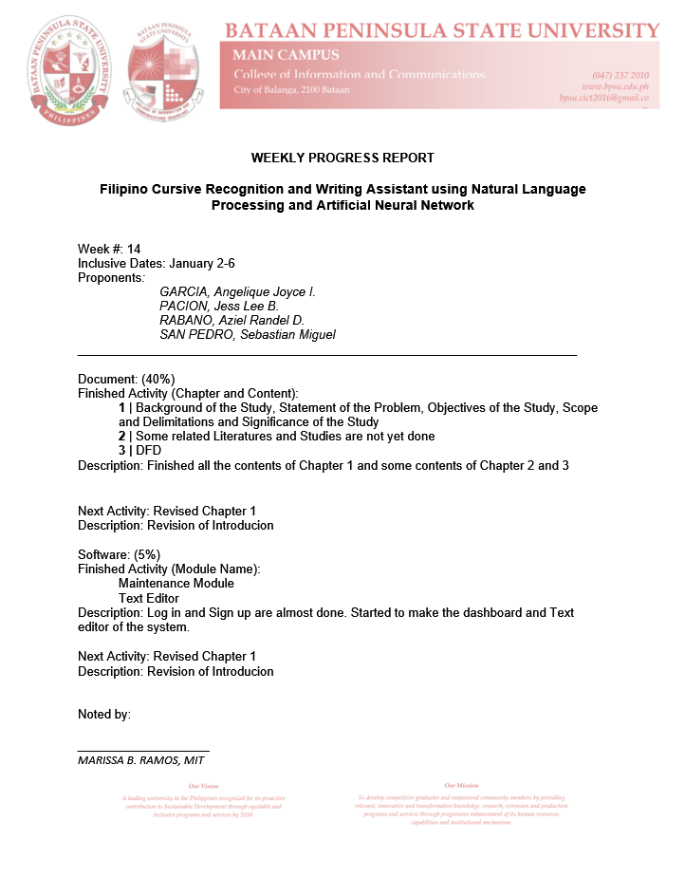

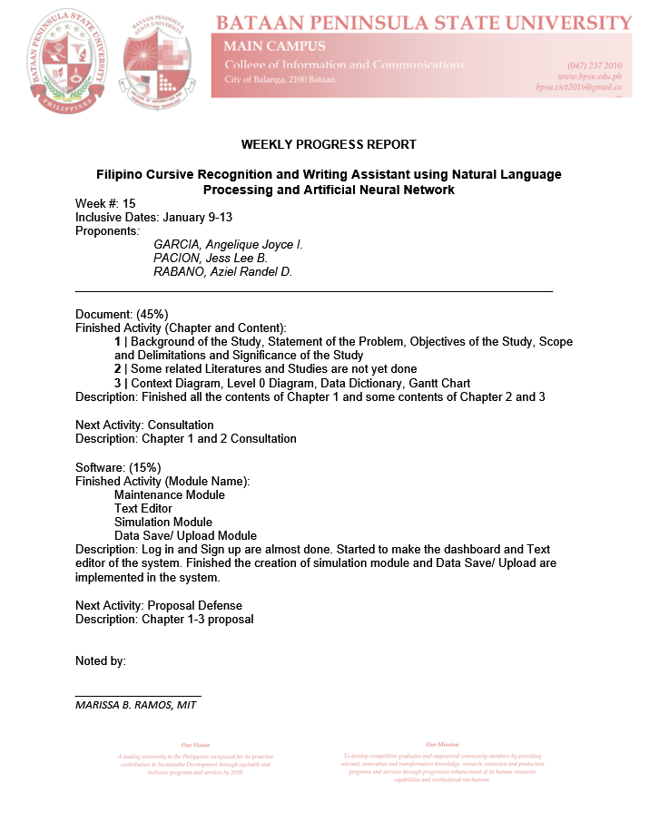

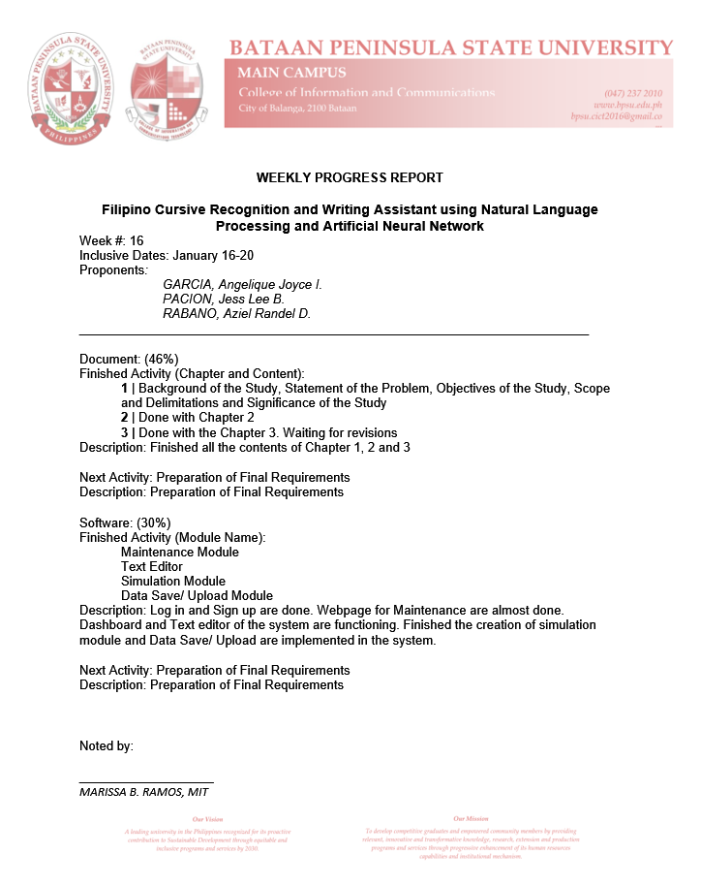

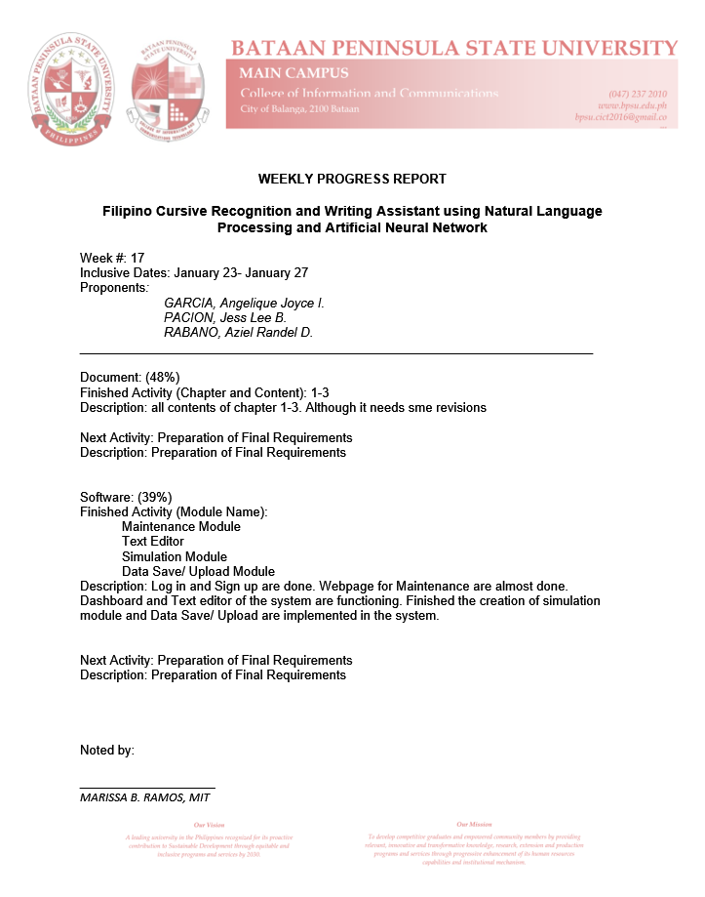

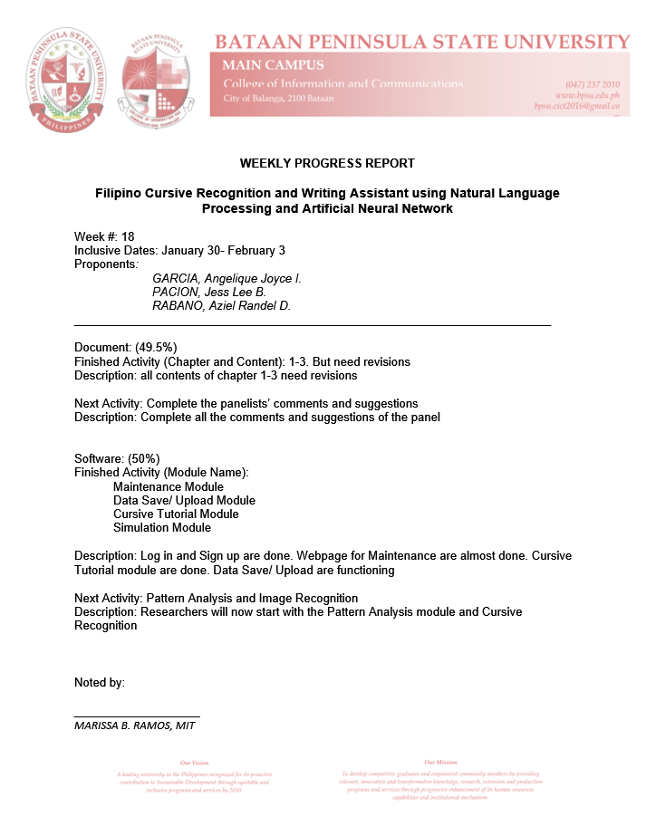

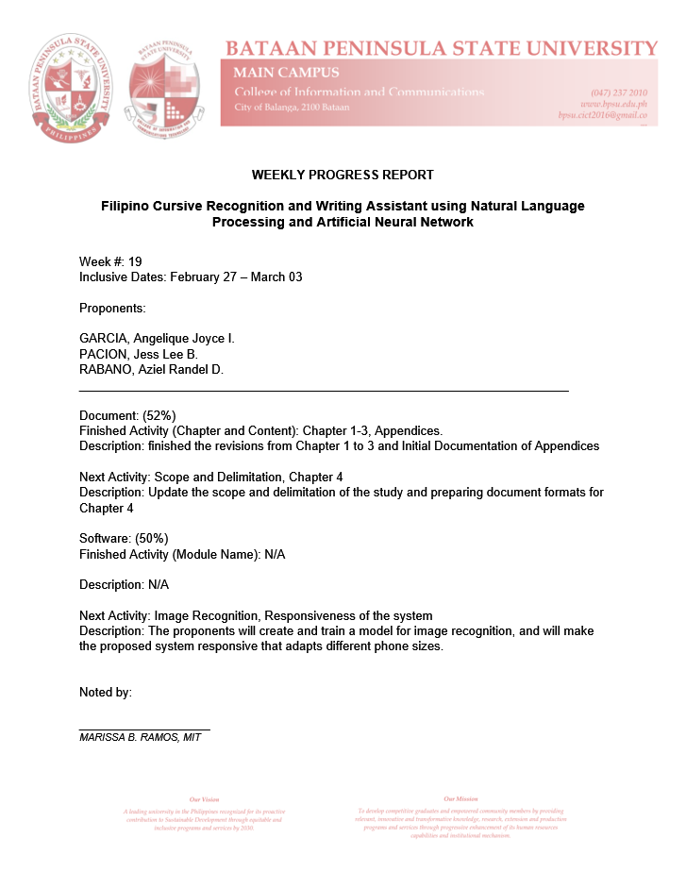

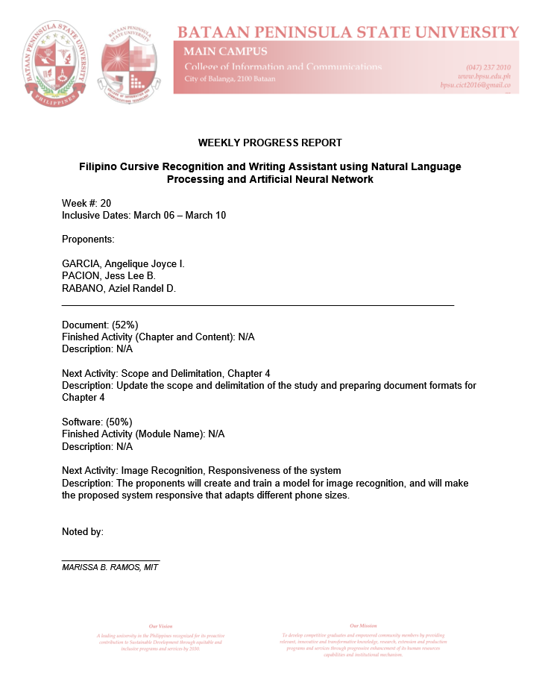

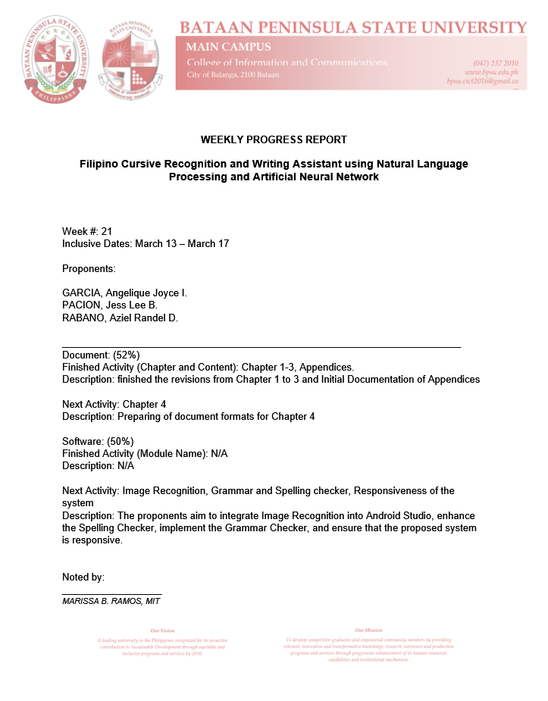

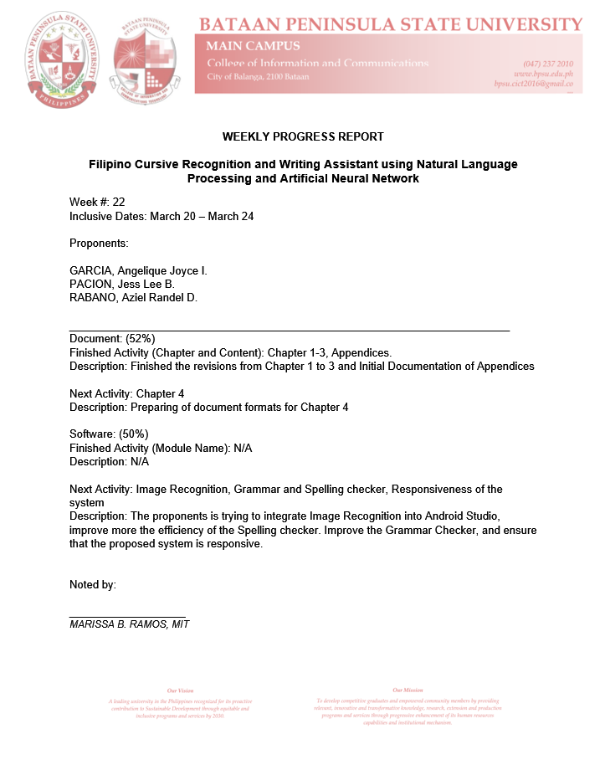

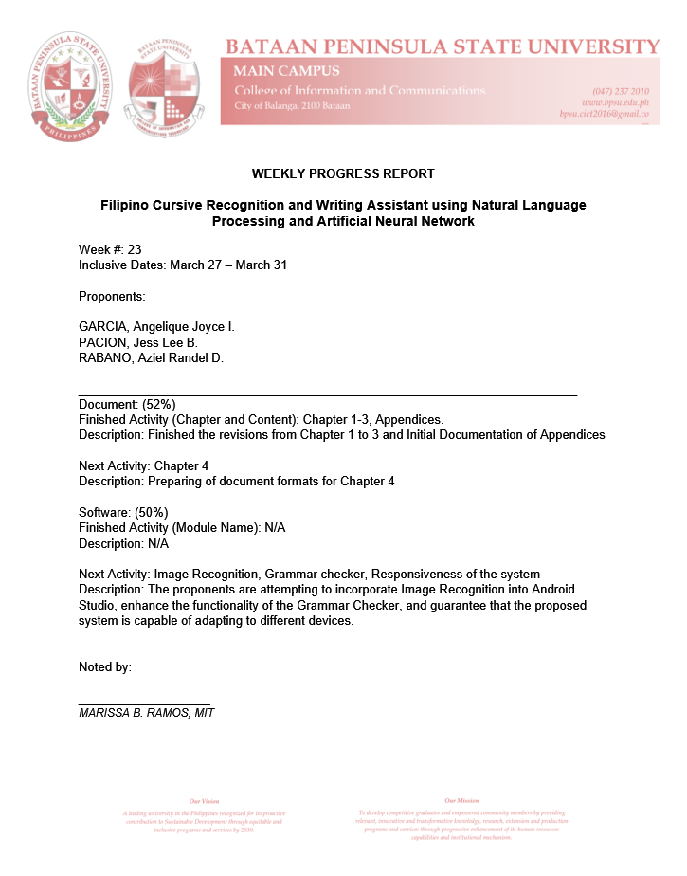

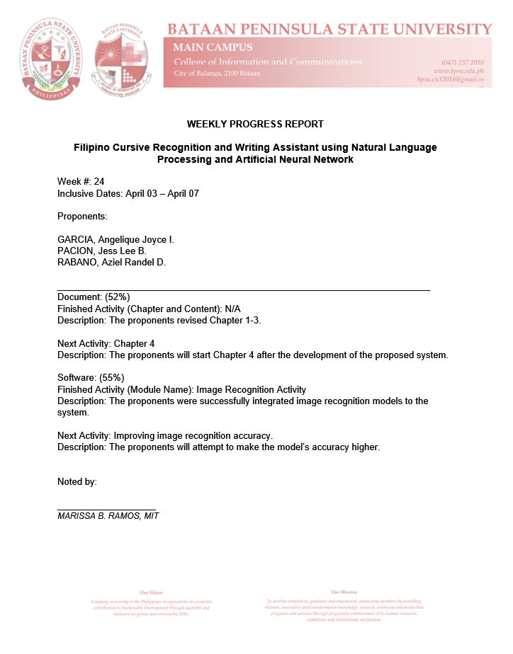

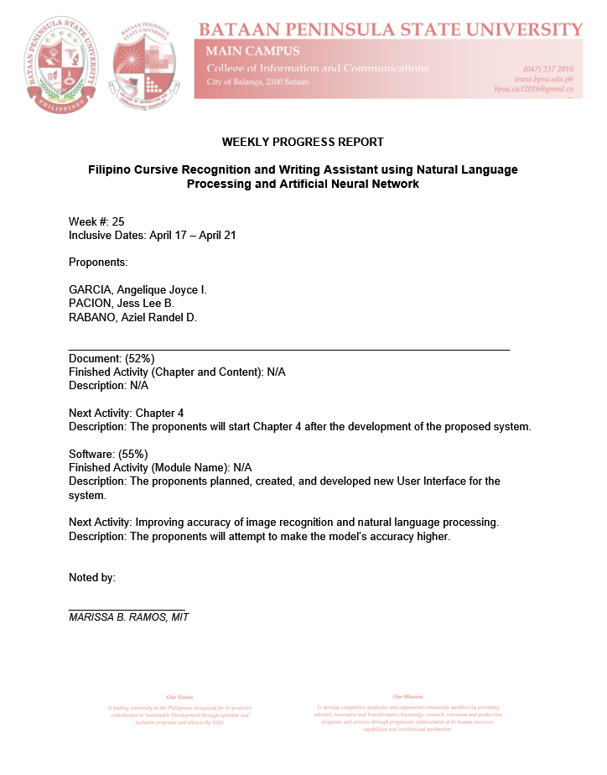

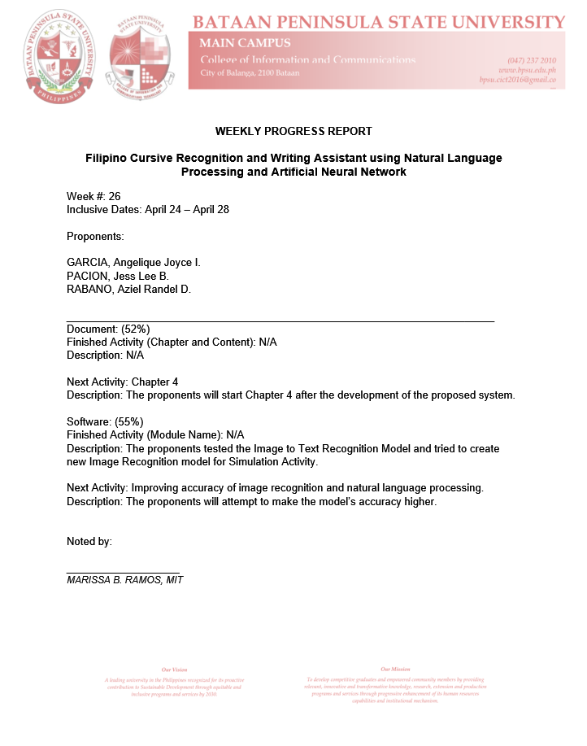

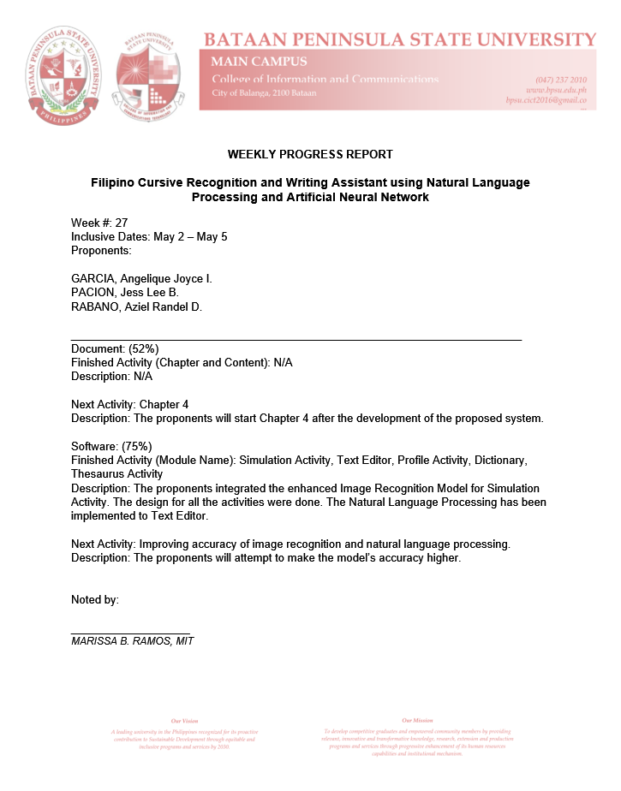

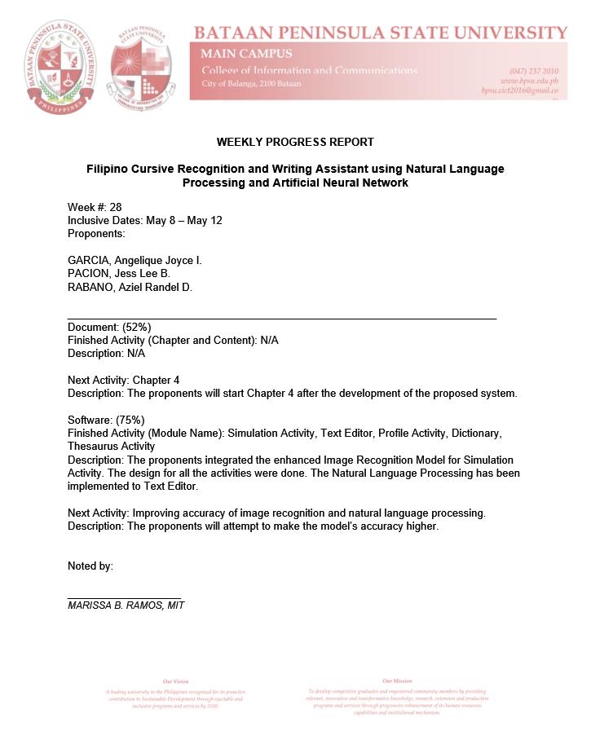

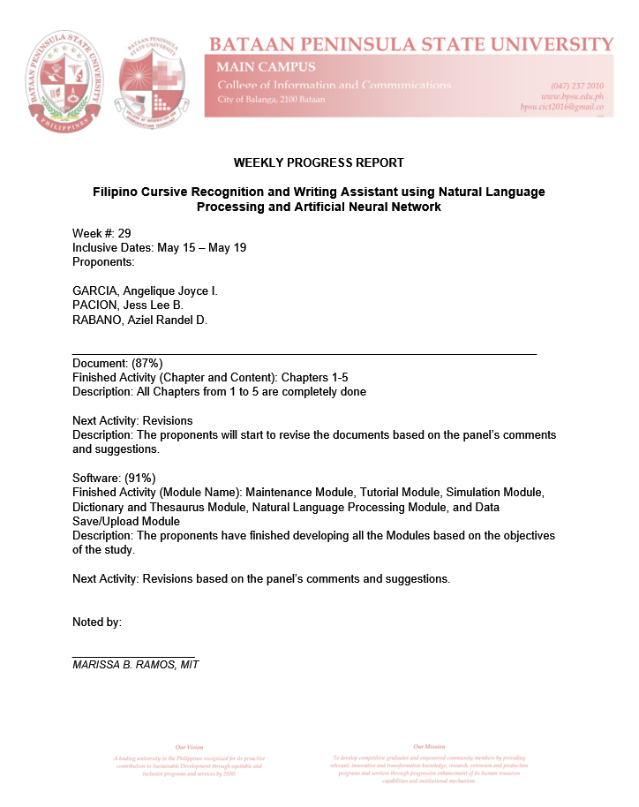

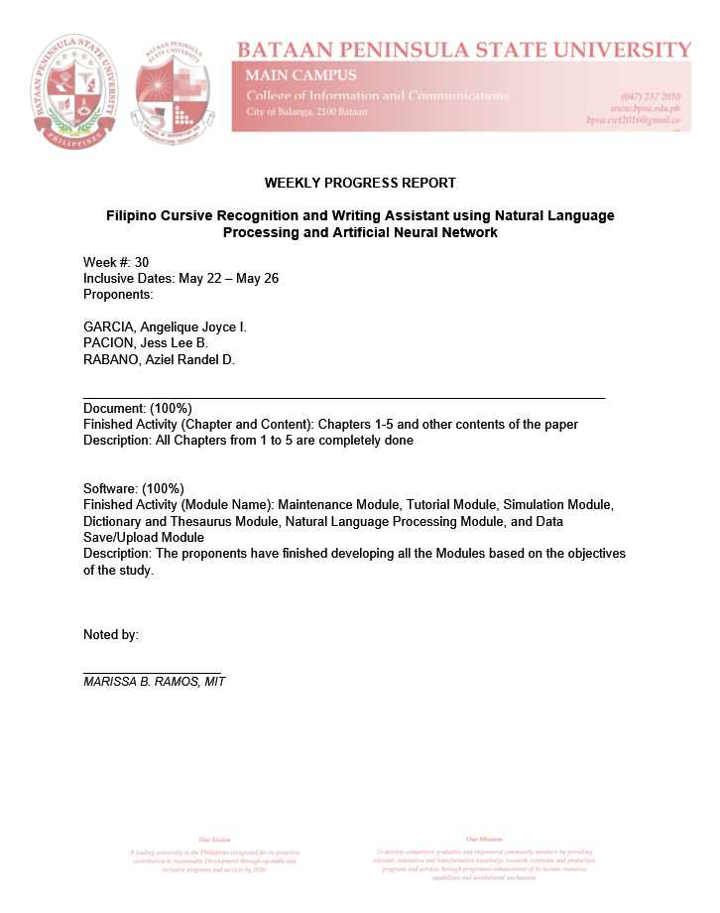

**APPENDIX G**

**User’s Manual**



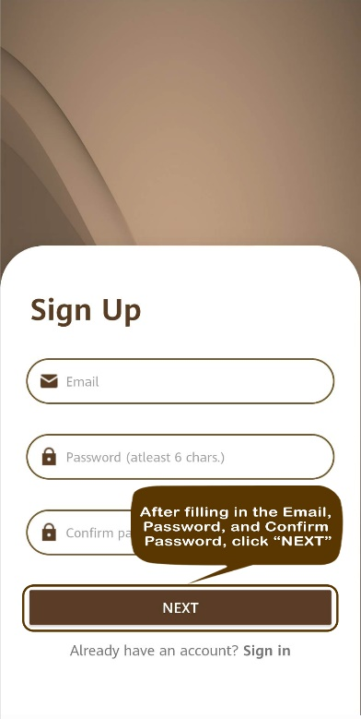 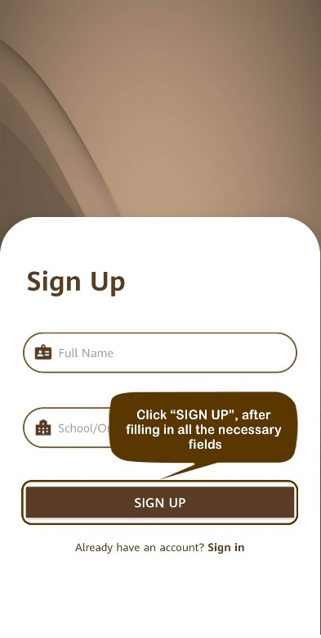 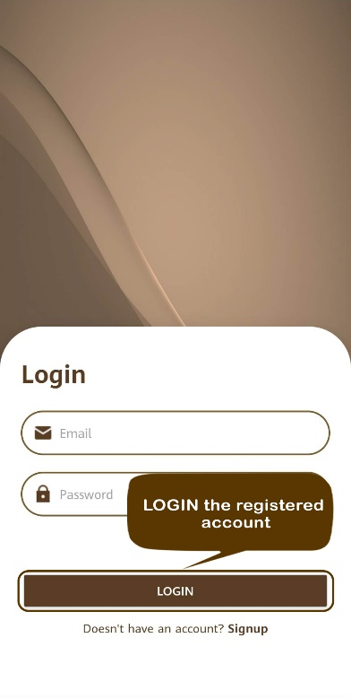

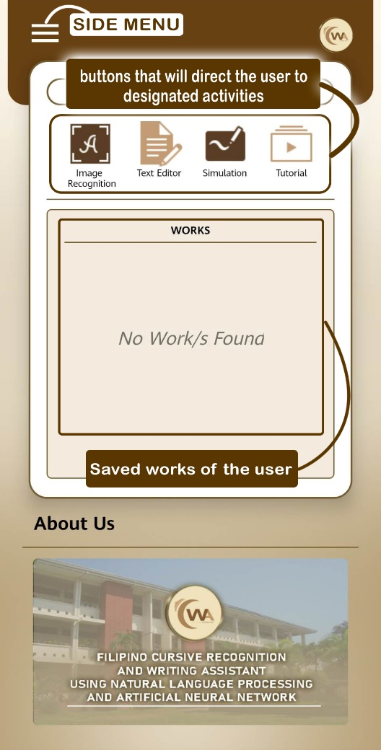

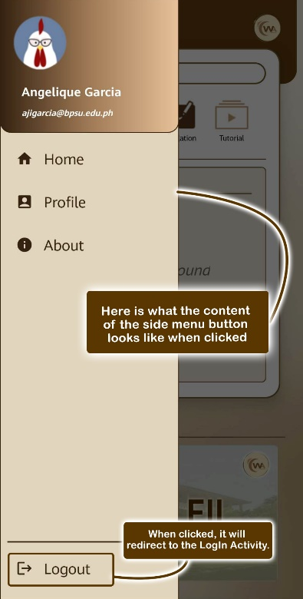 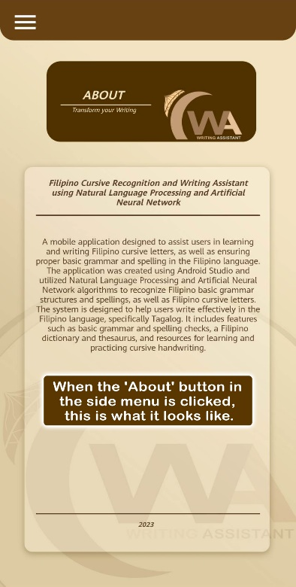 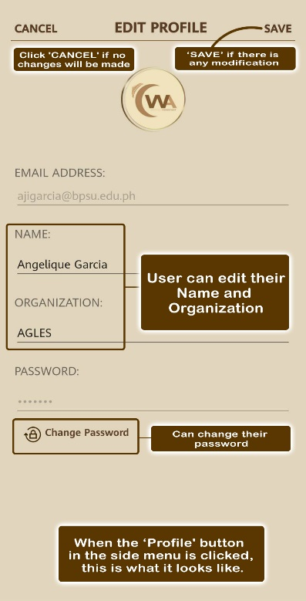

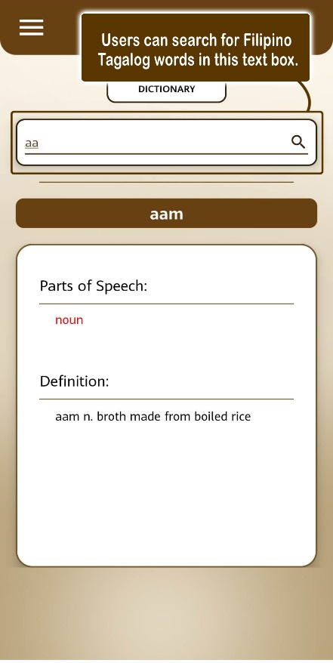 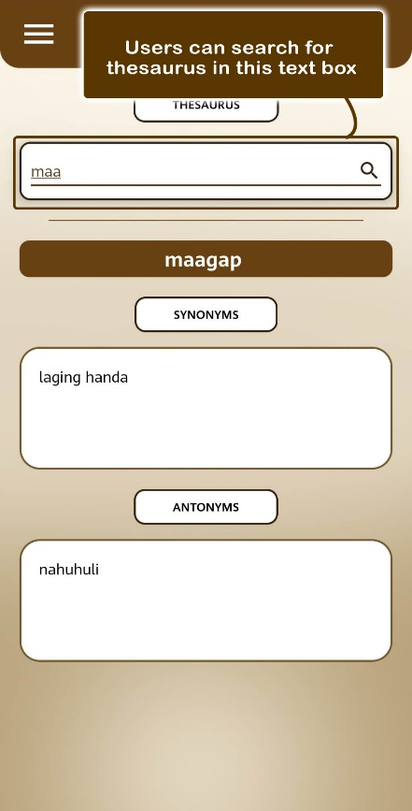

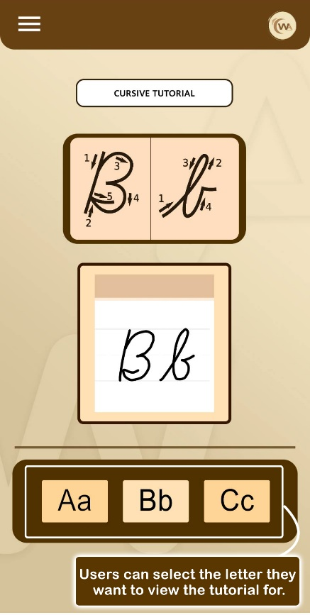

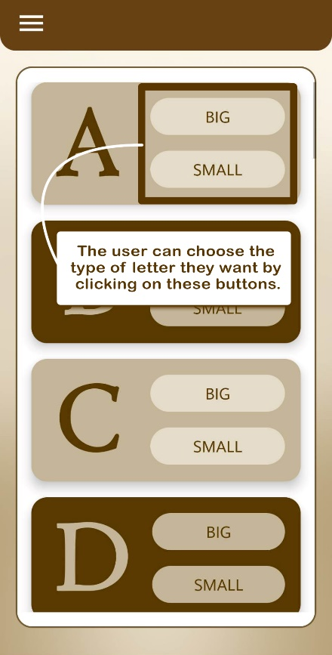 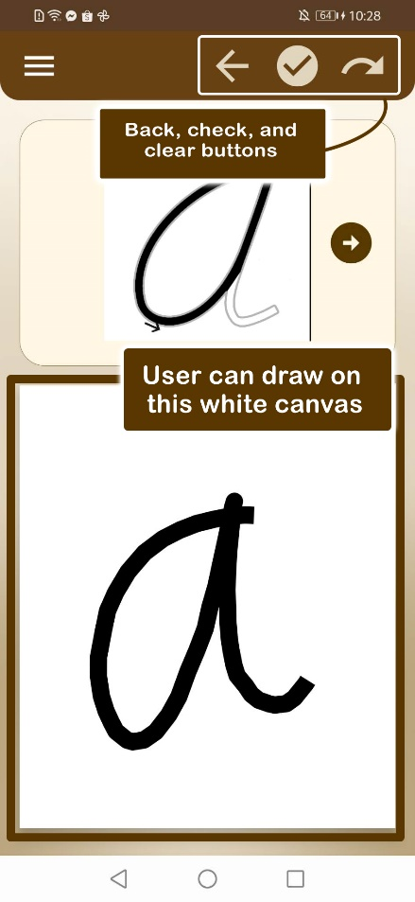

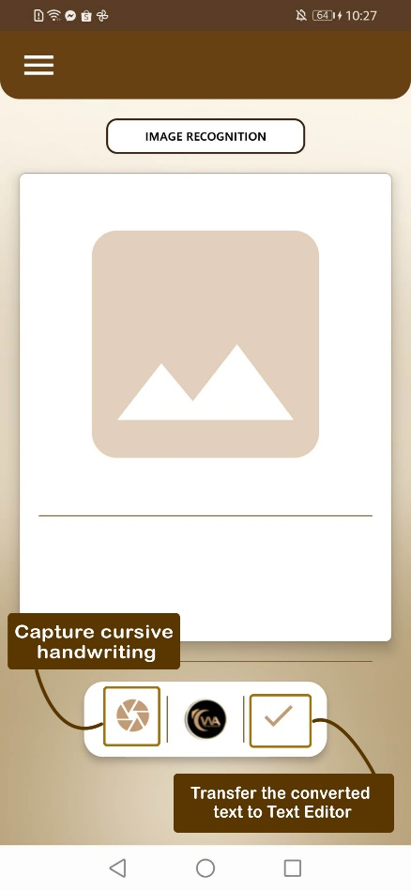 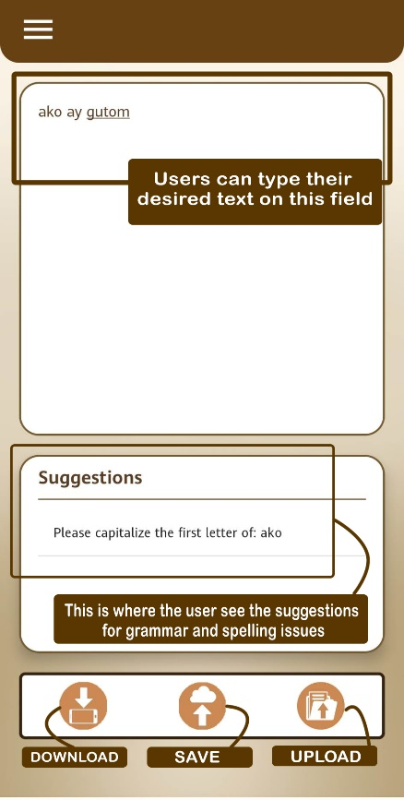

**Researcher’s Profile**



